

2025-2029 Consolidated Plan and 2025-2026 Annual Action Plan
Second Amendment
Public Comment Period
March 5, 2026 – April 3, 2026
Proposed Amendments
Section | Page
SP-45 | 117 &119
AP-20 | 135
AP-35 | 138
AP-38 | 145
AP-55 | 147

Executive Summary

ES-05 Executive Summary - 24 CFR 91.200(c), 91.220(b)
1. Introduction
Incorporated in 1888, the city of Escondido (City) is about 18 miles inland, strategically located 100 miles south of Los Angeles and 30 miles northeast of San Diego. Surrounded by avocado and citrus groves, Escondido is a diverse, vibrant community. As an entitlement jurisdiction under the U.S. Department of Housing and Urban Development (HUD), the City receives federal funds in proportion to its population size, concentration of poverty, and other socioeconomic and demographic data. To receive such funds, the City must submit a Consolidated Plan every five years to HUD. This document is the City’s Consolidated Plan for the 2025 to 2029 period.
The Consolidated Plan is a five-year planning document that identifies needs within low-to-moderate-income (LMI) communities and outlines how the City will address those needs. Ultimately, it guides investments and helps achieve HUD’s mission of providing decent housing, suitable living environments, and expanded economic opportunities for LMI populations. Jurisdictions participating in any of the following HUD funding programs must submit a Consolidated Plan every five years:
- Community Development Block Grants (CDBG) – CDBG is a flexible funding source that can be used for both housing and non-housing activities, including neighborhood revitalization, workforce and economic development, community and nonprofit facilities, and infrastructure and public services in LMI communities.
- HOME Investment Partnerships (HOME) – HOME is used for building, acquiring, and rehabilitating affordable housing for rent and homeownership. It may also be used for direct rental assistance to low-income residents.
- Emergency Solutions Grants (ESG) – ESG funds programs and services supporting persons experiencing homelessness. This includes operating shelters, providing essential services to shelter residents, administering rapid rehousing programs, and homelessness prevention.
- Housing Opportunities for Persons with AIDS (HOPWA) – HOPWA supports low-income people living with HIV/AIDS and their families by providing affordable housing opportunities.
Based on its population size, the City of Escondido directly receives and distributes CDBG and HOME. The City has received ESG funds in the past, but not in recent years. In the unlikely event that Escondido receives ESG funds during the 2025 to 2029 period, this Consolidated Plan would apply to ESG funds as well. The City does not receive HOPWA funds. The goals in this Consolidated Plan were developed through a collaborative process to identify the community's priority needs and outline the activities the City will undertake with these funds during the 2025 to 2029 period.
This Consolidated Plan includes the following components:
- A Needs Assessment that identifies the community’s affordable housing, community development, and homelessness needs.
- A Market Analysis that examines the existing housing market, public housing requirements, homeless population needs, and economic characteristics of the jurisdiction.
- A Strategic Plan outlining the strategies to address the identified priority needs over the next five years.
- An Action Plan that summarizes the specific activities to be undertaken during the program year to address the priority needs.
2. Summary of the objectives and outcomes identified in the Plan Needs Assessment Overview
The City determined its goals and priorities for the 2025-2029 Consolidated Plan based on community and stakeholder feedback, U.S. Census Bureau data, and data from 2-1-1 San Diego, the region’s Community Information Exchange (CIE). These priorities are as follows:
- Support the development and preservation of affordable rental and homeownership units.
- Expand access to supportive services to prevent and reduce homelessness, promote housing stability, and foster long-term solutions.
- Promote safe and healthy communities by improving public facilities, upgrading infrastructure, and supporting neighborhood revitalization efforts.
- Deliver essential supportive services to vulnerable populations, including youth, families, and seniors with low to moderate incomes and individuals with special needs.
These priorities represent the varied needs that emerged during the Consolidated Plan development process. Note that fair housing services also falls within the housing priorities.
3. Evaluation of past performance
As part of the Consolidated Plan process, the City is required to submit an annual Consolidated Annual Performance and Evaluation Report (CAPER), which reports on how funds were spent, the households that benefited from the funds, and the progress toward meeting its annual goals for housing and community development activities. These reports are posted on the City’s website.
The City has successfully implemented housing, homelessness, and public facilities activities in the previous Consolidated Plan cycle, impacting the lives of thousands of residents with low to moderate incomes. It is anticipated that the City and its partners will continue to positively impact residents through collaborative efforts. Below is a summary of some of the outcomes achieved during the first four years of the previous five-year Consolidated Plan cycle. Final outcome data for the previous Consolidated Plan cycle will be presented to HUD with the submittal of the Program Year 2024-25 CAPER.
- 1,628 households served through the provision of public service activities intended to increase access to recreational, educational, and healthcare resources
- 10 affordable ownership units assisted
- 2 households provided direct financial homebuyer assistance
- 14,540 businesses assisted
- 217 persons served through homelessness prevention services
- 190 persons experiencing homelessness were served in overnight shelters
4. Summary of citizen participation process and consultation process
The City’s community participation process was informed by the Citizen Participation Plan, which outlines the framework for engaging the community and providing notifications for public meetings and hearings. To ensure broad community involvement, the City organized three community meetings at the following times and locations:
- November 12, 2024, Park Avenue Community Center, 12:30 PM
- November 12, 2024, Escondido City Hall, 6:30 PM
- December 5, 2024, East Valley Community Center, 6:30 PM
Additionally, the City distributed both a Community Needs Assessment Survey and a stakeholder survey to gather input. To increase accessibility, the Community Needs Assessment Survey was made available in Spanish, and Spanish translation was made available at the community meetings. A public hearing was held before the City Council on March 19, 2025, to accept input from the public on the Consolidated Plan and establish priorities for spending HOME and CDBG during the 2025 to 2029 period. City Council also discussed and approved the allocation process for distributing funds for FY 2025-26. The Consolidated Plan was then made available for public review and comments for 30 days at Escondido City Hall and on the City's website, from April 24 to May 23, 2025. No public comments were received during this time. A second public hearing was held on June 25, 2025, to review and adopt the Final Consolidated Plan and FY 2025-26 Action Plan. Public notices for each hearing were published at least 10 days prior to the date of the hearing in the Escondido Times -Advocate newspaper, as well as posted at City Hall. All community engagement efforts are detailed further in the Process section of this plan.
5. Summary of public comments
Feedback on community needs was collected through community meetings, a Community Needs Assessment Survey, a stakeholder survey, a public comment period, and two formal public hearings. These comments provided insight into community needs and informed the goals of the Consolidated Plan. Top priority needs identified were homeless services, affordable housing development, and community services.
6. Summary of comments or views not accepted and the reasons for not accepting them
All public comments were accepted and incorporated into Appendix F – Public Comments.
7. Summary
The City’s Consolidated Plan sets forth the housing and community development strategies and objectives for the five-year period of Program Years 2025 to 2029 and satisfies the statutory requirements for receiving CDBG, HOME, and ESG funds. The City of Escondido will comply with all applicable administration priorities and executive orders.
More than merely meeting requirements, however, the City is committed to providing every opportunity for residents and stakeholders in Escondido to participate in the Consolidated Plan process and expanding opportunities for its LMI residents to thrive. This Consolidated Plan and the associated community engagement process are indicative of that commitment.

The Process

PR-05 Lead & Responsible Agencies 24 CFR 91.200(b)
1. Describe agency/entity responsible for preparing the Consolidated Plan and those responsible for administration of each grant program and funding source
The following are the agencies/entities responsible for preparing the Consolidated Plan and those responsible for administration of each grant program and funding source.
Agency Role | Name | Department/Agency
Lead Agency | Escondido

CDBG Administrator | Escondido | Housing and Neighborhood Services Division
HOPWA Administrator
HOME Administrator | Escondido | Housing and Neighborhood Services Division
ESG Administrator |  | Housing and Neighborhood Services Division
HOPWA-C Administrator
Table 1 – Responsible Agencies

Narrative
The City’s Housing and Neighborhood Services Division is the lead agency responsible for the preparation and administration of the Consolidated Plan, corresponding Annual Action Plans, CAPERs, and the CDBG, ESG, and HOME programs.
Consolidated Plan Public Contact Information
Danielle Lopez
Housing and Neighborhood Services Manager
City of Escondido
Phone: (760) 839-4518
Email: Danielle.Lopez@escondido.gov

PR-10 Consultation – 91.100, 91.110, 91.200(b), 91.300(b), 91.215(I) and 91.315(I)
1. Introduction
As part of the Consolidated Plan development process, the City of Escondido prioritizes broad citizen participation. Every effort has been made to engage all segments of the community, particularly those who may benefit from HOME, CDBG, and ESG funds.
Provide a concise summary of the jurisdiction’s activities to enhance coordination between public and assisted housing providers and private and governmental health, mental health and service agencies (91.215(I)).
The City of Escondido has long been committed to fostering relationships with local community groups. Several nonprofit organizations in the community have been working with the City to manage programs and projects that assist residents with lower incomes. A variety of support services in the areas of education, job training, and homeless, senior, and youth services also augment the City’s efforts in these areas. The City maintains an updated agency list and has included all interested groups in the Consolidated Plan development. In addition, City staff periodically attends Community Alliance For Escondido (CAFE) meetings where information from different service and housing agencies in the City is exchanged. The City also participates in quarterly convenings of local CDBG program administrators.
Describe coordination with the Continuum of Care and efforts to address the needs of homeless persons (particularly chronically homeless individuals and families, families with children, veterans, and unaccompanied youth) and persons at risk of homelessness
The San Diego Regional Task Force on Homelessness (RTFH) is the regional Continuum of Care for San Diego County. The RTFH is an integrated group of local government members, private individuals, and business and nonprofit stakeholders with a goal of ending homelessness in the San Diego region. The RTFH uses a web-based information technology system, Homeless Management Information System (HMIS), to capture and report on client, project, and system-level information regarding homeless services utilization, performance, and outcomes. The RTFH also uses a Coordinated Entry System (CES), as required by HUD, to increase efficiency and mainstream resources. The RTFH (including the City of Escondido) meets periodically to discuss the coordination of services and housing for the homeless population.
Describe consultation with the Continuum(s) of Care that serves the jurisdiction's area in determining how to allocate ESG funds, develop performance standards and evaluate outcomes, and develop funding, policies and procedures for the administration of HMIS
The City of Escondido has not received ESG funds in recent years. If the City were to be awarded ESG funds in the 2025 to 2029 period, the City would coordinate with other regional agencies and determine the current needs and priorities for assisting the County’s homeless population and spending ESG funds.
2. Describe Agencies, groups, organizations and others who participated in the process and describe the jurisdictions consultations with housing, social service agencies and other entities

Table 2 – Agencies, groups, organizations who participated
1 | Agency/Group/Organization | 2-1-1 San Diego
1 | Agency/Group/Organization Type | Community Information Exchange (CIE)
1 | What section of the Plan was addressed by Consultation? | Housing Need Assessment  Market Analysis
1 | How was the Agency/Group/Organization consulted and what are the anticipated outcomes of the consultation or areas for improved coordination? | Provided localized data to inform the Consolidated Plan.
2 | Agency/Group/Organization | COUNTY OF SAN DIEGO HEALTH AND HUMAN SERVICES AGENCY
2 | Agency/Group/Organization Type | Other government - County
2 | What section of the Plan was addressed by Consultation? | Housing Need Assessment  Public Housing Needs  Market Analysis
2 | How was the Agency/Group/Organization consulted and what are the anticipated outcomes of the consultation or areas for improved coordination? | Consulted with various County agencies to inform development of Consolidated Plan.
3 | Agency/Group/Organization | Regional Task Force on Homelessness
3 | Agency/Group/Organization Type | Regional organization  Continuum of Care
3 | What section of the Plan was addressed by Consultation? | Housing Need Assessment  Public Housing Needs  Market Analysis
3 | How was the Agency/Group/Organization consulted and what are the anticipated outcomes of the consultation or areas for improved coordination? | Provided localized data to inform the Consolidated Plan.
4 | Agency/Group/Organization | The Alabaster Jar Project
4 | Agency/Group/Organization Type | Local non-profit organization
4 | What section of the Plan was addressed by Consultation? | Housing Need Assessment
4 | How was the Agency/Group/Organization consulted and what are the anticipated outcomes of the consultation or areas for improved coordination? | Responded to stakeholder survey to provide insight on community needs.
5 | Agency/Group/Organization | Escondido Education Compact
5 | Agency/Group/Organization Type | Non-profit service provider
5 | What section of the Plan was addressed by Consultation? | Housing Need Assessment
5 | How was the Agency/Group/Organization consulted and what are the anticipated outcomes of the consultation or areas for improved coordination? | Responded to stakeholder survey to provide insight on community needs.
6 | Agency/Group/Organization | Center for Community Solutions
6 | Agency/Group/Organization Type | Local non-profit organization
6 | What section of the Plan was addressed by Consultation? | Housing Need Assessment
6 | How was the Agency/Group/Organization consulted and what are the anticipated outcomes of the consultation or areas for improved coordination? | Responded to stakeholder survey to provide insight on community needs.
7 | Agency/Group/Organization | San Diego Children's Discovery Museum
7 | Agency/Group/Organization Type | Local non-profit organization
7 | What section of the Plan was addressed by Consultation? | Housing Need Assessment
7 | How was the Agency/Group/Organization consulted and what are the anticipated outcomes of the consultation or areas for improved coordination? | Responded to stakeholder survey to provide insight on community needs.
8 | Agency/Group/Organization | United Way of San Diego County
8 | Agency/Group/Organization Type | Local non-profit organization
8 | What section of the Plan was addressed by Consultation? | Housing Need Assessment
8 | How was the Agency/Group/Organization consulted and what are the anticipated outcomes of the consultation or areas for improved coordination? | Responded to stakeholder survey to provide insight on community needs.
9 | Agency/Group/Organization | URBAN CORPS OF SAN DIEGO
9 | Agency/Group/Organization Type | Local non-profit organization
9 | What section of the Plan was addressed by Consultation? | Housing Need Assessment
9 | How was the Agency/Group/Organization consulted and what are the anticipated outcomes of the consultation or areas for improved coordination? | Responded to stakeholder survey to provide insight on community needs.

Identify any Agency Types not consulted and provide rationale for not consulting
No agency or organization was purposely excluded from providing input on the Consolidated Plan.

Other local/regional/state/federal planning efforts considered when preparing the Plan
Name of Plan | Lead Organization | How do the goals of your Strategic Plan overlap with the goals of each plan?
Continuum of Care | TBD | Need to include CoC for ESG and homeless activities
City of Escondido Housing Element | City of Escondido | The Housing Element is the State-recognized strategy for addressing the City's housing needs. This Consolidated Plan aligns with the goals outlined in the Housing Element.
Climate Action Plan | City of Escondido | The Climate Action Plan provides a roadmap for reducing greenhouse gas emissions (GHGs) through the implementation of various strategies, goals, actions, and supporting measures. This Consolidated Plan aligns with the goals outlined in the Climate Action Plan.
Table 3 – Other local / regional / federal planning efforts
Describe cooperation and coordination with other public entities, including the State and any adjacent units of general local government, in the implementation of the Consolidated Plan (91.215(l))
As previously noted, the Regional Continuum of Care includes representatives from all 18 cities in the county, nonprofit service providers, and other stakeholders committed to addressing homelessness in San Diego. This group collaborates to identify service gaps, set funding priorities, and implement a coordinated, systemic approach to homelessness. The City will continue working with County CDBG, HOME, and ESG entitlement jurisdictions, as well as local stakeholders, to align priorities and maximize the impact of available funding and resources.
Narrative (optional):
Please see above

PR-15 Citizen Participation – 91.105, 91.115, 91.200(c) and 91.300(c)
1. Summary of citizen participation process/Efforts made to broaden citizen participation
Summarize citizen participation process and how it impacted goal-setting

To develop the Consolidated Plan, the City conducted an extensive public outreach and participation process, which involved the following components:
- Community meetings
- Community Needs Assessment Survey
- Stakeholder survey
- Public hearings
- Public review of draft Consolidated Plan and FY 2025-26 Annual Action Plan
During the Consolidated Plan development, three community meetings were held. Two meetings were held on November 12, 2024, and one meeting was held on December 5, 2024. A total of 22 people attended the three meetings and provided feedback on what they identified as the City’s most pressing community needs. Spanish translation was available at the community meetings and upon request at City Hall. At the meetings, attendees received extensive information about the Consolidated Plan, the citizen participation process, HUD requirements for an entitlement city, the amount of funding that the City anticipates receiving, and how those funds can be used by the City. The City and its consultants facilitated small group discussions during which the attendees’ feedback on community needs was recorded on worksheets.
Additionally, a Community Needs Assessment Survey was offered online and via hard copy. The survey was made available in English and Spanish. A total of 164 individuals responded to the survey. A copy of the survey is provided in Appendix C – Community Needs Assessment Survey Responses. A public notice was posted at City Hall and printed in the Escondido Times-Advocate newspaper at least 10 days prior to the City Council public hearing on April 03, 2025, to review the draft Consolidated Plan and open a 30-day public comment period. Notice of the public review and comment period was advertised through a publication in the Escondido Times-Advocate newspaper. The draft Consolidated Plan and FY 2025-26 Annual Action Plan were available on the City website and in a hard copy format at City Hall during the 30-day public comment period from April 24, 2025, to May 23, 2025.[NO3] No comments were received during the 30-day public review period. A second public notice was posted at City Hall and printed in the Escondido Times-Advocate newspaper on May 29, 2025, prior to the City Council meeting on June 25, 2025, at which the Consolidated Plan was approved. Two public comments were received. All public comments received during both meetings are included in Appendix F of the Consolidated Plan. The findings from these outreach activities helped shape the priority needs in the Consolidated Plan.

Citizen Participation Outreach
Sort Order | Mode of Outreach | Target of Outreach | Summary of  response/attendance | Summary of  comments received | Summary of comments not accepted and reasons | URL (If applicable)
1 | In-person community meeting on November 12, 2024 at 12:30 pm | Non-targeted/broad community | 19 | Home repair assistance for homeowners, rental assistance, homeless services, senior programs, and infrastructure improvements were identified as top needs by attendees. | All comments were accepted. | Presentation slides are provided in Appendix B.
2 | In-person community meeting on November 12, 2024 at 12:30 pm | Non-targeted/broad community | 1 | Financial literary education, infrastructure improvements, homeless services, and increasing access to homeownership (e.g., down payment assistance) were identified as top needs by the attendee. | All comments were accepted. | Presentation slides are provided in Appendix B
3 | In-person community meeting on November 12, 2024 at 12:30 pm | Non-targeted/broad community | 2 | Homeless services, housing for college students, community center and library improvements, increased access to resources, alley improvements, and affordable housing (including permanent supportive housing) were identified as top needs by attendees. | All comments were accepted. | Presentation slides are provided in Appendix B.
4 | Public Meeting | Non-targeted/broad community | Escondido Education COMPACT/CAFE Meeting. Approximately 30 participants. | No comments received. | No comments received.
5 | In-person community meeting on November 12, 2024 at 12:30 pm | Non-targeted/broad community | 164 | Homeless services, affordable housing development, and community services were identified as the three areas of greatest community need by survey respondents. | All comments were accepted. | URL closed; survey and responses provided in Appendix C
6 | In-person community meeting on November 12, 2024 at 12:30 pm | Key stakeholders | 12 | Affordable housing, homeless services, youth services, workforce development and access to quality, affordable childcare services were identified as top needs by survey respondents. | All comments were accepted. | URL closed; survey and responses provided in Appendix D
7 | Public Hearing | Non-targeted/broad community | 1 | We are asking that the 5-year plan emphasizes the importance of proactive protection of the "Affordable Housing" in Mobile-Home Communities by using these and all other tools. We are very interested to find out what levels the Federal Government requires of the City of Escondido to maintain HIGH numbers of "Affordable Housing, in order for the City of Escondido to show the PUBLIC the ratio of Homes in MH Parks that maintain that US HUD and all requirements. | All comments were accepted.
8 | Public Hearing | Non-targeted/broad community | 2 | Representative advocating for the WeeCare Program. Representative advocating for Voices for Children. | All comments were accepted.
9 | Public Meeting | Non-targeted/broad community | Neighborhood Leadership Forum. 20 participants. | Residents advocating for daycares, sidewalks, affordable housing, and homeless services. | All comments were accepted.
10 | Internet Outreach | Non-targeted/broad community | 8 | More parks with accessible playgrounds, more parking, resources for homeless and drug addiction, affordable housing, improve streets and alleys. | All comments were accepted.
11 | Public Meeting | Non-targeted/broad community | Homeless Subcommittee Meeting. 4 members of the public. | Staff for Operation Hope advocating for funding. | All comments were accepted.
12 | Public Meeting | Non-targeted/broad community | Homeless Subcommittee Meeting. 2 members of the public. | Resident requesting reinstatement of community advisory group for homeless services. | All comments were accepted.
Table 4 – Citizen Participation Outreach

Needs Assessment

NA-05 Overview
Needs Assessment Overview
The primary source of data used in this needs assessment are HUD Comprehensive Housing Affordability Strategy (CHAS) tabulations, which are based on the U.S Census Bureau’s American Community Survey (ACS) data and incorporate HUD-specified criteria relating to housing needs, HUD-defined income limits, and household types. This Needs Assessment predominantly uses data drawn from CHAS’s most recent data set (2017-2021). The information contained in this section informs the preparation of Escondido’s housing and community development priorities and both five- and one-year investment strategies.
Both Area Median Income (AMI) and HUD Area Median Family Income (HAMFI) are represented in this Consolidated Plan and are essentially equivalent when discussing populations and households with lower incomes. HAMFI is the HUD-specific term for what is broadly referred to as AMI. Where the term AMI is used in this Consolidated Plan, assume it refers to HAMFI. Table NA-05.01 represents the 2024 HUD Income Limits for the San Diego-Carlsbad, CA MSA in which Escondido is included.
The HUD Area Median Family Income (HAMFI) categories used in this report are as follows:
- Extremely low income: 0 to 30 percent of HAMFI
- Very low income: 30 to 50 percent of HAMFI
- Low income: 50 to 80 percent of HAMFI
- Moderate income: 80 to 100 percent of HAMFI
- Upper income: 100 percent of HAMFI and above
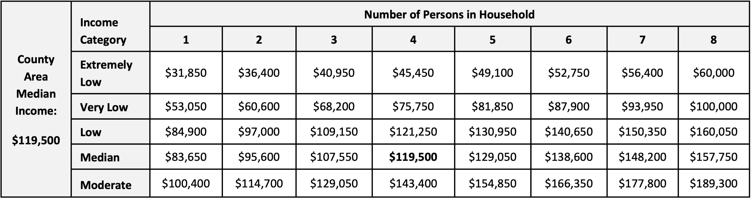
Table NA-05.01 San Diego County AMI, 2024
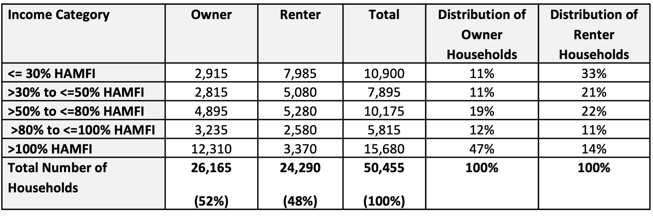
Table NA-05.02: Household Income Distribution
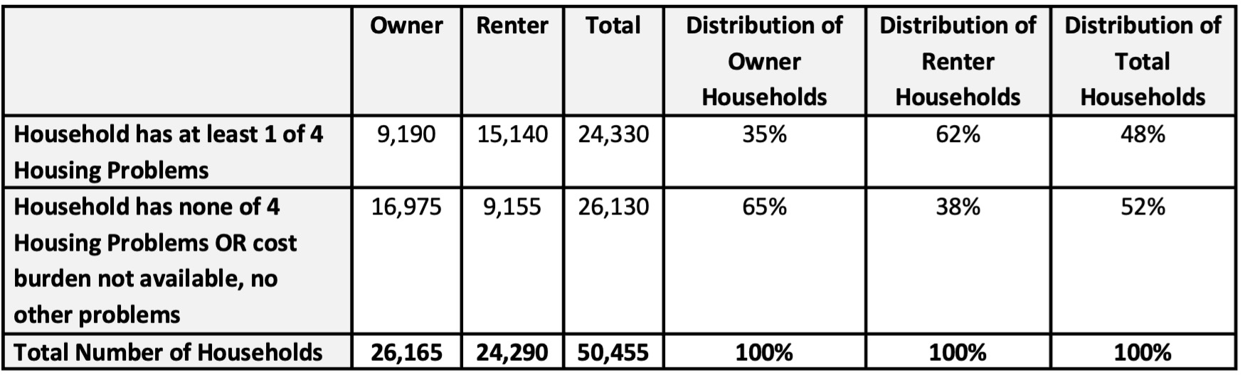
Table NA-05.03: Housing Problems
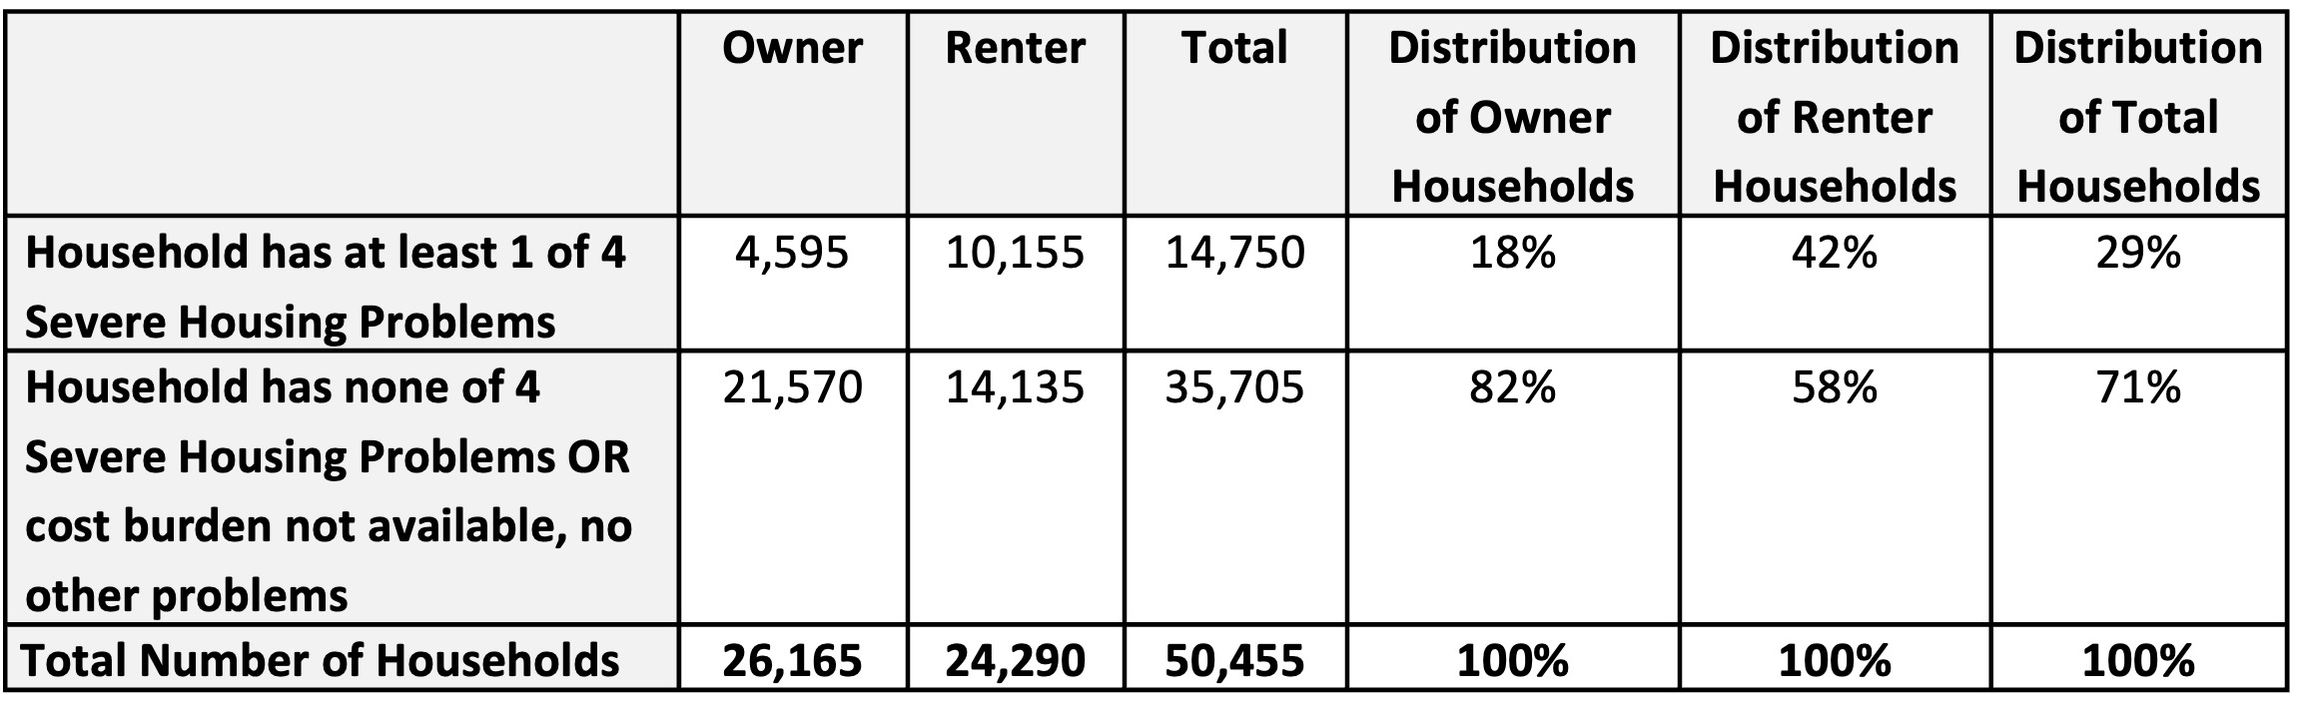
Table NA-05.04: Severe Housing Problems
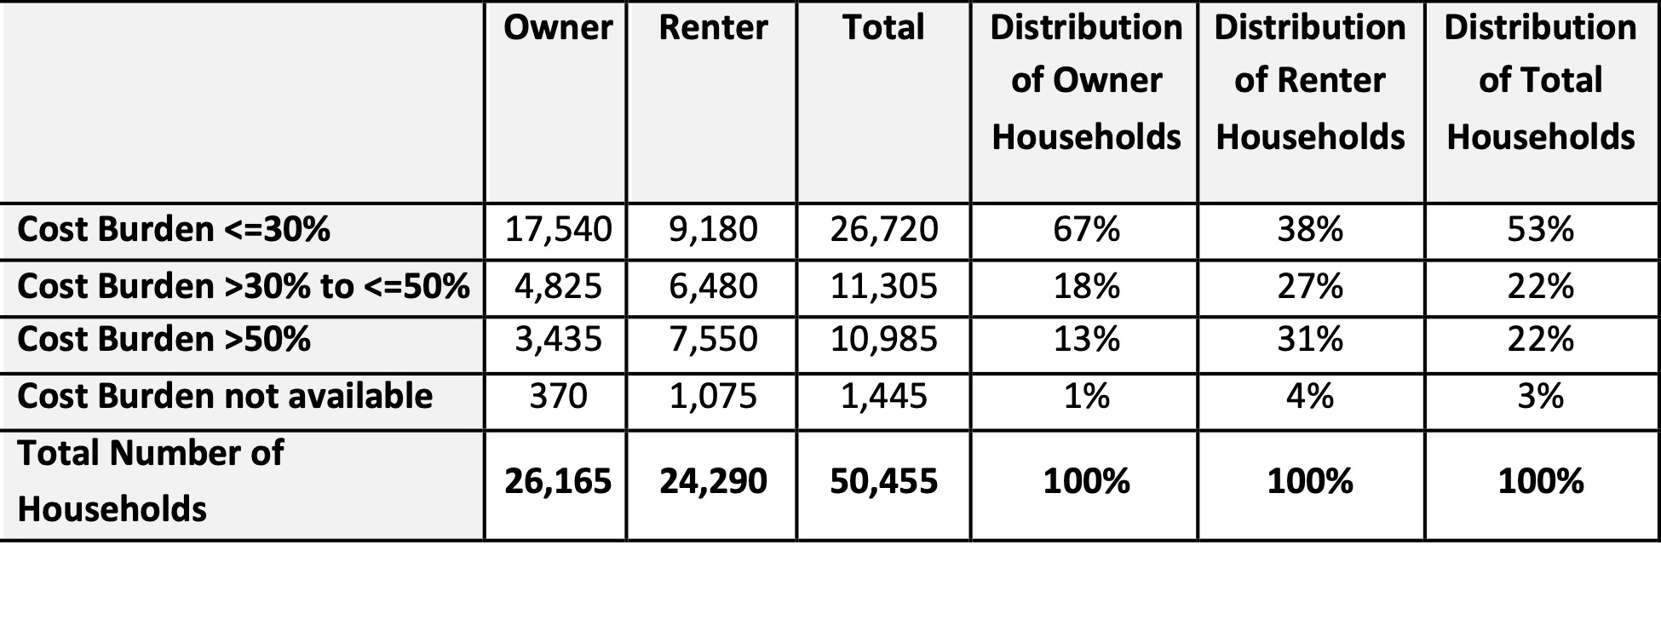
Table NA-05.05: Housing Cost Burden
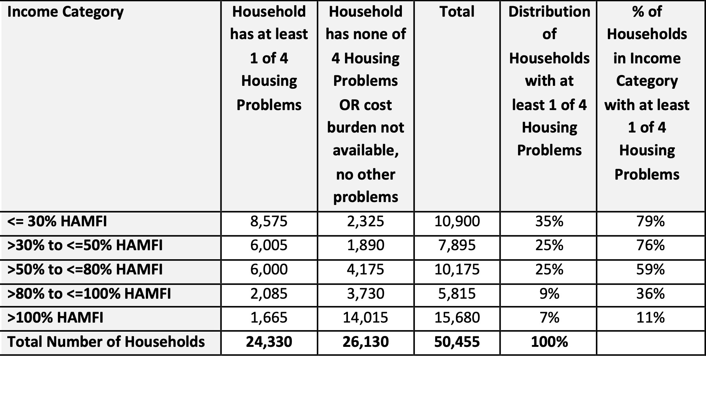
Table NA-05.06: Housing Problems by Income Level, All Households
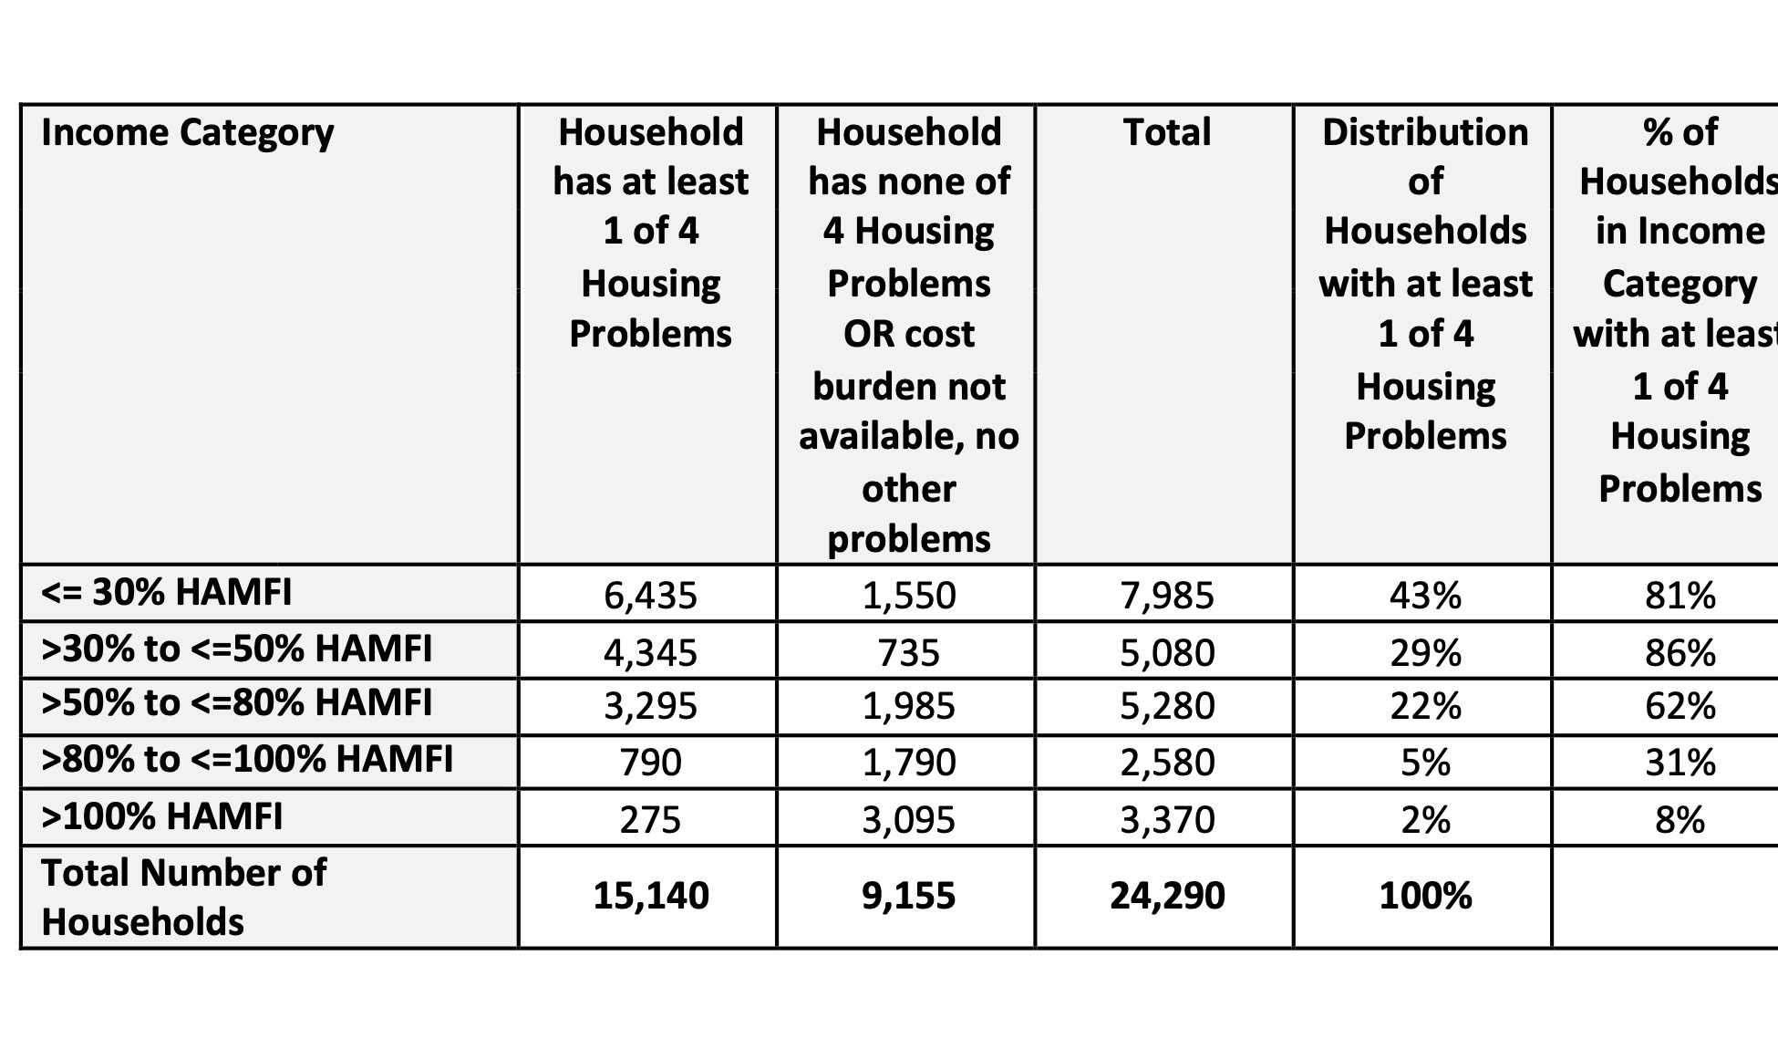
Table NA-05.07: Housing Problems by Income Level, Renters Only
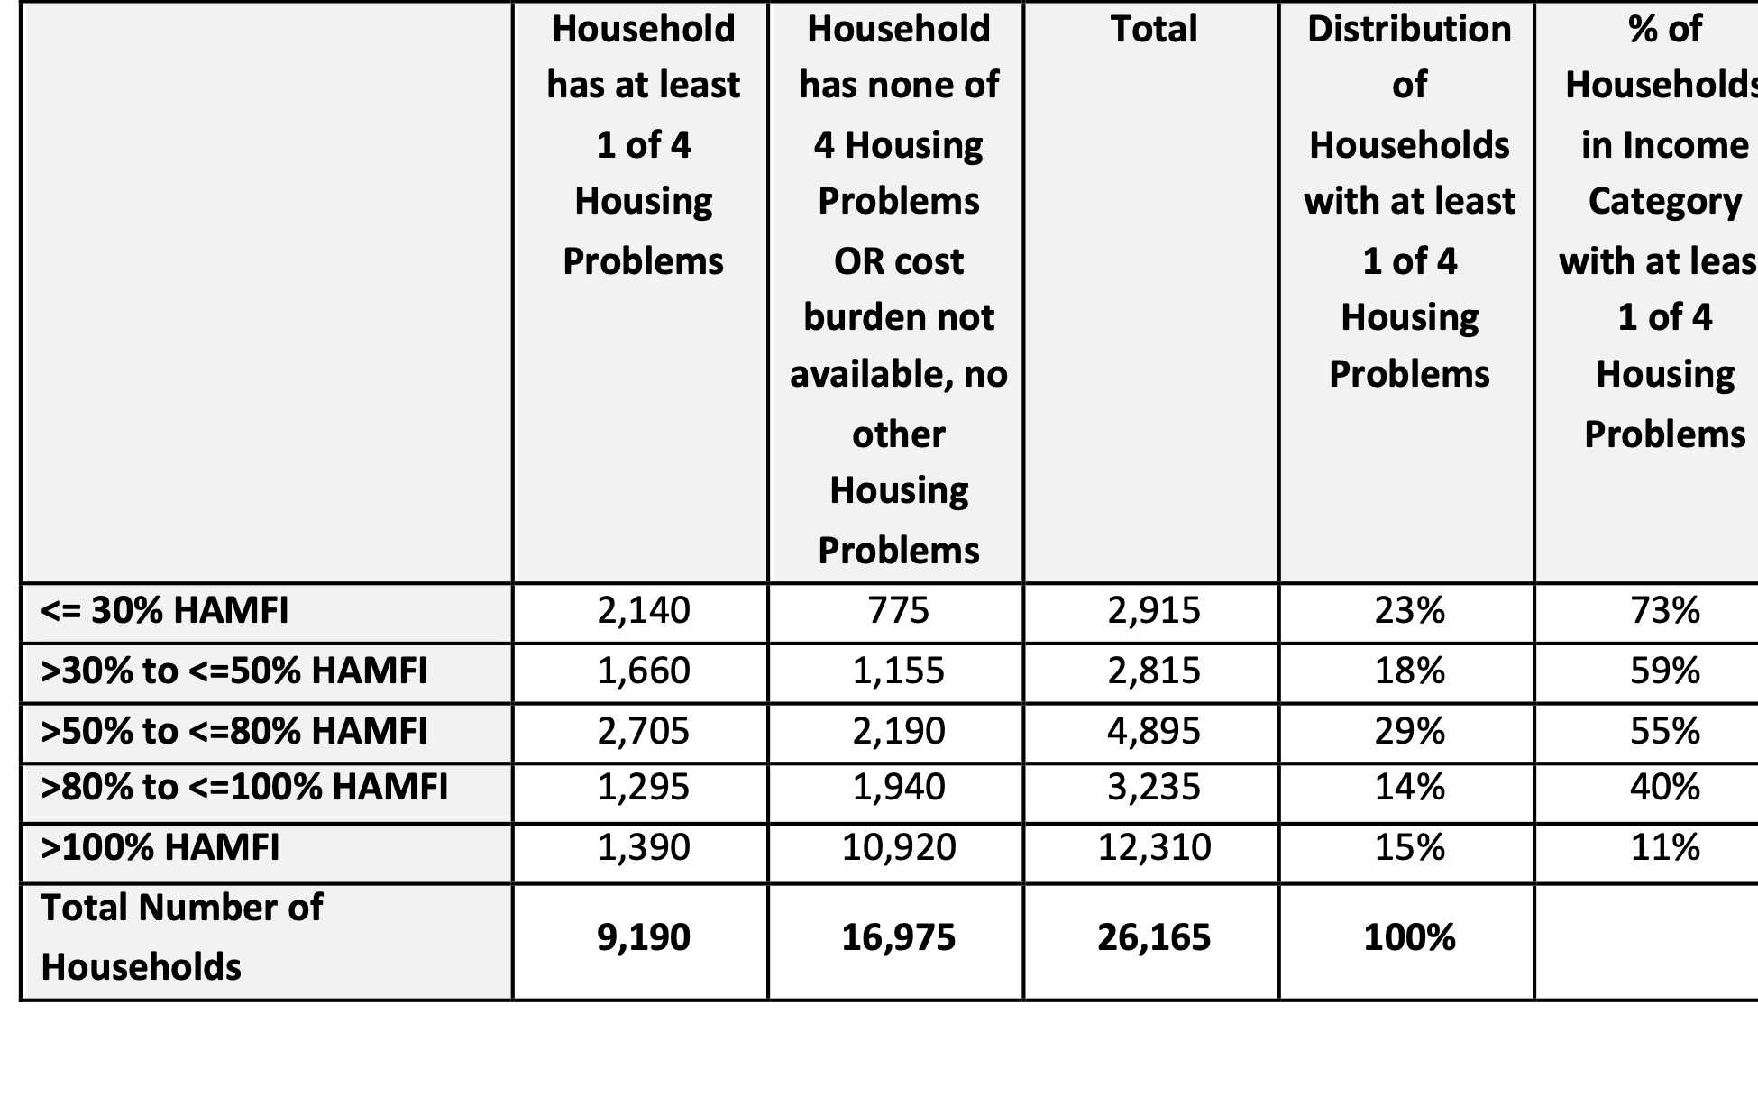
Table NA-05.08: Housing Problems by Income Level, Owners Only
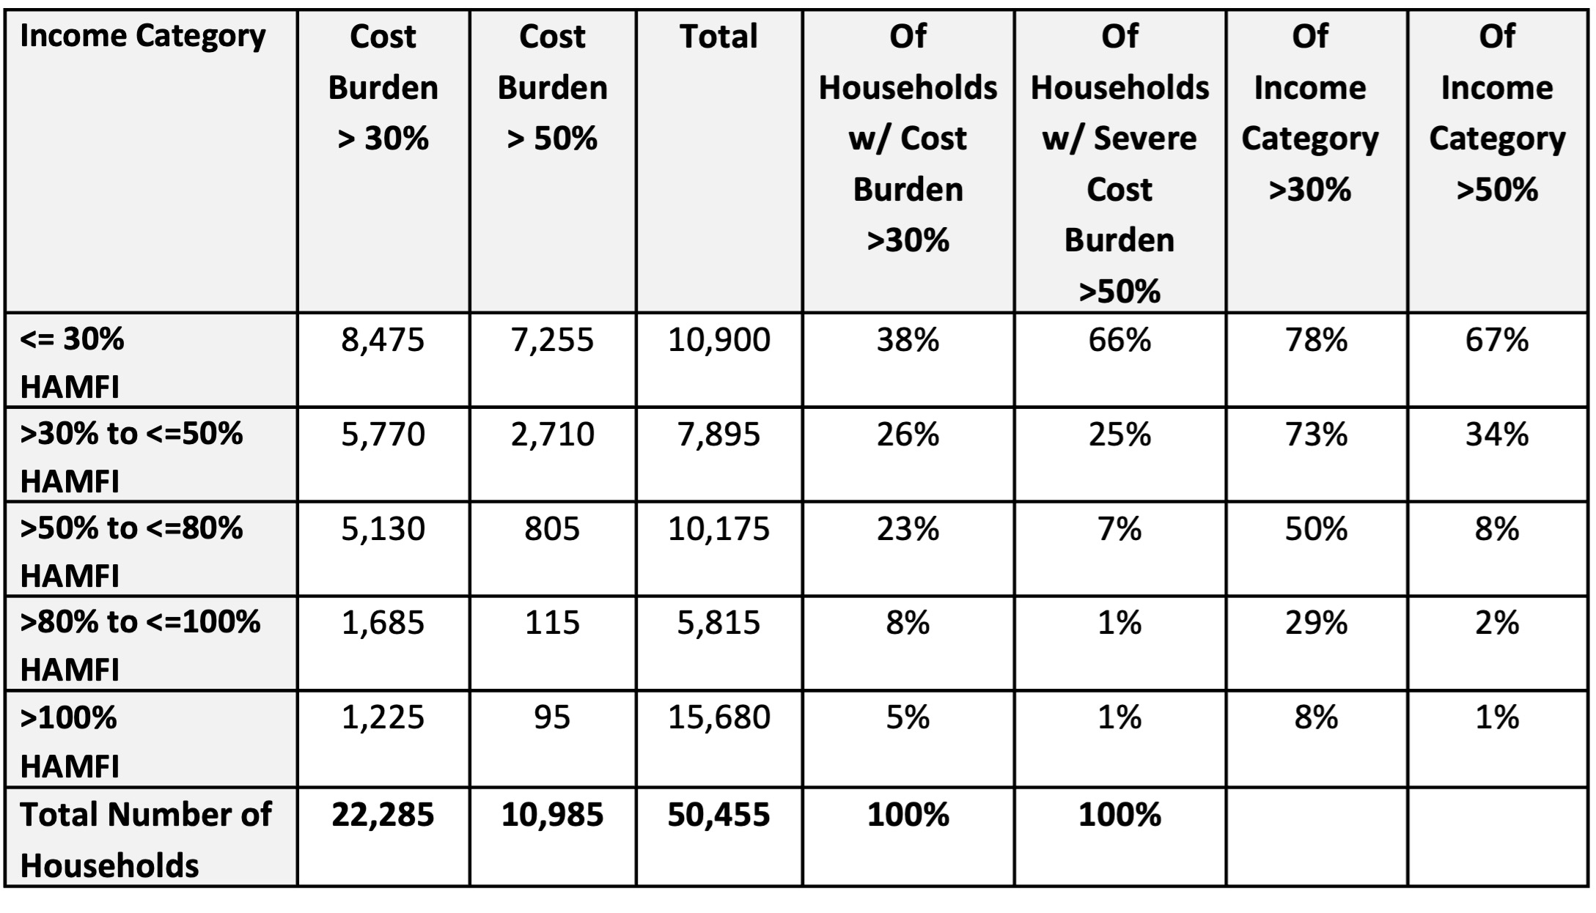
Table NA-05.09: Cost Burden by Income Level, All Households
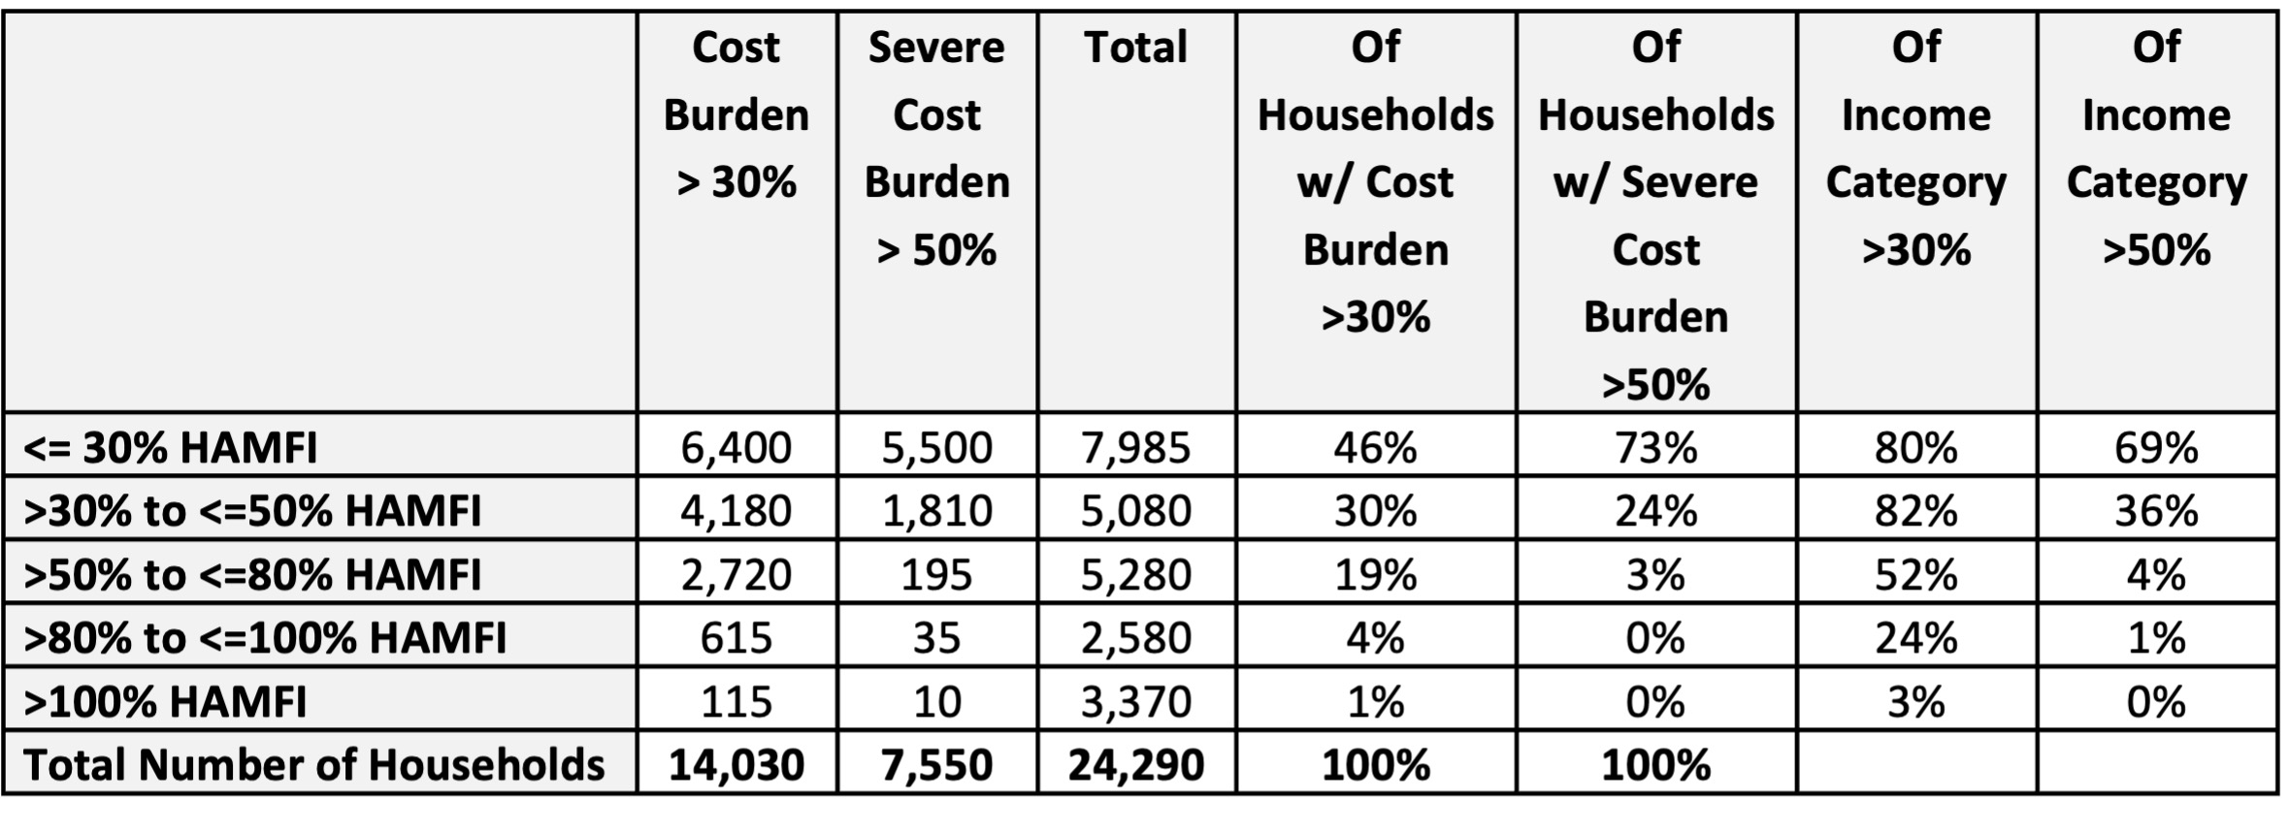
Table NA-05.10: Cost Burden by Income Level, Renters
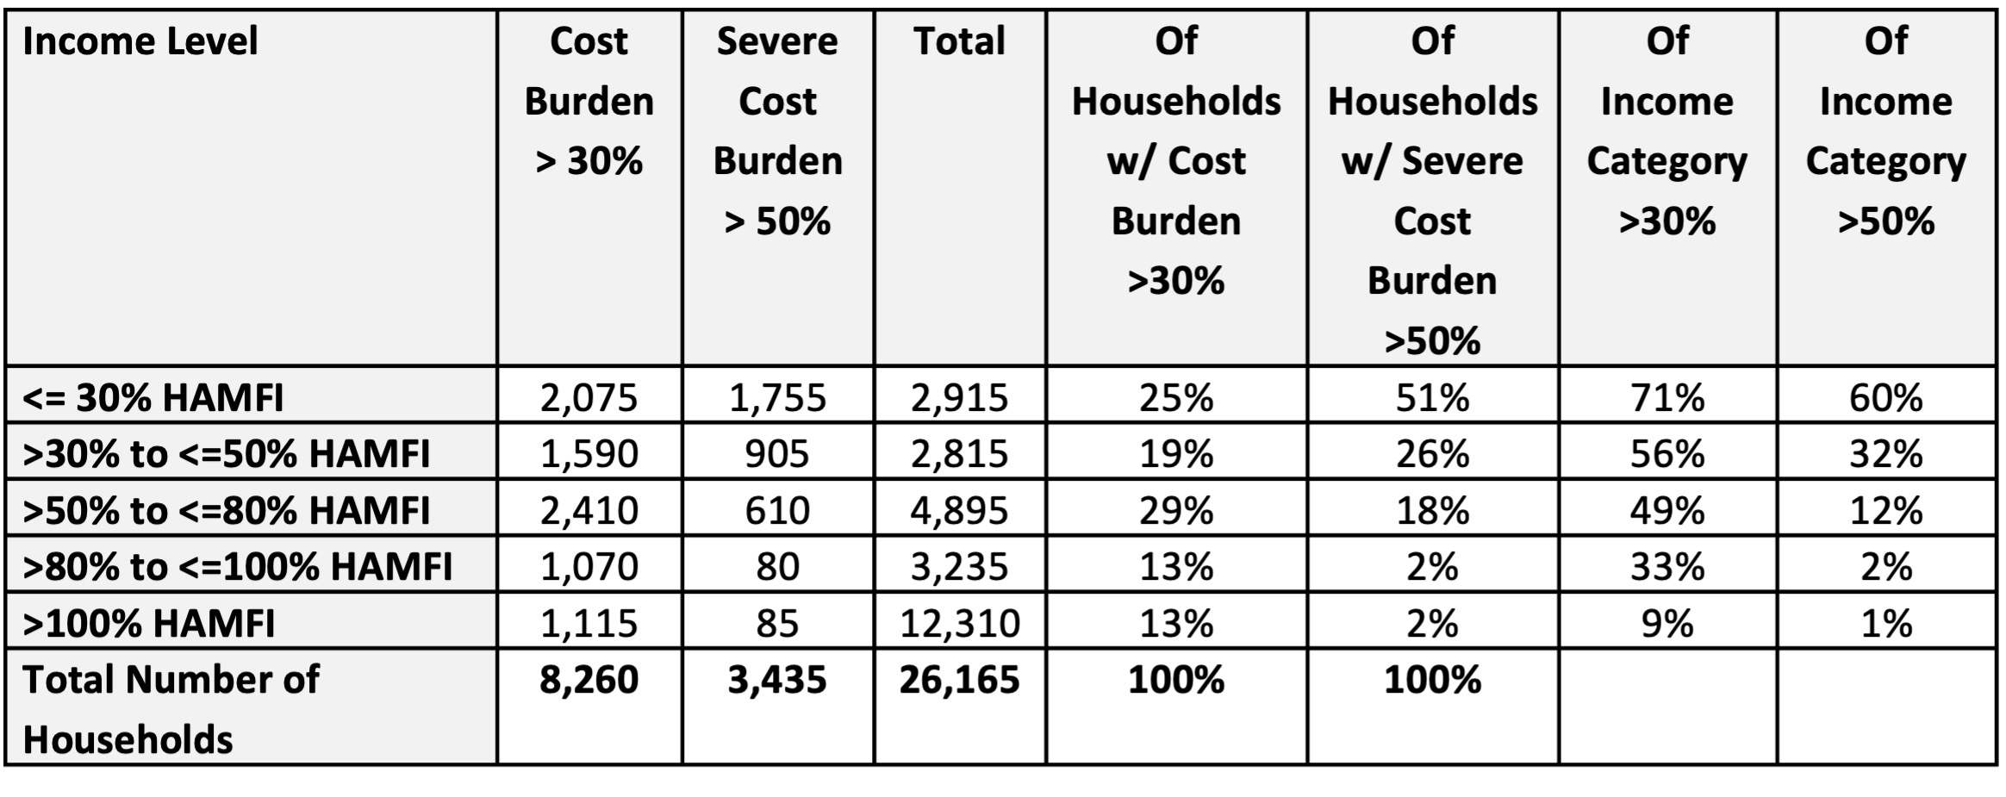
Table NA-05.11: Cost Burden by Income Level, Owners

NA-10 Housing Needs Assessment - 24 CFR 91.205 (a,b,c)
Summary of Housing Needs
The Housing Needs Assessment summarizes the housing needs in Escondido according to family type, income level, and household type. It also further discusses specific housing problems, including cost burden, substandard housing, and overcrowding. To the extent that any racial or ethnic group has a disproportionately greater need in any income category compared to the needs of that category as a whole, an assessment of that is also provided. A disproportionately greater need exists when the percentage of persons in a category of need who are members of a particular group is at least ten percentage points higher than the percentage of persons in the category as a whole.
As shown below in Table NA-10.01, according to the U.S. Census Bureau’s 2022 five-year American Community Survey (ACS) data, the population of Escondido is approximately 150,000, which is a 0.6 percent increase from 2015. The number of households has also increased by approximately 12.5 percent during this period to 50,658. Median income in 2023 was $84,477, which was 21 percent lower than the countywide median income of $102,285. Income is one of the most important factors in determining whether a household can balance housing costs with other necessities, while avoiding housing problems such as cost burden and overcrowding.
As shown in Table NA-10.02, according to 2020 ACS data auto-populated in this Consolidated Plan, 14 percent of low-income households in Escondido are large family households (five or more members). Additionally, 19 percent of low-income households include at least one child six years old or younger and 14 percent include at least one person aged 75 or older.
Demographics | Base Year: 2009 | Most Recent Year: 2020 | % Change
Population | 149,080 | 150,395 | 1%
Households | 45,040 | 48,725 | 8%
Median Income | $50,899.00 | $65,326.00 | 28%
Table 5 - Housing Needs Assessment Demographics

Data Source: | 2000 Census (Base Year), 2016-2020 ACS (Most Recent Year)

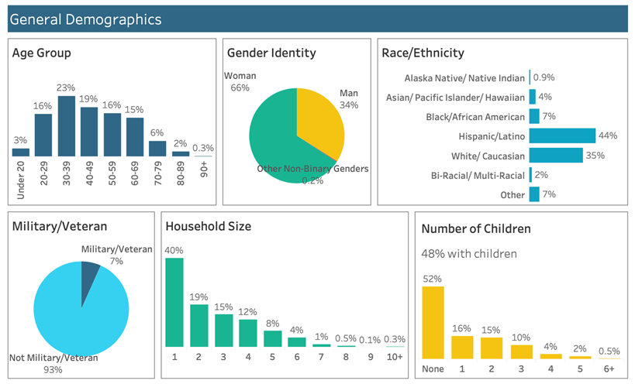
Figure NA-10.01: 2-1-1 Clients Living in Escondido Demographics
Number of Households Table
 | 0-30% HAMFI | >30-50% HAMFI | >50-80% HAMFI | >80-100% HAMFI | >100% HAMFI
Total Households | 10,490 | 7,975 | 9,715 | 5,320 | 15,225
Small Family Households | 3,095 | 3,045 | 4,320 | 2,310 | 8,200
Large Family Households | 940 | 1,525 | 1,470 | 640 | 1,745
Household contains at least one person 62-74 years of age | 1,860 | 1,510 | 2,320 | 1,335 | 3,475
Household contains at least one person age 75 or older | 1,965 | 1,185 | 930 | 520 | 1,195
Households with one or more children 6 years old or younger | 1,620 | 1,820 | 1,860 | 685 | 1,460

Table 6 - Total Households Table
Data Source: | 2016-2020 CHAS

Housing Needs Summary Tables
1. Housing Problems (Households with one of the listed needs)
 | Renter |  |  |  |  | Owner
 | 0-30% AMI | >30-50% AMI | >50-80% AMI | >80-100% AMI | Total | 0-30% AMI | >30-50% AMI | >50-80% AMI | >80-100% AMI | Total
NUMBER OF HOUSEHOLDS
Substandard Housing - Lacking complete plumbing or kitchen facilities | 175 | 130 | 60 | 25 | 390 | 50 | 60 | 15 | 0 | 125
Severely Overcrowded - With >1.51 people per room (and complete kitchen and plumbing) | 330 | 510 | 250 | 40 | 1,130 | 35 | 55 | 65 | 55 | 210
Overcrowded - With 1.01-1.5 people per room (and none of the above problems) | 530 | 900 | 460 | 130 | 2,020 | 65 | 155 | 310 | 140 | 670
Housing cost burden greater than 50% of income (and none of the above problems) | 4,580 | 1,760 | 155 | 30 | 6,525 | 1,545 | 820 | 675 | 80 | 3,120
Housing cost burden greater than 30% of income (and none of the above problems) | 1,000 | 1,620 | 2,010 | 390 | 5,020 | 255 | 455 | 1,760 | 780 | 3,250
Zero/negative Income (and none of the above problems) | 755 | 0 | 0 | 0 | 755 | 275 | 0 | 0 | 0 | 275
Table 7 – Housing Problems Table
Data Source: | 2016-2020 CHAS

2. Housing Problems 2 (Households with one or more Severe Housing Problems: Lacks kitchen or complete plumbing, severe overcrowding, severe cost burden)
 | Renter |  |  |  |  | Owner
 | 0-30% AMI | >30-50% AMI | >50-80% AMI | >80-100% AMI | Total | 0-30% AMI | >30-50% AMI | >50-80% AMI | >80-100% AMI | Total
NUMBER OF HOUSEHOLDS
Having 1 or more of four housing problems | 5,615 | 3,300 | 925 | 225 | 10,065 | 1,695 | 1,090 | 1,065 | 275 | 4,125
Having none of four housing problems | 2,220 | 2,055 | 4,065 | 2,155 | 10,495 | 965 | 1,525 | 3,655 | 2,665 | 8,810
Household has negative income, but none of the other housing problems | 0 | 0 | 0 | 0 | 0 | 0 | 0 | 0 | 0 | 0
Table 8 – Housing Problems 2
Data Source: | 2016-2020 CHAS

3. Cost Burden > 30%
 | Renter |  |  |  | Owner
 | 0-30% AMI | >30-50% AMI | >50-80% AMI | Total | 0-30% AMI | >30-50% AMI | >50-80% AMI | Total
NUMBER OF HOUSEHOLDS
Small Related | 2,290 | 1,925 | 1,245 | 5,460 | 530 | 555 | 1,015 | 2,100
Large Related | 725 | 950 | 305 | 1,980 | 105 | 245 | 305 | 655
Elderly | 1,595 | 770 | 160 | 2,525 | 870 | 550 | 745 | 2,165
Other | 1,950 | 1,015 | 640 | 3,605 | 375 | 120 | 470 | 965
Total need by income | 6,560 | 4,660 | 2,350 | 13,570 | 1,880 | 1,470 | 2,535 | 5,885
Table 9 – Cost Burden > 30%
Data Source: | 2016-2020 CHAS

4. Cost Burden > 50%
 | Renter |  |  |  | Owner
 | 0-30% AMI | >30-50% AMI | >50-80% AMI | Total | 0-30% AMI | >30-50% AMI | >50-80% AMI | Total
NUMBER OF HOUSEHOLDS
Small Related | 0 | 0 | 710 | 710 | 430 | 340 | 0 | 770
Large Related | 0 | 0 | 145 | 145 | 75 | 170 | 50 | 295
Elderly | 1,430 | 460 | 60 | 1,950 | 710 | 270 | 220 | 1,200
Other | 0 | 1,425 | 630 | 2,055 | 360 | 0 | 0 | 360
Total need by income | 1,430 | 1,885 | 1,545 | 4,860 | 1,575 | 780 | 270 | 2,625
Table 10 – Cost Burden > 50%
Data Source: | 2016-2020 CHAS

5. Crowding (More than one person per room)
 | Renter |  |  |  |  | Owner
 | 0-30% AMI | >30-50% AMI | >50-80% AMI | >80-100% AMI | Total | 0-30% AMI | >30-50% AMI | >50-80% AMI | >80-100% AMI | Total
NUMBER OF HOUSEHOLDS
Single family households | 840 | 1,285 | 475 | 155 | 2,755 | 65 | 135 | 130 | 130 | 460
Multiple, unrelated family households | 15 | 100 | 175 | 40 | 330 | 30 | 75 | 245 | 55 | 405
Other, non-family households | 20 | 25 | 60 | 0 | 105 | 0 | 0 | 0 | 10 | 10
Total need by income | 875 | 1,410 | 710 | 195 | 3,190 | 95 | 210 | 375 | 195 | 875
Table 11 – Crowding Information – 1/2
Data Source: | 2016-2020 CHAS

 | Renter |  |  |  | Owner
 | 0-30% AMI | >30-50% AMI | >50-80% AMI | Total | 0-30% AMI | >30-50% AMI | >50-80% AMI | Total
Households with Children Present | 0 | 0 | 0 | 0 | 0 | 0 | 0 | 0
Table 12 – Crowding Information – 2/2

Data Source Comments:

Describe the number and type of single person households in need of housing assistance.
According to 2023 five-year ACS estimates, 25 percent of occupied housing units in Escondido are occupied by a one-person household. Of these single-person households, 39 percent are aged 65 years or older. Half of seniors living alone are homeowners, while the other half are renters. Senior single-person households are often in need of housing assistance since they are typically on fixed incomes.
The most critical housing assistance needs for single-person households are experienced by the single homeless population. The 2024 WeAllCount report (annual Point-in-Time count data) from the Regional Task Force on Homelessness indicates that 588 individuals experience homelessness (sheltered and unsheltered) in Escondido. Of these 588 individuals, only about 13 percent were in families (78 individuals).
Estimate the number and type of families in need of housing assistance who are disabled or victims of domestic violence, dating violence, sexual assault and stalking.
According to 2023 five-year ACS estimates, the median income for those living with a disability in Escondido is 81 percent of those living without a disability. According to the San Diego Foundation’s October 2023 San Diego Economic Equity Report, 20 percent of people with disabilities in San Diego County are cost burdened (paying more than 30 percent of income on housing and utilities), which approximates the percentage of people without disabilities who are cost burdened (21 percent). However, 23 percent of people with disabilities are severely cost burdened (paying more than 50 percent), which is significantly higher than people without disabilities (16 percent).
There is no information available specifically on victims of domestic violence, dating violence, sexual assault, or stalking in Escondido. However, according to the U.S. Department of Justice 2020 Biennial Violence Against Women Report to Congress, approximately 44 percent of women and 25 percent of men nationwide experience some form of contact sexual violence in their lifetime. Due to the large number of domestic and sexual violence victims nationwide, it is anticipated that there is a need for housing assistance for domestic and sexual violence victims in Escondido. Low-income individuals are particularly susceptible to domestic or sexual violence as they have limited access to resources, such as safe and secure housing and legal representation. Also at higher risk are chronically underserved populations, including rural victims and victims with disabilities.
What are the most common housing problems?
The most common housing problem among both renters and owners in Escondido is housing cost burden (spending more than 30 percent of income on housing costs). As shown in Table NA-10.03 above, of households with a single housing problem, 7,100 households earning less than 80 percent of AMI have a housing cost burden of 31 to 50 percent of their income, while an additional 9,535 households earning less than 80 percent of AMI have a cost burden above 50 percent of income. Cost burden can lead to other issues, including overcrowding, deferred maintenance of the unit, and inability to afford other necessities, such as healthcare and transportation.
The second most common housing problem is overcrowding (more than one person per room). As shown in Table NA-10.03 above, of households with a single housing problem, 2,420 households earning less than 80 percent of AMI experience overcrowding, while an additional 1,245 households earning less than 80 percent of AMI experience severe overcrowding (more than 1.5 persons per room).
The least common housing problem is substandard housing (lacking complete kitchen or plumbing facilities). As shown in Table NA-10.03 above, of households with a single housing problem, 490 households earning less than 80 percent of AMI reside in substandard housing.

Are any populations/household types more affected than others by these problems?
While all lower income households are more susceptible to housing problems than the general population, housing problems are particularly common amongst the lowest income households (i.e., very low- and extremely low-income households). Table NA-10.05 indicates that 43 percent of low-income households experiencing housing cost burden earn less than 30 percent of AMI and 32 percent earn between 31 and 50 percent of AMI. Similarly, as shown in Table NA-10.07, 24 percent of low-income households experiencing overcrowding earn less than 30 percent of AMI and 40 percent earn between 31 and 50 percent of AMI.
Additionally, low-income renters experience housing cost burden and overcrowding at a higher rate than low-income homeowners. As shown in Table NA-10.05, 70 percent of low-income households experiencing housing cost burden are renters. As shown in Table NA-10.07, 78 percent of low-income households experiencing overcrowding are renters.
Describe the characteristics and needs of Low-income individuals and families with children (especially extremely low-income) who are currently housed but are at imminent risk of either residing in shelters or becoming unsheltered 91.205(c)/91.305(c)). Also discuss the needs of formerly homeless families and individuals who are receiving rapid re-housing assistance and are nearing the termination of that assistance
While there is no information available specifically on low-income individuals and families with children in Escondido who are currently housed but are at imminent risk of homelessness, 2-1-1 San Diego released a policy brief in September 2019 titled “Housing Instability in San Diego County,” in which it was reported that almost 24,000 students between grades K-12 live in households that are “doubled up” with family or friends because the household is unable to maintain housing independently. Regarding formerly homeless families and individuals who are receiving rapid re-housing assistance and are nearing the termination of that assistance, the following figure is from the Regional Task Force on Homelessness’ Homelessness Crisis Response System 2023 Data and Performance Report (published in June 2024). As shown in the figure, from 2021 to 2023, shelter and rapid rehousing programs in the region experienced slight variability in the rates of permanent destination exits – a decline from 28 percent in 2021 to 25 percent in 2022 followed by an increase to 27 percent in 2023.

If a jurisdiction provides estimates of the at-risk population(s), it should also include a description of the operational definition of the at-risk group and the methodology used to generate the estimates:
Generally, households are at risk of becoming homeless if they earn an extremely low income and experience severe housing cost burden. According to CHAS data shown above in Tables NA-05.10 and NA-05.11, 5,500 renter households (23 percent of all renter households) and 1,755 owner households (7 percent of all owner households) earn an extremely low income and a severe housing cost burden.
Specify particular housing characteristics that have been linked with instability and an increased risk of homelessness
Extremely low-income households experiencing severe housing cost burden are more likely to lose their homes and become homeless. Compared to other segments of the population, they are more financially unstable and likely to be significantly impacted by a job loss, medical emergency, or other unexpected expense. Many factors contribute to the recent increase in homelessness, including rising housing costs and a relatively slow increase in wages.

Discussion
Please see above.

NA-15 Disproportionately Greater Need: Housing Problems – 91.205 (b)(2)
Assess the need of any racial or ethnic group that has disproportionately greater need in comparison to the needs of that category of need as a whole.
Introduction
HUD defines a disproportionate need as any need for a race/ethnicity that is more than 10 percent above the need for the total households at a particular income level. For example, if 40 percent of all very low-income households in a jurisdiction experience one or more of the four defined housing problems, but 50 percent of one specific ethnic group’s very low-income households experience housing problems, that would be considered a disproportionate need.
Again, the four housing problems are:
- Unit lacks complete kitchen facilities;
- Unit lacks complete plumbing facilities;
- Household spends more than 30 percent of income on housing costs; and
- Household includes more than one person per room, excluding bathrooms, porches, foyers, halls, and half-rooms.
The following tables and analyses outline the share of households by race/ethnicity and income level experiencing a housing problem.
0%-30% of Area Median Income
Housing Problems | Has one or more of four housing problems | Has none of the four housing problems | Household has no/negative income, but none of the other housing problems
Jurisdiction as a whole | 5,710 | 595 | 990
White | 2,060 | 335 | 645
Black / African American | 150 | 20 | 40
Asian | 285 | 60 | 4
American Indian, Alaska Native | 55 | 0 | 0
Pacific Islander | 25 | 0 | 0
Hispanic | 2,985 | 140 | 290
Table 13 - Disproportionally Greater Need 0 - 30% AMI
Data Source: | 2016-2020 CHAS

*The four housing problems are:
1. Lacks complete kitchen facilities, 2. Lacks complete plumbing facilities, 3. More than one person per room, 4.Cost Burden greater than 30%

30%-50% of Area Median Income
Housing Problems | Has one or more of four housing problems | Has none of the four housing problems | Household has no/negative income, but none of the other housing problems
Jurisdiction as a whole | 6,685 | 1,160 | 0
White | 2,325 | 655 | 0
Black / African American | 180 | 10 | 0
Asian | 210 | 70 | 0
American Indian, Alaska Native | 10 | 0 | 0
Pacific Islander | 10 | 0 | 0
Hispanic | 3,860 | 395 | 0
Table 14 - Disproportionally Greater Need 30 - 50% AMI
Data Source: | 2016-2020 CHAS

*The four housing problems are:
1. Lacks complete kitchen facilities, 2. Lacks complete plumbing facilities, 3. More than one person per room, 4.Cost Burden greater than 30%

50%-80% of Area Median Income
Housing Problems | Has one or more of four housing problems | Has none of the four housing problems | Household has no/negative income, but none of the other housing problems
Jurisdiction as a whole | 5,685 | 2,985 | 0
White | 2,285 | 1,610 | 0
Black / African American | 195 | 75 | 0
Asian | 270 | 140 | 0
American Indian, Alaska Native | 4 | 30 | 0
Pacific Islander | 0 | 0 | 0
Hispanic | 2,855 | 1,100 | 0
Table 15 - Disproportionally Greater Need 50 - 80% AMI
Data Source: | 2016-2020 CHAS

*The four housing problems are:
1. Lacks complete kitchen facilities, 2. Lacks complete plumbing facilities, 3. More than one person per room, 4.Cost Burden greater than 30%
80%-100% of Area Median Income
Housing Problems | Has one or more of four housing problems | Has none of the four housing problems | Household has no/negative income, but none of the other housing problems
Jurisdiction as a whole | 2,250 | 3,155 | 0
White | 1,040 | 1,555 | 0
Black / African American | 25 | 125 | 0
Asian | 120 | 165 | 0
American Indian, Alaska Native | 0 | 10 | 0
Pacific Islander | 0 | 15 | 0
Hispanic | 990 | 1,175 | 0
Table 16 - Disproportionally Greater Need 80 - 100% AMI
Data Source: | 2016-2020 CHAS

*The four housing problems are:
1. Lacks complete kitchen facilities, 2. Lacks complete plumbing facilities, 3. More than one person per room, 4.Cost Burden greater than 30%
Discussion
0-30 Percent of AMI (Extremely Low Income)
As shown in Table NA-15.01, 78 percent of extremely low-income households in Escondido experience one or more of the four housing problems. Two populations, American Indian/Alaska Native and Pacific Islander households, experience these housing problems at a disproportionately higher rate – both at 100 percent. Note that, in absolute numbers, American Indian/Alaska Native and Pacific Islander households with extremely low incomes constitute a small population with only 55 and 25 extremely low-income households, respectively. Also note that over 65 percent of extremely low-income households among all races experience one or more of the four housing problems, indicating a correlation to income.
30-50 Percent of AMI (Very Low Income)
As shown in Table NA-15.02, 85 percent of very low-income households in Escondido experience one or more of the four housing problems. Three populations, Black/African American, American Indian/Alaska Native and Pacific Islander households, experience these housing problems at a disproportionately higher rate at 95, 100, 100 percent, respectively. Note that, in absolute numbers, Black/African American, American Indian/Alaska Native and Pacific Islander households with very low incomes constitute a small population with only 190, 10, and 10 very low-income households, respectively.
50-80 Percent of AMI (Low Income)
As shown in Table NA-15.03, 66 percent of low-income households in Escondido experience one or more of the four housing problems. There is no disproportionate need among racial/ethnic groups.
80-100 Percent of AMI (Middle Income)
As shown in Table NA-15.04, 42 percent of middle-income households in Escondido experience one or more of the four housing problems. There is no disproportionate need among racial/ethnic groups.

0-30 Percent of AMI (Extremely Low Income)
As shown in Table NA-15.01, 78 percent of extremely low-income households in Escondido experience one or more of the four housing problems. Two populations, American Indian/Alaska Native and Pacific Islander households, experience these housing problems at a disproportionately higher rate – both at 100 percent. Note that, in absolute numbers, American Indian/Alaska Native and Pacific Islander households with extremely low incomes constitute a small population with only 55 and 25 extremely low-income households, respectively. Also note that over 65 percent of extremely low-income households among all races experience one or more of the four housing problems, indicating a correlation to income.
30-50 Percent of AMI (Very Low Income)
As shown in Table NA-15.02, 85 percent of very low-income households in Escondido experience one or more of the four housing problems. Three populations, Black/African American, American Indian/Alaska Native and Pacific Islander households, experience these housing problems at a disproportionately higher rate at 95, 100, 100 percent, respectively. Note that, in absolute numbers, Black/African American, American Indian/Alaska Native and Pacific Islander households with very low incomes constitute a small population with only 190, 10, and 10 very low-income households, respectively.
50-80 Percent of AMI (Low Income)
As shown in Table NA-15.03, 66 percent of low-income households in Escondido experience one or more of the four housing problems. There is no disproportionate need among racial/ethnic groups.
80-100 Percent of AMI (Middle Income)
As shown in Table NA-15.04, 42 percent of middle-income households in Escondido experience one or more of the four housing problems. There is no disproportionate need among racial/ethnic groups.

NA-20 Disproportionately Greater Need: Severe Housing Problems – 91.205 (b)(2)
Assess the need of any racial or ethnic group that has disproportionately greater need in comparison to the needs of that category of need as a whole.
Introduction
While Section NA-15 measured disproportionate housing problems, this section measures disproportionate severe housing problems, which are defined as follows:
- Unit lacks complete kitchen facilities;
- Unit lacks complete plumbing facilities;
- Household spends more than 50 percent of income on housing costs; and
- Household includes more than 1.5 person per room, excluding bathrooms, porches, foyers, halls, and half-rooms.

Again, HUD defines a disproportionate need as any need for a race/ethnicity that is more than 10 percent above the need for the total households at a particular income level. The following tables and analyses outline the share of households by race/ethnicity and income level experiencing a severe housing problem.
0%-30% of Area Median Income
Severe Housing Problems* | Has one or more of four housing problems | Has none of the four housing problems | Household has no/negative income, but none of the other housing problems
Jurisdiction as a whole | 5,140 | 1,165 | 990
White | 1,785 | 610 | 645
Black / African American | 140 | 30 | 40
Asian | 245 | 105 | 4
American Indian, Alaska Native | 40 | 15 | 0
Pacific Islander | 25 | 0 | 0
Hispanic | 2,760 | 365 | 290
Table 17 – Severe Housing Problems 0 - 30% AMI
Data Source: | 2016-2020 CHAS

*The four severe housing problems are:
1. Lacks complete kitchen facilities, 2. Lacks complete plumbing facilities, 3. More than 1.5 persons per room, 4.Cost Burden over 50%

30%-50% of Area Median Income
Severe Housing Problems* | Has one or more of four housing problems | Has none of the four housing problems | Household has no/negative income, but none of the other housing problems
Jurisdiction as a whole | 4,630 | 3,215 | 0
White | 1,495 | 1,485 | 0
Black / African American | 165 | 25 | 0
Asian | 105 | 175 | 0
American Indian, Alaska Native | 0 | 10 | 0
Pacific Islander | 10 | 0 | 0
Hispanic | 2,805 | 1,445 | 0
Table 18 – Severe Housing Problems 30 - 50% AMI
Data Source: | 2016-2020 CHAS

*The four severe housing problems are:
1. Lacks complete kitchen facilities, 2. Lacks complete plumbing facilities, 3. More than 1.5 persons per room, 4.Cost Burden over 50%

50%-80% of Area Median Income
Severe Housing Problems* | Has one or more of four housing problems | Has none of the four housing problems | Household has no/negative income, but none of the other housing problems
Jurisdiction as a whole | 2,665 | 6,000 | 0
White | 865 | 3,025 | 0
Black / African American | 40 | 230 | 0
Asian | 125 | 285 | 0
American Indian, Alaska Native | 0 | 34 | 0
Pacific Islander | 0 | 0 | 0
Hispanic | 1,590 | 2,365 | 0
Table 19 – Severe Housing Problems 50 - 80% AMI
Data Source: | 2016-2020 CHAS

*The four severe housing problems are:
1. Lacks complete kitchen facilities, 2. Lacks complete plumbing facilities, 3. More than 1.5 persons per room, 4.Cost Burden over 50%

80%-100% of Area Median Income
Severe Housing Problems* | Has one or more of four housing problems | Has none of the four housing problems | Household has no/negative income, but none of the other housing problems
Jurisdiction as a whole | 830 | 4,580 | 0
White | 205 | 2,395 | 0
Black / African American | 0 | 150 | 0
Asian | 45 | 235 | 0
American Indian, Alaska Native | 0 | 10 | 0
Pacific Islander | 0 | 15 | 0
Hispanic | 535 | 1,630 | 0
Table 20 – Severe Housing Problems 80 - 100% AMI
Data Source: | 2016-2020 CHAS

*The four severe housing problems are:
1. Lacks complete kitchen facilities, 2. Lacks complete plumbing facilities, 3. More than 1.5 persons per room, 4.Cost Burden over 50%

Discussion
0-30 Percent of AMI (Extremely Low Income)
As shown in Table NA-20.01, 70 percent of extremely low-income households in Escondido experience one or more of the four severe housing problems. Two populations, Pacific Islander and Hispanic households, experience these housing problems at a disproportionately higher rate of 100 and 81, respectively. Again, note that, in absolute numbers, Pacific Islander households with extremely low incomes constitute a small population with only 25 extremely low-income households. Also note that over 55 percent of extremely low-income households among all races experience one or more of the four severe housing problems, indicating a correlation to income.
30-50 Percent of AMI (Very Low Income)
As shown in Table NA-20.02, 59 percent of very low-income households in Escondido experience one or more of the four severe housing problems. Two populations, Black/African American and Pacific Islander households, experience these housing problems at a disproportionately higher rate at 87 and 100 percent, respectively. Note that, in absolute numbers, Black/African American and Pacific Islander households with very low incomes constitute a small population with only 190 and 10 very low-income households, respectively.
50-80 Percent of AMI (Low Income)
As shown in Table NA-20.03, 31 percent of low-income households in Escondido experience one or more of the four severe housing problems. There is no disproportionate need among racial/ethnic groups.
80-100 Percent of AMI (Middle Income)
As shown in Table NA-20.04, 15 percent of middle-income households in Escondido experience one or more of the four severe housing problems. Hispanic households experience these housing problems at a disproportionately higher rate of 25 percent.

NA-25 Disproportionately Greater Need: Housing Cost Burdens – 91.205 (b)(2)
Assess the need of any racial or ethnic group that has disproportionately greater need in comparison to the needs of that category of need as a whole.
Introduction:
Disproportionate greater need relative to housing cost burden is calculated by dividing the number of households in a cost burden category (i.e., spending more than 30 percent on housing or spending more than 50 percent on housing) by the total number of households for that given racial or ethnic group or the jurisdiction for a whole. For example, 58.1 percent of the jurisdiction spends 30 percent or less of their income on housing costs. This is calculated by dividing 220,709, or the number of households in this category, by the total households, or 380,066. The total households are calculated by summing the numbers in the top data row shown below. Again, HUD defines a disproportionate need as any need for a race/ethnicity that is more than 10 percent above the need for the total households in a cost burden category.
Housing Cost Burden
Housing Cost Burden | <=30% | 30-50% | >50% | No / negative income (not computed)
Jurisdiction as a whole | 23,920 | 10,855 | 9,370 | 1,035
White | 13,220 | 4,875 | 3,975 | 665
Black / African American | 655 | 280 | 275 | 40
Asian | 1,860 | 600 | 435 | 4
American Indian, Alaska Native | 80 | 29 | 40 | 0
Pacific Islander | 65 | 10 | 25 | 0
Hispanic | 7,625 | 4,915 | 4,345 | 300
Table 21 – Greater Need: Housing Cost Burdens AMI
Data Source: | 2016-2020 CHAS

Discussion:
30-50 Percent Cost Burden
Approximately 24 percent of the general population spends 30 to 50 percent of their income on housing costs (10,855 of 45,180 households). No ethnic or racial group experiences this level of housing cost burden at a significantly greater rate than the jurisdiction as a whole.
Greater than 50 Percent Cost Burden
Approximately 21 percent of the jurisdiction spends more than 50 percent of their income on housing costs (9,370 of 45,180 households). No ethnic or racial group experiences this level of housing cost burden at a significantly greater rate than the jurisdiction as a whole.

NA-30 Disproportionately Greater Need: Discussion – 91.205(b)(2)
Are there any Income categories in which a racial or ethnic group has disproportionately greater need than the needs of that income category as a whole?
The data presented in Sections NA-15 through NA-25 show that some racial or ethnic groups experience disproportionately greater need in terms of housing problems and cost burden. Again, HUD defines a disproportionate need as any need for a certain race/ethnicity that is more than 10 percent above the need for the total households at a particular level of income or cost burden. To summarize the preceding sections, the following racial or ethnic groups have disproportionately greater need:
Housing Problems:
- 0-30 percent AMI: American Indian/Alaska Native, Pacific Islander
- 30-50 percent AMI: Black/African American, American Indian/Alaska Native, Pacific Islander
Severe Housing Problems:
- 0-30 percent AMI: Pacific Islander, Hispanic
- 30-50 percent AMI: Black/African American, Pacific Islander
- 80-100 percent AMI: Hispanic

Housing Cost Burden:
- None

Pacific Islander followed by American Indian/Alaska Native, Black/African American, and Hispanic households are the most common groups to experience disproportionately greater needs. White and Asian households do not have disproportionately greater need in any category at any income level.
If they have needs not identified above, what are those needs?
Not applicable.
Are any of those racial or ethnic groups located in specific areas or neighborhoods in your community?
Most of Escondido is within CDBG-eligible census tracts. The City has some minority concentration areas. Figure NA-30.01 below shows a map of the city using HUD’s Minority Concentration Analysis Tool. The map highlights in red areas in which the percentage of persons of a particular racial or ethnic minority is at least 20 points higher than that minority's percentage in the housing market as a whole; the neighborhood's total percentage of minority persons is at least 20 points higher than the total percentage of minorities for the housing market area as a whole; or in the case of a metropolitan area, the neighborhood's total percentage of minority persons exceeds 50 percent of its population

NA-35 Public Housing – 91.205(b)
Introduction
HUD defines public housing as affordable rental housing for eligible low-income families, elderly individuals, and persons with disabilities. Public housing varies in size and type. For example, public housing includes single-family homes and high-rise apartments. Local public housing agencies manage public housing developments. HUD provides federal aid to these agencies, as well as technical and professional assistance in planning, developing, and managing these developments.
The Housing Authority of the County of San Diego (HACSD) administers public housing and the Housing Choice Voucher (HCV) program in many jurisdictions within San Diego County, including Escondido. Thus, the City does not operate its own Housing Authority. No public housing projects are within the boundaries of the City of Escondido. The tables below summarize the information provided by the HACSD regarding the types of vouchers administered by HACSD, as well as the demographics of the voucher recipients.
Several HUD programs assist various populations in securing affordable and stable housing. Descriptions of each of the programs shown in the tables in this section are as follows:
- Certificate Program: The Certificate Program was an earlier form of rental assistance under Section 8, where HUD provided subsidies to landlords on behalf of low-income tenants. This program has been largely replaced by the Housing Choice Voucher Program.
- Moderate Rehabilitation (Mod-Rehab): Initiated in 1978, the Mod-Rehab program aimed to provide project-based rental assistance for low-income families. It focused on properties needing moderate rehabilitation and is no longer active for new commitments.
- Public Housing: Public housing consists of housing units managed by local public housing agencies to provide decent and safe rental housing for eligible low-income families, the elderly, and persons with disabilities.
- Housing Choice Vouchers: This program offers tenant-based assistance, allowing families to choose and lease safe, decent, and affordable privately-owned rental housing. Participants pay a portion of the rent based on their income, with the remainder covered by the voucher.
- Project-Based Vouchers: Under this component of the Housing Choice Voucher Program, rental assistance is linked to specific housing units. Tenants residing in these units receive assistance while they live in the designated property.
- Special Purpose Vouchers:Veterans Affairs Supportive Housing (VASH): Combines HUD's Housing Choice Voucher rental assistance with case management and clinical services provided by the Department of Veterans Affairs for homeless veterans.Family Unification Program: Provides housing assistance to families for whom the lack of adequate housing is a primary factor in the separation or threat of separation of children from their families.Mainstream Vouchers for Persons with Disabilities: Offers housing assistance specifically for non-elderly persons with disabilities to enable them to lease affordable private housing.
Totals in Use
Program Type
 | Certificate | Mod-Rehab | Public Housing | Vouchers
 |  |  |  | Total | Project -based | Tenant -based | Special Purpose Voucher
 |  |  |  |  |  |  | Veterans Affairs Supportive Housing | Family Unification Program | Disabled  *
# of units vouchers in use | 0 | 83 | 117 | 10,566 | 0 | 10,411 | 110 | 0 | 42

Table 22 - Public Housing by Program Type
*includes Non-Elderly Disabled, Mainstream One-Year, Mainstream Five-year, and Nursing Home Transition

Data Source: | PIC (PIH Information Center)

Characteristics of Residents

Program Type
 | Certificate | Mod-Rehab | Public Housing | Vouchers
 |  |  |  | Total | Project -based | Tenant -based | Special Purpose Voucher
 |  |  |  |  |  |  | Veterans Affairs Supportive Housing | Family Unification Program
Average Annual Income | 0 | 12,491 | 18,844 | 15,253 | 0 | 15,270 | 13,174 | 0
Average length of stay | 0 | 3 | 6 | 6 | 0 | 6 | 0 | 0
Average Household size | 0 | 2 | 2 | 2 | 0 | 2 | 1 | 0
# Homeless at admission | 0 | 0 | 2 | 3 | 0 | 3 | 0 | 0
# of Elderly Program Participants (>62) | 0 | 18 | 47 | 3,465 | 0 | 3,432 | 14 | 0
# of Disabled Families | 0 | 12 | 23 | 2,885 | 0 | 2,828 | 33 | 0
# of Families requesting accessibility features | 0 | 83 | 117 | 10,566 | 0 | 10,411 | 110 | 0
# of HIV/AIDS program participants | 0 | 0 | 0 | 0 | 0 | 0 | 0 | 0
# of DV victims | 0 | 0 | 0 | 0 | 0 | 0 | 0 | 0
Table 24 – Characteristics of Public Housing Residents by Program Type

Data Source: | PIC (PIH Information Center)

Race of Residents
Program Type
Race | Certificate | Mod-Rehab | Public Housing | Vouchers
 |  |  |  | Total | Project -based | Tenant -based | Special Purpose Voucher
 |  |  |  |  |  |  | Veterans Affairs Supportive Housing | Family Unification Program | Disabled  *
White | 0 | 71 | 98 | 8,511 | 0 | 8,408 | 66 | 0 | 35
Black/African American | 0 | 6 | 15 | 1,603 | 0 | 1,555 | 41 | 0 | 6
Asian | 0 | 4 | 2 | 297 | 0 | 294 | 2 | 0 | 1
American Indian/Alaska Native | 0 | 0 | 1 | 84 | 0 | 84 | 0 | 0 | 0
Pacific Islander | 0 | 2 | 1 | 71 | 0 | 70 | 1 | 0 | 0
Other | 0 | 0 | 0 | 0 | 0 | 0 | 0 | 0 | 0

*includes Non-Elderly Disabled, Mainstream One-Year, Mainstream Five-year, and Nursing Home Transition
Table 25 – Race of Public Housing Residents by Program Type
Data Source: | PIC (PIH Information Center)

Ethnicity of Residents
Program Type
Ethnicity | Certificate | Mod-Rehab | Public Housing | Vouchers
 |  |  |  | Total | Project -based | Tenant -based | Special Purpose Voucher
 |  |  |  |  |  |  | Veterans Affairs Supportive Housing | Family Unification Program | Disabled  *
Hispanic | 0 | 24 | 73 | 3,644 | 0 | 3,619 | 17 | 0 | 8
Not Hispanic | 0 | 59 | 44 | 6,922 | 0 | 6,792 | 93 | 0 | 34

*includes Non-Elderly Disabled, Mainstream One-Year, Mainstream Five-year, and Nursing Home Transition
Table 26 – Ethnicity of Public Housing Residents by Program Type
Data Source: | PIC (PIH Information Center)

Section 504 Needs Assessment: Describe the needs of public housing tenants and applicants on the waiting list for accessible units:
As stated above, no public housing projects are within the boundaries of the City of Escondido. Regarding applicants on the waiting list for accessible units, the FY 2024-2025 HACSD Public Housing Agency Annual Plan states that there were 10,779 applicants with disabilities on the HACSD’s public housing waiting list at the end of 2023 (22.4 percent of 48,122 applicants). According to 2022 five-year ACS Estimates, 48 percent of the County’s disabled population have mobility disabilities. Based on that percentage, it is estimated that, of the 10,779 applicants with disabilities on the public housing waiting list, up to 5,174 applicants may need accessible units (48 percent of 10,779 applicants). Note that the waiting period for public housing applicants is about 8 to 11 years, depending on household size.
Most immediate needs of residents of Public Housing and Housing Choice voucher holders
Again, there are no public housing units located in the City of Escondido. According to the FY 2024-2025 HACSD Public Housing Agency Annual Plan, at the end of 2023, the countywide Public Housing Program waiting list included 48,122 applicants, who were:
- 22 percent disabled
- 9 percent elderly
- 61 percent White
- 25 percent Black/African American
- 6 percent Asian
- 3 percent American Indian
- 3 percent Pacific Islander
- 44 percent Hispanic/Latino
To ascertain the needs of residents of HACSD’s Public Housing Program and participants of its HCV Program, the HACSD’s Resident Advisory Board meets at least twice per year. The Board makes recommendations regarding the development of the HACSD’s annual plan for submittal to HUD. The Board is comprised of nine appointed seats, which include current residents of public housing or participants of the HCV programs. Annually, at least one meeting is held with the residents of public housing. The areas of interest and immediate needs of public housing residents and HCV holders include the following: Transportation services for medical appointments and stores; services for domestic violence victims, seniors, and people with disabilities; transportation to special events and on weekends; emergency food assistance; family selfâ¿Âsufficiency employment services; fair housing information, including tenant rights; clothing assistance; tax preparation services; employment training; information on employment; tutoring; emergency preparation; and college scholarships.
HCV holders have reported the following issues when searching for eligible rental units to initiate their assistance: high rents, low vacancy rates, landlords not interested in participating in the program, overly strict credit worthiness standards, and amount of security deposits.
How do these needs compare to the housing needs of the population at large
Comparing the housing needs of HCV holders to the general population is challenging because participants in these affordable housing programs do not face the same extent of challenges as those without public housing assistance. While monthly housing costs are limited for program participants of the HACSD’s rental assistance programs, as shown in Table NA-05.10, 58 percent of renters citywide spend more than 30 percent of their income on rent and utilities, and 31 percent of renters spend more than half of their income on rent and utilities.
Discussion
Please see above.

NA-40 Homeless Needs Assessment – 91.205(c)
Introduction:
Homelessness is a growing issue across California and the San Diego region. Many factors have contributed to the rise in homelessness. According to the Regional Task Force on Homelessness’ (RTFH) 2024 WeAllCount Point-in-Time Count data, an estimated 588 homeless individuals were located in Escondido at the time of the count, which represents 5.5 percent of the homeless population in San Diego County. The count of 588 individuals includes 401 unsheltered individuals and 187 sheltered individuals.
Youth homelessness is a concern across all regions of San Diego County. Many factors are associated with youth homelessness, including poverty, sex trafficking, foster care, mental health, family dysfunction, and being members of the LGBTQ+ community. The RTFH oversees the region’s Homeless Management Information System (HMIS), a local web-based information technology system which captures data on clients and projects regarding homeless services utilization, performance and outcomes. RTFH is the lead HMIS agency and administers the system.
Definitions:
- Number experiencing homelessness each year: Unduplicated count of all persons enrolled during the program year
- Number becoming homeless each year: Unduplicated count of persons with new HMIS entries during the year
- Number exiting homelessness each year: Unduplicated count of persons exiting programs to a permanent destination as defined by HUD
- Number of days persons experience homelessness: Average of the sums of the lengths of stays for each person
The RTFH Project Level Dashboard displays key data points graphed over time from HMIS and are considered conservative, as not all homeless service providers within the County of San Diego utilize HMIS and are not required to do so, unless funded by HUD. Detailed demographic information on the homeless population in Escondido, as provided by RTFH, are shown in the tables below. No information is available for a rural population in Escondido.
Homeless Needs Assessment
Population | Estimate the # of persons experiencing homelessness on a given night |  | Estimate the # experiencing homelessness each year | Estimate the # becoming homeless each year | Estimate the # exiting homelessness each year | Estimate the # of days persons experience homelessness
 | Sheltered | Unsheltered
Persons in Households with Adult(s) and Child(ren) | 10 | 74 | 916 | 208 | 191 | 0
Persons in Households with Only Children | 0 | 0 | 0 | 0 | 0 | 0
Persons in Households with Only Adults | 391 | 113 | 1,296 | 370 | 164 | 0
Chronically Homeless Individuals | 191 | 37 | 582 | 116 | 63 | 0
Chronically Homeless Families | 10 | 0 | 323 | 37 | 72 | 0
Veterans | 21 | 18 | 151 | 39 | 26 | 0
Unaccompanied Child | 0 | 26 | 201 | 45 | 29 | 0
Persons with HIV | 0 | 1 | 30 | 5 | 7 | 126
Table 27 - Homeless Needs Assessment

Data Source Comments: | Source: Regional Task Force on Homelessness, October 1, 2023 to September 30, 2024 period

Indicate if the homeless population is: | Has No Rural Homeless

If data is not available for the categories "number of persons becoming and exiting homelessness each year," and "number of days that persons experience homelessness," describe these categories for each homeless population type (including chronically homeless individuals and families, families with children, veterans and their families, and unaccompanied youth):
not applicable

Nature and Extent of Homelessness: (Optional)
Race: | Sheltered: | Unsheltered (optional)
White | 84 | 185
Black or African American | 44 | 40
Asian | 0 | 7
American Indian or Alaska Native | 4 | 12
Pacific Islander | 6 | 10
Ethnicity: | Sheltered: | Unsheltered (optional)
Hispanic | 84 | 145
Not Hispanic | 103 | 256

Data Source Comments: | Source: Regional Task Force on Homelessness, October 1, 2023 to September 30, 2024

Estimate the number and type of families in need of housing assistance for families with children and the families of veterans.
According to the RTFH 2024 Point-in-Time Count data, the demographics of the 401 unsheltered individuals located in Escondido at the time of the count were as follows:
- 13 percent veterans (51 individuals)
- 6 percent persons aged 24 and younger (26 individuals)
- 1 percent families (4 individuals)

The demographics of the 187 sheltered individuals located in Escondido at the time of the count were as follows:
- 45 percent persons aged 24 and younger (84 individuals)
- 40 percent families (74 individuals)
- 10 percent veterans (18 individuals)
Regarding families with children, the San Diego Foundation’s October 2023 San Diego Economic Equity Report indicates that youth poverty in San Diego County disproportionately impacts certain racial and ethnic groups. Black children are two and a half times as likely as White children to live in poverty. Hispanic children are twice as likely as White children to live in poverty. Black public school students are more than six times as likely to be unhoused than White students, and Hispanic students are more than five times as likely.
Regarding families of veterans, the National Alliance to End Homelessness has found that veterans are more likely than civilians to experience homelessness. According to 2023 five-year ACS data, 8,079 veterans reside in Escondido. Approximately 9 percent of those veterans earned income in the past 12 months that places them below the poverty level (696 individuals). Most veterans and their families require services similar to the civilian population. Their housing crises are due to a lack of affordable housing and economic hardship, but it is coupled with the unique challenges brought on by having experienced multiple and/or extended deployments. Many of these families can be housed through rapid rehousing by receiving housing location services, rental and move-in assistance, and case management to end their housing instability. A smaller percentage of veteran families need to be served through HUD Veterans Affairs Supportive Housing (VASH), which combines Housing Choice Voucher (HCV) rental assistance with clinical case management from the Department of Veteran Affairs (VA).
Describe the Nature and Extent of Homelessness by Racial and Ethnic Group.
As shown in Table NA-40.02, the breakdown of Escondido’s homeless population by racial and ethnic group is as follows:
- 38.9 percent Hispanic of any race (229 individuals)
- 37.4 percent White alone (220 individuals)
- 13.9 percent Black, African American, or African alone (82 individuals)
- 4.1 percent Multi-Racial (not Hispanic) (24 individuals
- 2.4 percent Native Hawaiian or Pacific Islander alone (14 individuals)
- 1.7 percent American Indian, Alaska Native, or Indigenous alone (10 individuals)
- 1.2 percent Asian or Asian American alone (7 individuals)
- 0.3 percent Middle Eastern or North African alone (2 individuals) According to 2023 five-year ACS data, Blacks/African Americans comprise only 2.1 percent of the population in Escondido. However, 13.9 percent of the homeless population is Black, African American, or African. Similarly, Native Hawaiian and Other Pacific Islanders comprise only 0.4 percent of the population, but 2.4 percent of the homeless population is Native Hawaiian or Pacific Islander.
Describe the Nature and Extent of Unsheltered and Sheltered Homelessness.
Based on the RTFH 2024 Point-in-Time Count, 588 persons experience homelessness in the San Diego region on any given night. Approximately 401 individuals are unsheltered (a 32 percent increase from 2023), and 187 individuals are sheltered (a 2 percent increase from 2023). The sheltered population of 187 individuals includes 121 individuals in emergency shelters, 4 individuals in safe havens and 62 individuals in transitional housing.
At the time of the count, the homeless housing inventory in Escondido was as follows:
- Emergency Shelter: 204 beds with 59 percent utilization
- Safe Haven: 12 beds with 33 percent utilization
- Transitional Housing: 82 beds with 76 percent utilization
- Permanent Supportive Housing: 329 beds with 81 percent utilization
- Rapid Re-housing: 73 beds with 100 percent utilization
Discussion:
See above.

NA-45 Non-Homeless Special Needs Assessment - 91.205 (b,d)
Introduction:
The non-homeless special needs group is described as persons who are not homeless but who require housing or supportive services because of special characteristics. This includes elderly (aged 62 and older); frail elderly; persons with mental, physical or developmental disabilities; persons with HIV/AIDS and their families; persons with alcohol or other drug addictions; and victims of domestic violence, dating violence, sexual assault and stalking.

Describe the characteristics of special needs populations in your community:
Certain segments of the population may have more difficulty finding safe, decent, affordable housing due to their special needs. These residents may experience higher incidences of housing cost burden, overcrowding, or other housing problems. Census and Regional Task Force on Homelessness data provide information on the special needs groups in Escondido.
Seniors (those 65 years of age and older) are considered a special needs group due to their relatively low income and relatively high presence of disabilities or limitations and dependency needs. According to 2023 five-year ACS estimates, 14 percent of Escondido’s population is aged 65 years or older. Approximately 5,080 Escondido households (10 percent of all households) consist of a person aged 65 or older living alone. Of seniors living alone, half own their residence and half are renters. Senior households are particularly vulnerable to housing problems due to limited income, prevalence of mental and physical disabilities, limited mobility and high health care costs. As shown in Table NA-10.06, 42 percent of low-income households experiencing severe housing cost burden are elderly (3,150 households).
According to 2023 five-year ACS estimates, more than 18,800 Escondido residents – 12.7 percent of the population – live with a disability, slightly above the countywide rate of 10.7 percent. Federal laws define a person with a disability as “any person who has a physical or mental impairment that substantially limits one or more major life activities; has a record of such impairment; or is regarded as having such an impairment.” As categorized, a person can have multiple disabilities. Among the Escondido population, 6.9 percent have an ambulatory difficulty, 6.8 percent have an independent living difficulty, 5.4 percent have a cognitive difficulty, 3.5 percent have a hearing difficulty, and 3.1 percent have a vision difficulty. Persons with disabilities have a wide range of housing needs, which can vary depending on the type and severity of the disability. According to 2023 five-year ACS estimates, of Escondido residents with a disability, 23 percent live below 100 percent of the poverty level. An additional 12 percent live between 100 percent and 149 percent of the poverty level.
Specific information on the numbers of Escondido residents with HIV/AIDS; residents with drug or alcohol addiction; and victims of domestic violence, dating violence, sexual assault and stalking is not readily available.
What are the housing and supportive service needs of these populations and how are these needs determined?
Please see above.
Discuss the size and characteristics of the population with HIV/AIDS and their families within the Eligible Metropolitan Statistical Area:
According to AIDSVu, a website maintained by Emory University, 13,766 people were living with HIV in San Diego County in 2022. This is a prevalence rate of 493 people out of every 100,000 residents in 2022, which is higher than the state of California (419 out of every 100,000 residents), the western U.S. (327), and the nation (388). Latino and Black residents are disproportionately impacted, representing 43 and 12 percent of the county population living with HIV, respectively. Nine out of ten residents living with HIV in San Diego County identify as male and residents aged 55 and older comprise 45 percent of the county’s population living with HIV.
If the PJ will establish a preference for a HOME TBRA activity for persons with a specific category of disabilities (e.g., persons with HIV/AIDS or chronic mental illness), describe their unmet need for housing and services needed to narrow the gap in benefits and services received by such persons. (See 24 CFR 92.209(c)(2) (ii))
Not applicable.
Discussion:
As detailed above, certain households face greater challenges in securing safe, affordable housing due to their unique needs. Seniors, a significant part of Escondido's population, often struggle to find suitable housing on fixed incomes. Similarly, individuals with disabilities require adaptable housing, but affordability and design limitations restrict availability.

NA-50 Non-Housing Community Development Needs – 91.215 (f)
Describe the jurisdiction’s need for Public Facilities:
Public facilities offer a range of services for all residents and typically include, include libraries, community centers, youth centers, and other facilities that address the needs of residents, including residents with low to moderate incomes. In the Community Needs Assessment Survey, the community identified the top following public facility needs:
- Youth centers
- Parks and recreation facilities
- Libraries and community centers (tied for third highest need)
How were these needs determined?
Public facilities needs were identified through community and stakeholder meetings and responses to surveys distributed to the community and identified stakeholders.

Describe the jurisdiction’s need for Public Improvements:
Given the age of the City and the condition of the City’s infrastructure, there is a definite need for public improvements. Public improvements typically include upgrades or expansions to streets, curbs and gutters, sewer and drainage systems, streetlights, and sidewalks. Proposed infrastructure projects are documented in the City’s Capital Improvement Program (CIP) and Budget, which is a five-year planning tool that is developed and updated annually. The CIP and Budget details specific funding sources that are restricted by certain guidelines and regulations or sources that were committed by City Council for a specific purpose. Preliminary budget information is brought to the budget briefing City Council meeting for discussion in April/May. Then, final budget information is presented to City Council in June for adoption.
In the Community Needs Assessment Survey, the community identified the top three following public improvement needs:
- Trees/urban greenspace
- Street improvements
- Sidewalk improvements
How were these needs determined?
Public improvement needs were identified through multiple sources, including community and stakeholder meetings and responses to surveys distributed to the community and identified stakeholders.

Describe the jurisdiction’s need for Public Services:
An essential part of the City’s five-year plan is to provide services for those in most critical need. These programs are designed to fill voids due to a household’s lack of resources or lack of direct access to these necessities. In the Community Needs Assessment Survey, the community identified the top three following public service needs:
- Childcare centers and services
- Mental health services
- Transportation services
How were these needs determined?
Public services needs were identified through multiple sources, including community and stakeholder meetings and responses to surveys distributed to the community and identified stakeholders.

Housing Market Analysis

MA-05 Overview
Housing Market Analysis Overview:
The following Market Analysis, along with the Needs Assessment and insights from the citizen participation process, will help shape Escondido’s priority community development, housing, and homelessness needs over the next five years. Escondido is approximately 37 square miles in size, within a sphere of influence area of 68 square miles. As of 2023, the San Diego Association of Governments (SANDAG) estimates that Escondido has a total of 50,172 housing units, representing a 3.8 percent increase since 2018. A detailed breakdown by unit type is shown in Table MA-05.01 below.
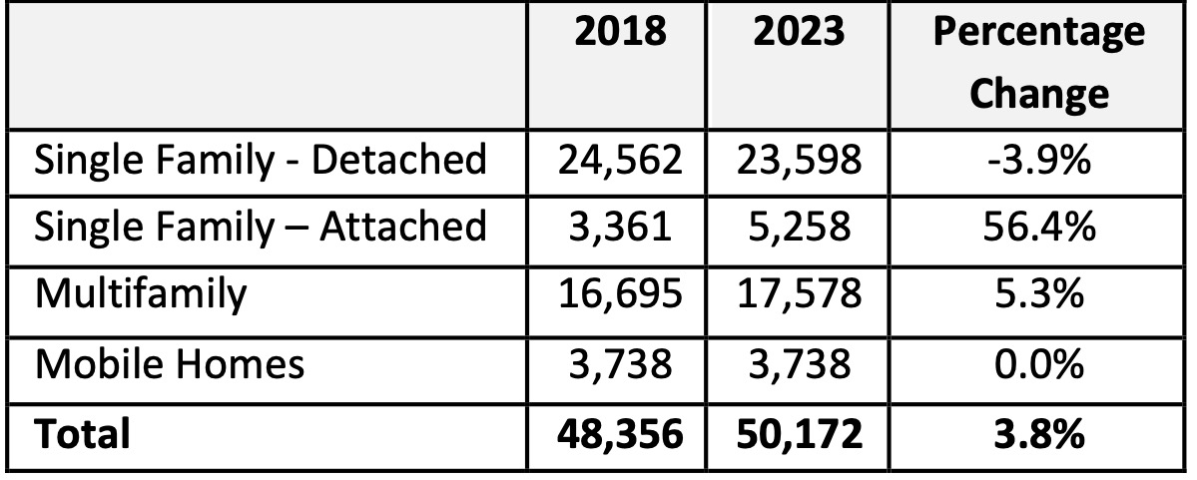
Table MA-05.01: Housing Units by Type
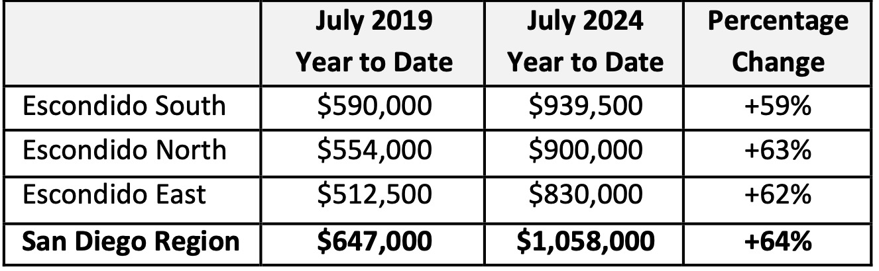
Table MA-05.02: Median Single-Family Home Sales Prices
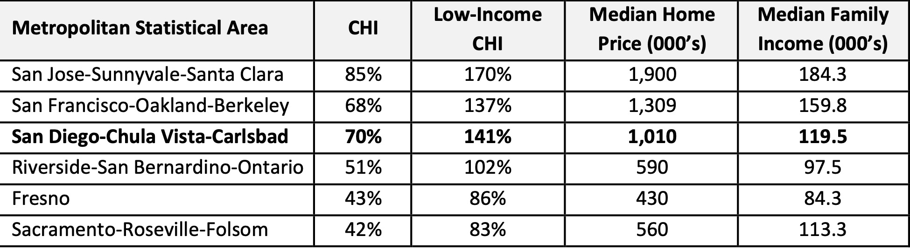
Table MA-05.03: Cost of Housing Index by Affordability Rank, 3rd Quarter 2024

MA-10 Number of Housing Units – 91.210(a)&(b)(2)
Introduction
The City of Escondido continues to have available land for development, much of the remaining open space is concentrated in the city's perimeter areas, where infrastructure and zoning constraints may impact feasibility. Additionally, there are significant opportunities for infill and redevelopment in the central urban core, particularly in areas identified for mixed-use and higher-density residential development. The City's Housing Element and strategic planning efforts focus on increasing housing supply through infill development, adaptive reuse, and the expansion of accessory dwelling units (ADUs) to address growing housing needs. The community supports a wide range of housing types, and the current growth consists of both new single-family development on the outskirts of the city and multi-family development near the downtown core. As shown in Table MA-10.01, based on 2022 five-year ACS estimates, the city includes 53,082 housing units. Half of the existing housing stock is detached single-family units. The next most common housing type is multifamily properties with 20 or more units, which comprise 21 percent of the housing stock.
As shown in Table MA-10.02, 2022 five-year ACS estimates indicate that, of the 51,288 occupied housing units, 52 percent are owner-occupied and 48 percent are renter-occupied. Regarding unit size, most owner-occupied units include three or more bedrooms (78 percent), while only 24 percent of rental units include three or more bedrooms. Nearly half of renter-occupied units (47 percent) include two bedrooms. This information provides additional context to Table NA-10.07, which shows that 78 percent of overcrowded households are renter-occupied.
All residential properties by number of units
Property Type | Number | %
1-unit detached structure | 26,684 | 50%
1-unit, attached structure | 3,663 | 7%
2-4 units | 2,731 | 5%
5-19 units | 4,692 | 9%
20 or more units | 11,222 | 21%
Mobile Home, boat, RV, van, etc | 4,090 | 8%
Total | 53,082 | 100%
Table 31 – Residential Properties by Unit Number

Data Source Comments: | Source: ACS, 2018-2022 [Series B25024]

Unit Size by Tenure
 | Owners |  | Renters
 | Number | % | Number | %
No bedroom | 163 | 1% | 1,673 | 7%
1 bedroom | 488 | 2% | 5,591 | 23%
2 bedrooms | 5,318 | 20% | 11,576 | 47%
3 or more bedrooms | 20,583 | 78% | 5,896 | 24%
Total | 26,552 | 101% | 24,736 | 101%
Table 32 – Unit Size by Tenure

Data Source Comments: | Source: ACS, 2018-2022 [Series B25024]

Describe the number and targeting (income level/type of family served) of units assisted with federal, state, and local programs.
With the dissolution of redevelopment agencies in California in 2012, Escondido’s ability to provide affordable housing opportunities has been significantly limited . Nonetheless, the City has attempted to leverage as many funding sources as possible to continue to provide affordable housing opportunities, and will continue to do so. The city has an inventory of 25 developments that include 1,642 units set aside for households with low to moderate incomes. These developments were assisted with state redevelopment, HOME, CDBG, and/or tax credits. Over the years, the City has partnered in the production of a variety of housing types including multifamily, single-family and multifamily ownership, co-op, mobile home parks, and mobile home ownership.
Provide an assessment of units expected to be lost from the affordable housing inventory for any reason, such as expiration of Section 8 contracts.
Escondido’s 2021-2029 Housing Element included an evaluation of at-risk units was completed. Within the 2021-2031 at-risk housing analysis period, only one development called Silvercrest Residence was identified as being at low risk of converting to market rate housing. Silvercrest includes 75 rental units and was assisted with HUD Section 202 funding. Though Silvercrest’s earliest date of conversion is in 2022, the City considers the risk of conversion low, because the project is managed by a non-profit organization (The Salvation Army), which has the mission to provide permanent affordable housing. Furthermore, HUD has established priority for the renewal of project-based Section 8 assistance for housing for seniors and persons with disabilities.
Does the availability of housing units meet the needs of the population?
The current availability of housing units in Escondido is insufficient to meet the needs of the population, particularly the lower income population. According to the FY 2024-2025 HACSD Public Housing Agency Annual Plan, the average waiting period for a Housing Choice Voucher is 13 years. Additionally, most, if not all, of the affordable income-restricted residential projects in the city have waiting lists and very low vacancy rates. As shown in Table NA-05.09, 19,375 low-income Escondido households (67 percent of all low-income households) spend at least 30 percent of their income on housing, indicating a need for more affordable units. Furthermore, according to 2023 five-year ACS estimates, 50 percent of Escondido’s 53,082 housing units (26,495 units) were constructed prior to 1980, indicating a potential need for rehabilitation/repair.
Describe the need for specific types of housing:
Escondido has a great need for affordable housing units for lower income households, as indicated in the Needs Assessment. Most, if not all, affordable residential projects in Escondido currently have waiting lists and turn over vacancies quickly. In addition, the average waiting period for a Housing Choice Voucher is 13 years.
Furthermore, there is a need for larger affordable units (three or more bedrooms). According to 2023 five-year ACS data, 30 percent of occupied housing units in Escondido (15,230 units) house four or more persons. These units are essential to house low-income families, particularly those with children.
Discussion
Please see above.

MA-15 Housing Market Analysis: Cost of Housing - 91.210(a)
Introduction
As is the situation throughout much of California and particularly San Diego County, housing costs in Escondido have increased tremendously in the past decade. The following section provides information on the cost of housing in Escondido.
Cost of Housing
 | Base Year: 2015 | Most Recent Year: 2022 | % Change
Median Home Value | 346,000 | 616,400 | 78%
Median Contract Rent | 1,128 | 1,729 | 53%
Table 33 – Cost of Housing

Data Source Comments: | Source: ACS, 2011-2015 (Base Year) and 2018-2022 (Most Recent Year) [Series B25077 Ã¢Â¿Â¿ Median Home Value & B25058 Ã¢Â¿Â¿ Median Contract Rent]

Rent Paid | Number | %
Less than $500 | 743 | 0.0%
$500-999 | 1,533 | 0.0%
$1,000-1,499 | 4,165 | 0.0%
$1,500-1,999 | 8,563 | 0.0%
$2,000 or more | 9,271 | 0.0%
Total | 24,275 | 0.0%
Table 34 - Rent Paid

Data Source Comments: | Source: ACS, 2018-2022 [B25063]

Housing Affordability
Number of Units affordable to Households earning | Renter | Owner
30% HAMFI | 1,590 | No Data
50% HAMFI | 4,650 | 1,480
80% HAMFI | 16,695 | 3,270
100% HAMFI | No Data | 5,630
Total | 22,935 | 10,380
Table 35 – Housing Affordability
Data Source: | 2016-2020 CHAS

Monthly Rent
Monthly Rent ($) | Efficiency (no bedroom) | 1 Bedroom | 2 Bedroom | 3 Bedroom | 4 Bedroom
Fair Market Rent | 2,062 | 2,248 | 2,833 | 3,819 | 4,638
High HOME Rent | 1,779 | 1,907 | 2,291 | 2,638 | 2,923
Low HOME Rent | 1,326 | 1,420 | 1,705 | 1,970 | 2,197
Table 36 – Monthly Rent

Data Source Comments: | Source: HUD FRM and HOME Rents, 2024

Is there sufficient housing for households at all income levels?
No. As shown in Table MA-15.03 above, 6,130 units affordable to households earning 31 to 50 percent of the AMI are in Escondido. However, Table NA-05.02 shows that 7,895 households earning 31 to 50 percent of the AMI live in Escondido, indicating a deficit of 1,765 units. While complete data is not available on unit affordability for households earning up to 30 percent of the AMI, it is reasonable to assume a deficit for that income level as well.
How is affordability of housing likely to change considering changes to home values and/or rents?
Although it is unknown whether home values and/or rents will increase in the foreseeable future and by how much, it is likely that housing affordability will not significantly improve in the near-term. Although the State has been implementing many new housing regulations and requirements intended to spur construction of additional affordable housing, it is unknown whether it will be adequate to result in the construction of enough housing units to meaningfully reduce home prices and rents. According to the Southern California Rental Housing Association’s 2024 Vacancy and Rental Rate Survey, the vacancy rate among all units in Escondido was only 5.1 percent.
How do HOME rents / Fair Market Rent compare to Area Median Rent? How might this impact your strategy to produce or preserve affordable housing?
Table MA-15.4 shows the current HUD fair market rents for rental housing, as well as the allowable high and low HOME rents. These rents are the upper limits of rents that can be charged by property owners with units assisted by HUD rental housing programs. Rapidly increasing rents in the region’s market have widened the gap between HUD fair market rents and market rents, creating problems for low-income households seeking units that will accept their HUD voucher for rent assistance.
Discussion
Please see above.

MA-20 Housing Market Analysis: Condition of Housing – 91.210(a)
Introduction
Escondido’s aging housing stock has led to an increasing number of substandard units. Many homes were built before 1980, often requiring lead-based paint abatement.
Describe the jurisdiction's definition of "standard condition" and "substandard condition but suitable for rehabilitation":
The City of Escondido defines standard and substandard housing condition based on California Health and Safety Code. California Health and Safety Code Section 17920.3 defines a substandard structure as any building or portion thereof in which there exists any of the following conditions to an extent that endangers the life, limb, health, property, safety, or welfare of the occupants, nearby residents, or the public:
- Inadequate sanitation (including lack of or improper bathroom facilities, running water, and heating);
- Structural hazards;
- Any nuisance;
- Faulty wiring;
- Unsafe or improper plumbing;
- Unsafe or improper mechanical equipment;
- Faulty weather protection;
- Conditions that could cause or augment the spread of a fire or explosion;
- Unsafe or improper construction materials;
- Debris constituting a fire, health, or safety hazard;
- Inadequate maintenance;
- Inadequate exits;
- Inadequate fire protection; or
- Space occupied for living, sleeping, cooking, or dining that were not intended for those purposes.
A standard housing condition is one in which none of the above conditions exist.
As shown in Table MA-20.01 below, 35 percent of owner-occupied units and 64 percent of renter-occupied units in Escondido have one or two selected physical or financial conditions. Note that the conditions are identical to the following four housing problems: (1) lacking complete plumbing facilities, (2) lacking complete kitchen facilities, (3) more than one occupant per room, and (4) housing costs greater than 30 percent of household income.
Condition of Units
Condition of Units | Owner-Occupied |  | Renter-Occupied
Condition of Units | Number | % | Number | %
With one selected Condition | 0 | 0% | 0 | 0%
With two selected Conditions | 0 | 0% | 0 | 0%
With three selected Conditions | 0 | 0% | 0 | 0%
With four selected Conditions | 0 | 0% | 0 | 0%
No selected Conditions | 0 | 0% | 0 | 0%
Total | 0 | 0% | 0 | 0%
Table 37 - Condition of Units
Data Source: | 2016-2020 ACS

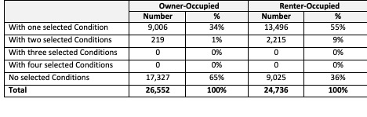
Table MA-20.01: Condition of Units

Year Unit Built
Year Unit Built | Owner-Occupied |  | Renter-Occupied
Year Unit Built | Number | % | Number | %
2000 or later | 0 | 0% | 0 | 0%
1980-1999 | 0 | 0% | 0 | 0%
1950-1979 | 0 | 0% | 0 | 0%
Before 1950 | 0 | 0% | 0 | 0%
Total | 0 | 0% | 0 | 0%
Table 38 – Year Unit Built
Data Source: | 2016-2020 CHAS

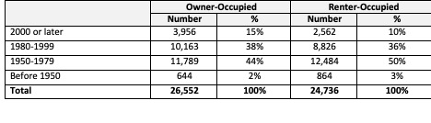
Table MA-20.02: Year Unit Built by Tenure

Risk of Lead-Based Paint Hazard
Risk of Lead-Based Paint Hazard | Owner-Occupied |  | Renter-Occupied
Risk of Lead-Based Paint Hazard | Number | % | Number | %
Total Number of Units Built Before 1980 | 0 | 0% | 0 | 0%

Housing Units build before 1980 with children present | 0 | 0% | 0 | 0%
Table 39 – Risk of Lead-Based Paint
Data Source: | 2016-2020 ACS (Total Units) 2016-2020 CHAS (Units with Children present)

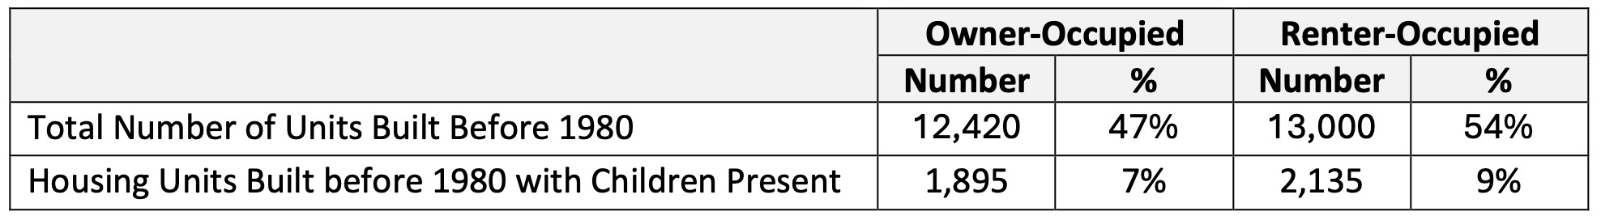
Table MA-20.03: Risk of Lead-Based Paint Hazard

Vacant Units
 | Suitable for Rehabilitation | Not Suitable for Rehabilitation | Total
Vacant Units | 0 | 0 | 0
Abandoned Vacant Units | 0 | 0 | 0
REO Properties | 0 | 0 | 0
Abandoned REO Properties | 0 | 0 | 0
Table 40 - Vacant Units
Data Source: | 2005-2009 CHAS

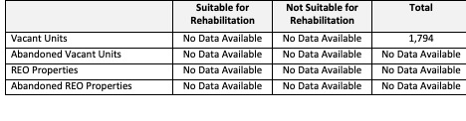
Table MA-20.04: Vacant Units

Need for Owner and Rental Rehabilitation
<TYPE=[text] REPORT_GUID=[F8DC4D3147433947165558A235C46686] PLAN_SECTION_ID=[1313801000]>
Estimated Number of Housing Units Occupied by Low or Moderate Income Families with LBP Hazards
Housing age is the key indicator used to estimate the number of housing units containing lead-based paint. Beginning in 1978, the federal government prohibited the consumer use of paint containing lead, and all residential uses. According to the U.S. Centers for Disease Control and Prevention (CDC), all housing units built prior to 1978 are likely to contain some lead-based paint. Again, half of Escondido’s residential units were constructed before 1980.
According to the CDC, children under six years old are at a higher risk of lead exposure, because their bodies are rapidly developing and more susceptible to taking in lead if exposed. Young children tend to put their hands or other objects in their months, which can result in lead exposure if their hands or other objects are lead-contaminated. Of households earning up to 80 percent of AMI with one or more children under six years old, 46 percent (2,525 households) live in housing units built before 1980.
While the above figures help estimate the number of homes that contain lead-based paint hazards, not all units with lead-based paint have lead-based paint hazards. In addition, some pre-1978 housing units have already been remediated during remodeling or other actions.
Discussion
Please see above.

MA-25 Public and Assisted Housing – 91.210(b)
Introduction
The Housing Authority of the County of San Diego (HACSD) administers the Public Housing and Housing Choice Voucher programs within most San Diego County jurisdictions, including Escondido. No public housing units are within Escondido’s boundaries. Table MA-25.01 below summarizes existing housing vouchers administered by the HACSD – not only within Escondido.
Totals Number of Units
Program Type
 | Certificate | Mod-Rehab | Public Housing | Vouchers
 |  |  |  | Total | Project -based | Tenant -based | Special Purpose Voucher
 |  |  |  |  |  |  | Veterans Affairs Supportive Housing | Family Unification Program | Disabled  *
# of units vouchers available | 0 | 87 | 121 | 10,905 | 0 | 10,905 | 1,031 | 0 | 432
# of accessible units

*includes Non-Elderly Disabled, Mainstream One-Year, Mainstream Five-year, and Nursing Home Transition
Table 41 – Total Number of Units by Program Type
Data Source: | PIC (PIH Information Center)

Describe the supply of public housing developments:
Describe the number and physical condition of public housing units in the jurisdiction, including those that are participating in an approved Public Housing Agency Plan:
No public housing developments are in Escondido.

Public Housing Condition
Public Housing Development | Average Inspection Score
Table 42 - Public Housing Condition

Describe the restoration and revitalization needs of public housing units in the jurisdiction:
No public housing units are in Escondido.
Describe the public housing agency's strategy for improving the living environment of low- and moderate-income families residing in public housing:
No public housing units are in Escondido.
Discussion:
No public housing units are in Escondido.

MA-30 Homeless Facilities and Services – 91.210(c)
Introduction
The San Diego Regional Task Force on Homelessness (RTFH) is a regional group of 18 cities, the County of San Diego, nonprofit service providers, and other stakeholders making up the San Diego County Continuum of Care (CoC). The RTFH provides regional leadership and oversight of the homeless crisis response system. The overall goal and vision of the RTFH is to reduce and end homelessness across the San Diego region. The RTFH meets jointly to coordinate regional and local efforts to provide services.
Interfaith Community Services is the agency in Escondido currently providing the most shelter and supportive housing beds, including youth, veterans and seniors.
Currently, the agencies providing year-round shelter beds for the homeless in Escondido include:
- Manzanita operated by Community HousingWorks: 10 beds for chronically homeless
- Haven House operated by Interfaith Community Services: 49 beds
Permanent supportive housing is available as follows:
- El Norte Parkway operated by Community HousingWorks: 8 units for veterans
- Las Casitas operated by Community HousingWorks: 14 units/42 beds for individuals & families
- Mental Health Systems: 28 units/42 beds for individuals & families with preference for chronically homeless
- Mental Health System: 20 units/24 beds for chronically homeless
- Interfaith RAP operated by Interfaith CS: 15 units for chronically homeless experiencing substance abuse & mental issues
- Raymond’s Refuge operated by Interfaith: 16 beds for seniors with mental or physical disabilities
- Home Now operated by Interfaith: 22 units of rapid rehousing
- NC Safe Haven operated by Mental Health Systems: 12 safe haven beds for individuals experiencing serious mental illness
- Veterans Villages operated by Veterans Village of San Diego: 54 units for chronically homeless veterans and families
- Manzanita operated by Community HousingWorks: 6 units/13 beds for single adults, 10 for chronically homeless
Transitional housing is available as follows:
- Path to Permanence operated by Interfaith: 4 families.
Facilities and Housing Targeted to Homeless Households
 | Emergency Shelter Beds |  | Transitional Housing Beds | Permanent Supportive Housing Beds
 | Year Round Beds (Current & New) | Voucher / Seasonal / Overflow Beds | Current & New | Current & New | Under Development
Households with Adult(s) and Child(ren) | 40 | 8 | 36 | 175 | 0
Households with Only Adults | 156 | 0 | 46 | 154 | 0
Chronically Homeless Households | 0 | 0 | 0 | 0 | 0
Veterans | 16 | 0 | 0 | 121 | 0
Unaccompanied Youth | 0 | 0 | 28 | 0 | 0
Table 43 - Facilities and Housing Targeted to Homeless Households

Data Source Comments: | Source: Regional Task Force on Homelessness, October 1, 2023 to September 30, 2024 period

Describe mainstream services, such as health, mental health, and employment services to the extent those services are use to complement services targeted to homeless persons
Community-based organizations in Escondido have developed a wide range of supportive services in conjunction with shelter and transitional housing to promote self-sufficiency among residents and to prepare them for permanent housing. A variety of agencies are able to provide services, such as job training, parenting classes, basic needs, social work, case management and other self-sufficiency training for homeless families; pregnant/parenting women; men and women with alcohol/drug addictions; veterans; individuals with mental illness; unaccompanied youth, women, and their children fleeing domestic violence; and others. Many local homeless service providers directly help individuals experiencing homeless in Escondido, including Interfaith Community Services, Interfaith Shelter Network, Veterans Village San Diego, Community Housing Works, Mental Health Systems, and Salvation Army.
List and describe services and facilities that meet the needs of homeless persons, particularly chronically homeless individuals and families, families with children, veterans and their families, and unaccompanied youth. If the services and facilities are listed on screen SP-40 Institutional Delivery Structure or screen MA-35 Special Needs Facilities and Services, describe how these facilities and services specifically address the needs of these populations.
To effectively deal with the complications presented by the unique homeless clientele of veterans, chronic homeless, unaccompanied youth, and families, services need to be well-coordinated and integrated. Effective coordination involves the Police Department, County mental health personnel, health care providers, public health personnel, and alcohol/drug recovery services. A range of intervention, case management, stabilization and recovery services is needed to effectively treat individuals with mentally illness, in addition to shelter placement. Several organizations, including Interfaith Community Services, Veterans Village San Diego, Community Housing Works, Mental Health Systems, and Salvation Army provide a variety of homeless-related services. Available services include navigation, case work, life and vocation training, healthcare, transportation, legal services and life skills. Interfaith Community Services serves as a North County inland access site to the coordinated entry system (CES). The CES is the assessment for the network of resources in San Diego County and the prioritization through the RTFH, which allow individuals and families experiencing homelessness to access valuable resources, including shelter, meals, day centers, and support. Interfaith will continue to provide many supportive homeless services, including shelters, homeless prevention, case management services, and rapid re-housing.

MA-35 Special Needs Facilities and Services – 91.210(d)
Introduction
The City will continue to maintain and coordinate services to assist individuals with special needs. Existing service providers will be supported when possible and existing funds will be prioritized and expended when appropriate and feasible.

Including the elderly, frail elderly, persons with disabilities (mental, physical, developmental), persons with alcohol or other drug addictions, persons with HIV/AIDS and their families, public housing residents and any other categories the jurisdiction may specify, and describe their supportive housing needs
Elderly persons, including the frail elderly, persons with disabilities (mental, physical, developmental), persons with alcohol or other drug addictions, veterans, and persons with HIV/AIDS and their families, may require long-term supportive housing that could include an assisted living, supportive housing, or nursing care component. There is a need for services, such as transportation services, help with basic living, home care, meal delivery, and housing that is adapted to specific needs, especially for seniors and veterans, at an affordable price.
Throughout San Diego County, there are a wide range of housing options for the elderly, including supportive housing, group homes, and state-licensed residential care facilities. According to the San Diego County Health and Human Services Agency’s Aging & Independence Services, there is a concentration of community care facilities in and around Escondido. Many residential facilities in Escondido provide long-term supportive housing for the elderly, those with memory care needs, and those with other disabilities, including assisted living and residential care. Still, additional affordable service options are needed.
Veterans also have a unique need for supportive services and housing, including mental health services, substance abuse services, case management, employment training, life skills and parenting classes, and assistance with paperwork and legal matters. Although there are several providers of services for veterans in Escondido, additional affordable help is needed.
Describe programs for ensuring that persons returning from mental and physical health institutions receive appropriate supportive housing
<TYPE=[text] REPORT_GUID=[F8DC4D3147433947165558A235C46686] PLAN_SECTION_ID=[1350402000]>
Specify the activities that the jurisdiction plans to undertake during the next year to address the housing and supportive services needs identified in accordance with 91.215(e) with respect to persons who are not homeless but have other special needs. Link to one-year goals. 91.315(e)
The City proposes to put a particular focus on housing and community services for seniors. Additionally, the City plans to focus CDBG public service funds on basic needs, homelessness, and human development.
For entitlement/consortia grantees: Specify the activities that the jurisdiction plans to undertake during the next year to address the housing and supportive services needs identified in accordance with 91.215(e) with respect to persons who are not homeless but have other special needs. Link to one-year goals. (91.220(2))
Please see above.

MA-40 Barriers to Affordable Housing – 91.210(e)
Negative Effects of Public Policies on Affordable Housing and Residential Investment
Public policies can negatively impact the availability of affordable housing. Below is a list of barriers to affordable housing in Escondido.
Land Use Controls
Land use policies and zoning requirements are often cited as a barrier to development, specifically affordable housing. The City has streamlined the process for adding an accessory dwelling unit, allowing increased opportunities for individual property owners to add additional affordable housing. The Density Bonus Ordinance also allows affordable housing development in accordance with State requirements. The City is continuously reviewing requirements for other opportunities to streamline housing development.
Environmental Protection
The level of environmental review required for a residential project depends on the project type and financing sources. Both state (California Environmental Quality Act) and federal (National Environmental Policy Act) regulations can increase costs due to required studies and extended timelines. However, much of this process is beyond the City’s control.
Planning and Development Fees
The cost of development, including permit fees paid to the City, is often cited as a barrier to housing development. Building, zoning, and site improvement fees can add significantly to construction costs and have a negative impact on housing production. The City of Escondido periodically reviews all fees to ensure cost recovery while balancing the needs of the public and developers.
Public Opposition to Affordable Housing
Public opposition to housing, and in particular affordable housing, can cause delays in the development process, add costs, and possibly result in a project being denied. In recent years, the State of California has enacted new housing laws meant to discourage NIMBY-ism (Not In My Backyard).
Permit and Processing Procedures/Times
The time required to obtain development and building permits is often cited as a factor in housing costs. Processing times vary by project complexity, but the State has introduced expedited permitting for certain residential projects. The City of Escondido actively streamline project approvals and is implementing additional programs to further reduce development timelines.
Lack of Affordable Housing Funds
The City of Escondido, like many cities in California, faces significant challenges in continuing to provide affordable housing opportunities. Some previously available funding has been eliminated or reduced, and costs have increased exponentially. The City will continue to leverage other funding sources as available to develop affordable housing opportunities.
Prevailing Wage Requirements
The State Department of Industrial Relations (DIR) has expanded the types of projects that require the payment of prevailing wages. In addition, Davis-Bacon prevailing wages must be paid when federal funds are used on new and multi-family rehabilitation projects with eight or more units. The prevailing wage is usually higher than competitive wages, raising the cost of housing production and rehabilitation activities. Prevailing wage also adds to a project’s costs by requiring documentation of compliance.
Building Codes and Enforcement
Building Codes could be considered an adverse impact on the timing and cost of affordable housing. The California Building Standards Code is updated every three years. The City has adopted the 2022 California Building Standards Code, which includes the 2022 California Building Code and 2022 Green Building Standards Code.

MA-45 Non-Housing Community Development Assets – 91.215 (f)
Introduction
The City of Escondido remains dedicated to fostering economic growth by supporting the expansion, attraction, and retention of key industry clusters that drive the local economy. These priority sectors include Agribusiness and Ag-Tech; Cleantech; Culture, Entertainment, and Tourism; Healthcare and Life Sciences; Information and Communication Technology; and Specialty Food and Beverage Manufacturing. The City's economic development initiatives align with the latest market trends and strategic priorities to enhance business opportunities, create jobs, and strengthen Escondido’s position as a regional economic hub.
In June 2023, the Escondido City Council approved the 2023-2028 Comprehensive Economic Development Strategy (CEDS). This document provides an in-depth analysis of the City's economic landscape and outlines a five-year plan to improve the local economy.
The following are key highlights of Non-Housing Community Development assets and improvements that have recently occurred or are planned in the City:
• Creek Trail Enhancements
• Downtown Revitalization & Infrastructure Investments
• Business and Real Estate Engagement
• Hospitality & Commercial Expansion
• Sustainable Water Infrastructure
• Membrane Filtration/Reverse Osmosis (MFRO) Facility
• Public Safety & Community Services
• Support for Childcare & Economic Development
• Affordable Housing Initiatives
• Community & Youth Services
• Emergency & Homeless Services
• Recreational Investments
• Volunteer & Community Engagement Programs
• Climate Action & Sustainability Initiatives
• Community Events & Cultural Activities
These initiatives reflect Escondido’s commitment to long-term economic development, business expansion, sustainable infrastructure, housing affordability, and community well-being, ensuring that public spaces, infrastructure, and programs remain accessible and engaging for residents and visitors alike.
Economic Development Market Analysis
Business Activity
Business by Sector | Number of Workers | Number of Jobs | Share of Workers  % | Share of Jobs  % | Jobs less workers  %
Agriculture, Mining, Oil & Gas Extraction | 985 | 292 | 2 | 1 | -1
Arts, Entertainment, Accommodations | 7,294 | 4,129 | 11 | 8 | -3
Construction | 5,510 | 8,363 | 9 | 17 | 8
Education and Health Care Services | 13,084 | 12,138 | 21 | 25 | 4
Finance, Insurance, and Real Estate | 3,168 | 1,521 | 5 | 3 | -2
Information | 1,267 | 438 | 2 | 1 | -1
Manufacturing | 6,513 | 2,415 | 10 | 5 | -5
Other Services | 2,309 | 2,023 | 4 | 4 | 0
Professional, Scientific, Management Services | 11,633 | 8,715 | 18 | 18 | 0
Public Administration | 1,714 | 867 | 3 | 2 | -1
Retail Trade | 6,161 | 6,706 | 10 | 14 | 4
Transportation and Warehousing | 1,700 | 320 | 3 | 1 | -2
Wholesale Trade | 2,458 | 1,174 | 4 | 2 | -2
Total | 63,796 | 49,101 | -- | -- | --
Table 45 - Business Activity

Data Source Comments: | U.S. Census Bureau 2022 Longitudinal Employer-Household Dynamics

Labor Force
Total Population in the Civilian Labor Force | 76,233
Civilian Employed Population 16 years and over | 72,943
Unemployment Rate | 4.30
Unemployment Rate for Ages 16-24 | 9.30
Unemployment Rate for Ages 25-65 | 3.10
Table 46 - Labor Force

Data Source Comments: | Source: 2018-2022 ACS

Occupations by Sector | Number of People
Management, business and financial | 10,509
Farming, fisheries and forestry occupations | 1,164
Service | 15,574
Sales and office | 14,878
Construction, extraction, maintenance and repair | 7,367
Production, transportation and material moving | 9,758
Table 47 – Occupations by Sector

Data Source Comments: | Source: ACS, 2018-2022 [Data Series S2401]

Travel Time
Travel Time | Number | Percentage
< 30 Minutes | 35,624 | 55%
30-59 Minutes | 24,261 | 38%
60 or More Minutes | 4,355 | 7%
Total | 64,240 | 100%
Table 48 - Travel Time

Data Source Comments: | Source: ACS, 2018-2022 [Data Series B08303]

Education:
Educational Attainment by Employment Status (Population 16 and Older)
Educational Attainment | In Labor Force
Educational Attainment | Civilian Employed | Unemployed | Not in Labor Force
Less than high school graduate | 10,843 | 220 | 4,849
High school graduate (includes equivalency) | 12,880 | 579 | 5,508
Some college or Associate's degree | 18,659 | 715 | 5,755
Bachelor's degree or higher | 17,334 | 421 | 3,220
Table 49 - Educational Attainment by Employment Status

Data Source Comments: | Source: ACS, 2018-2022 [Data Series B23006]

Educational Attainment by Age
 | Age
 | 18–24 yrs | 25–34 yrs | 35–44 yrs | 45–65 yrs | 65+ yrs
Less than 9th grade | 175 | 855 | 3,411 | 6,225 | 3,226
9th to 12th grade, no diploma | 1,560 | 1,038 | 1,401 | 2,982 | 1,216
High school graduate, GED, or alternative | 4,155 | 6,596 | 4,269 | 8,125 | 4,018
Some college, no degree | 5,901 | 6,668 | 3,899 | 8,634 | 5,020
Associate's degree | 700 | 2,520 | 1,180 | 2,638 | 1,603
Bachelor's degree | 1,275 | 4,145 | 4,170 | 6,165 | 3,485
Graduate or professional degree | 67 | 1,684 | 2,166 | 2,777 | 2,691
Table 50 - Educational Attainment by Age

Data Source Comments: | Source: ACS, 2018-2022 [Data Series B15001]

Educational Attainment – Median Earnings in the Past 12 Months
Educational Attainment | Median Earnings in the Past 12 Months
Less than high school graduate | 32,538
High school graduate (includes equivalency) | 36,256
Some college or Associate's degree | 45,146
Bachelor's degree | 68,400
Graduate or professional degree | 86,627
Table 51 – Median Earnings in the Past 12 Months

Data Source Comments: | Source: ACS, 2018-2022

Based on the Business Activity table above, what are the major employment sectors within your jurisdiction?
Based on the Business Activity Table (Table MA-45.01), the three sectors with the greatest number of jobs in Escondido are Education and Health Care Services; Construction; and Retail Trade. All three sectors were the top employing sectors during the last Consolidated Plan period as well. In terms of the labor force, the largest share of workers are employed in the Education and Health Care Services sector (21 percent).
In several sectors, the number of workers exceeds the number of jobs, meaning that residents employed in these sectors are commuting to other jurisdictions to work. For example, there are only 3,432 Professional, Scientific, and Management Services jobs in the city, but 6,804 workers. At the other end of the spectrum, there are more jobs than workers in some sectors, such as the Construction sector, demonstrating that additional people are commuting into the city for work. Overall, there are about 63,796 workers in Escondido, but just 49,101 jobs (a 30 percent discrepancy).
As shown in Table MA-45.02, the overall unemployment rate in Escondido is 4.3 percent, according to 2022 five-year ACS estimates. California Employment Development Department data from December 2024 indicates that the overall unemployment rate is 4.2 percent. The low unemployment rate reflects a robust local economy. Unemployment is notably higher among younger workers, with a rate of 9.3 percent for those aged 16 to 24, compared to workers aged 25 to 64 (3.1 percent).
Table MA-45.04 highlights commuting patterns for Escondido workers. Most workers commute less than 30 minutes (55 percent). Only 7 percent of workers travel more than an hour to work. This figure is consistent with regional patterns in San Diego County, where 7 percent of commuters travel more than one hour. Longer commute times are associated with higher transportation costs, increased greenhouse gas emissions, and a range of negative health impacts.
Educational attainment strongly correlates with labor force participation and employment rates. As shown in Table MA-45.05, of the population aged 25 to 64 years old with less than a high school diploma, 30 percent are not participating in the labor force. In contrast, only 15 percent of individuals with a bachelor’s degree or higher are not in the labor force. This data indicates that higher education levels increase the likelihood of employment.
The relationship between education and earnings is clear. As shown in Table MA-45.07, median earnings for Escondido residents aged 25 years old and above without a high school diploma are $32,538, while high school graduates earn a median income of $36,256, representing an 11 percent increase. Earnings continue to rise with higher education levels. Those with a bachelor’s degree have median earnings of $68,400, and individuals with a graduate or professional degree have median earnings of $86,627. This data underscores the significant economic benefits of obtaining a high school diploma, college degree, or higher education
Describe the workforce and infrastructure needs of the business community:
The business community needs municipal support with zoning and development, along with access to a skilled workforce, to drive growth, increase revenue, and meet market demands.
Describe any major changes that may have an economic impact, such as planned local or regional public or private sector investments or initiatives that have affected or may affect job and business growth opportunities during the planning period. Describe any needs for workforce development, business support or infrastructure these changes may create.
Workforce development in English as a Second Language (ESL), apprenticeships, and construction trades can help Escondido’s labor force—particularly those without a high school diploma or college degree—boost their earnings and spending power. Many residents are underemployed rather than unemployed, often working part-time in service industries. Expanding specialized training programs would provide pathways to higher-paying, full-time jobs.
How do the skills and education of the current workforce correspond to employment opportunities in the jurisdiction?
The city faces a labor shortage in construction and retail. Upskilling workers in construction trades, business skills, and customer service is essential to meeting employment demands.
Describe any current workforce training initiatives, including those supported by Workforce Investment Boards, community colleges and other organizations. Describe how these efforts will support the jurisdiction's Consolidated Plan.
The Consolidated Plan goals are intended to improve the lives of households with low to moderate incomes. Strengthening the workforce and labor market can create more jobs and higher wages, reducing financial strain on residents with lower incomes. Several areas of the city show significant economic distress based on employment and income data. Related initiatives in the CEDS include developing an educational enhancement plan focused on higher education, addressing training and job readiness gaps, and reinforcing collaborative efforts like STEM programs in Escondido’s primary and secondary schools.
Does your jurisdiction participate in a Comprehensive Economic Development Strategy (CEDS)?
Yes
If so, what economic development initiatives are you undertaking that may be coordinated with the Consolidated Plan? If not, describe other local/regional plans or initiatives that impact economic growth.
<TYPE=[text] REPORT_GUID=[F8DC4D3147433947165558A235C46686] PLAN_SECTION_ID=[1370705000]>
Discussion
Please see above.

MA-50 Needs and Market Analysis Discussion
Are there areas where households with multiple housing problems are concentrated? (include a definition of "concentration")
As stated previously, the four major housing problems recognized by HUD are as follows:
- Substandard Housing Unit – Lacks Complete Kitchen Facilities. A complete kitchen consists of a sink with running water, a stove or range, and a refrigerator.
- Substandard Housing Unit – Lacks Complete Plumbing Facilities: Complete plumbing consists of hot and cold running water, a flush toilet, and a bathtub or shower.
- Cost Burdened Household: Monthly housing costs exceed 30 percent of monthly income. A household is severely cost burdened if their monthly housing costs exceed 50 percent of their monthly income. Note that, for renters, housing costs include contract rent and utilities. For owners, housing costs include mortgage payments, utilities, association fees, insurance, and real estate taxes.
- Overcrowded Household: More than one person per room. Severe overcrowding is more than 1.5 persons per room.
Are there any areas in the jurisdiction where racial or ethnic minorities or low-income families are concentrated? (include a definition of "concentration")
A minority concentration is defined as a census tract whose proportion of a non-white population is at least 20 percentage points higher than the area as a whole, according to HUD’s Rental Assistance Determination Minority Concentration Analysis Tool. Based on this definition, a large area in the central portion of the City is considered a Hispanic minority concentration area.
What are the characteristics of the market in these areas/neighborhoods?
In Escondido, low- and moderate-income and minority-concentrated areas are primarily in the city's central region. These areas also have a high concentration of rental and multi-family housing.
Are there any community assets in these areas/neighborhoods?
The central core of the city and surrounding low- and moderate-income neighborhoods are home to many community assets, including the City Library, East Valley Community Center, Park Avenue Community Center and Senior Center, Grape Day Park, and several neighborhood parks. Additional resources in the area include the Boys & Girls Club, Escondido Education Compact and its Success Center, Interfaith Community Services, and the Salvation Army.
Are there other strategic opportunities in any of these areas?
The central area of the city presents many opportunities for assistance. The City will continue collaborating with North County agencies to ensure cost-effective delivery of services and programs. Federal funding will be directed to those most in need.
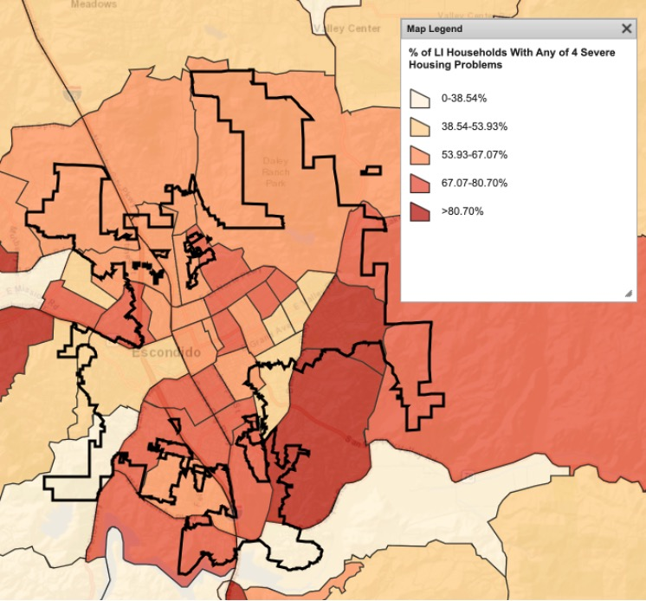
Figure MA-50.01: Percentage of Low-Income Households with Any of the Four Severe Housing Problems
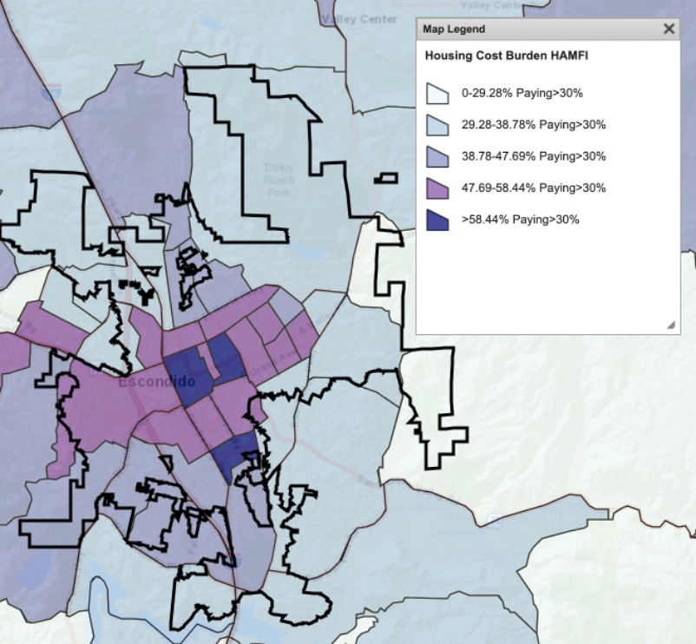
Figure MA-50.02: Percentage of Cost-Burdened Households by Census Tract
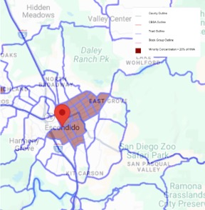
Figure MA-50.03: Minority Concentration Map

MA-60 Broadband Needs of Housing occupied by Low- and Moderate-Income Households - 91.210(a)(4), 91.310(a)(2)
Describe the need for broadband wiring and connections for households, including low- and moderate-income households and neighborhoods.
HUD guidelines require all Consolidated Plans to include a discussion on the broadband needs of the jurisdiction and the prevalence of the digital divide, defined as the gap between households with access to computers and internet on a regular basis and those who do not. In preparing the Consolidated Plan, the City used data from the Federal Communications Commission (FCC) to estimate the number of households with and without internet access.
The internet is an essential communications and information tool, enabling users to benefit from the growing interconnectedness of business, education, commerce, and daily activity. Reliable internet access is increasingly recognized as a necessity for thriving in today’s economic environment. Communities without broadband access face significant challenges in keeping pace with the rest of the country, as limited connectivity hinders their residents’ ability to access educational and entrepreneurial opportunities online. The issue is particularly pronounced in low to moderate-income areas, where economic opportunities are already limited. Research indicates a strong correlation between expanded high-speed internet access and improved educational and employment prospects, especially in small cities and rural communities.
The City of Escondido is leading the effort to develop a Broadband and Digital Access Study to understand where the digital divide exists and who is most impacted locally. As a result of this study, the City will create a roadmap to improve the community’s access to the internet, digital devices, and digital skills. Though most of Escondido has Internet access, the City strives to ensure that all residents can fully access the Internet and leverage online opportunities across education, employment, healthcare, social connection, community services, and more.
Describe the need for increased competition by having more than one broadband Internet service provider serve the jurisdiction.
Multiple broadband providers serve Escondido. Having a variety of broadband internet providers fosters competition, which often leads to improved service quality, lower prices, and greater innovation in technology. It gives consumers more choices, enabling them to select a provider that best meets their needs in terms of speed, reliability, and cost. Multiple providers can also increase network resilience, as alternative options ensure connectivity in case of service disruptions. This competitive landscape drives providers to continually enhance their offerings, ultimately benefiting both residential and business users with better overall internet services.
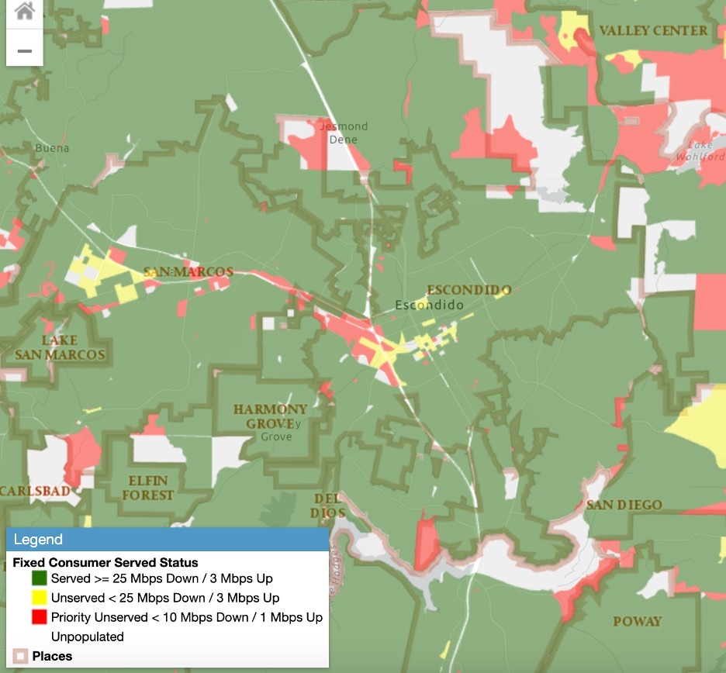
Figure MA-60.01: Map of Broadband Access
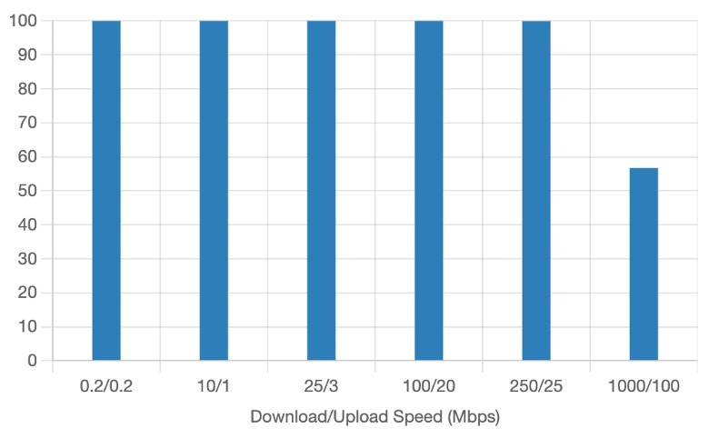
Figure MA-60.02: Units with Fixed Broadband Access in Escondido
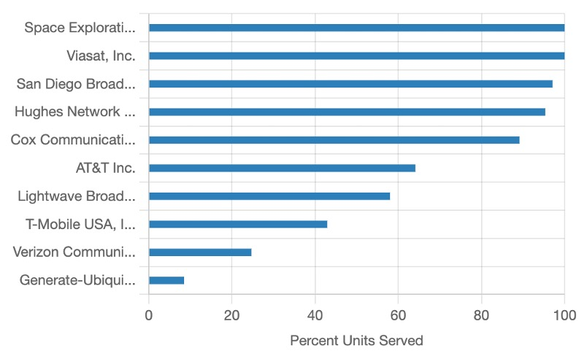
Figure MA-60.03: Top 10 Fixed Broadband Providers in Escondido

MA-65 Hazard Mitigation - 91.210(a)(5), 91.310(a)(3)
Describe the jurisdiction’s increased natural hazard risks associated with climate change.
Climate change is increasingly impacting the San Diego region, including Escondido, with rising temperatures, more frequent heatwaves, and disruptions to local ecosystems. According to the Intergovernmental Panel on Climate Change (IPCC), global warming is unequivocal, contributing to rising sea levels, more intense wildfires, and shifts in precipitation patterns. In Escondido, this translates to a heightened wildfire risk threatening both urban and rural areas, along with increased potential for droughts, flooding, and other extreme weather events.
To address these risks, the County of San Diego, including Escondido, has developed a Multi-Jurisdictional Hazard Mitigation Plan (MJHMP) in accordance with the federal Disaster Mitigation Act of 2000. This plan identifies and mitigates potential hazards, aiming to reduce risks to people and property from both natural and human-made disasters. A collaborative effort involving the County, its incorporated cities, and local agencies, the MJHMP serves several key functions:
- Enhancing Public Awareness: Educating residents about potential hazards and promoting proactive risk reduction.
- Guiding Decision-Making: Providing a framework for informed hazard mitigation investments and policies.
- Ensuring Compliance: Aligning with state and federal requirements to secure hazard mitigation funding.
- Promoting Coordination: Strengthening collaboration among local and regional government entities.
The MJHMP is updated regularly to reflect evolving conditions and new data, with the most recent update completed in 2023.
Describe the vulnerability to these risks of housing occupied by low- and moderate-income households based on an analysis of data, findings, and methods.
Households with low to moderate incomes are especially vulnerable to the effects of climate change and natural disasters due to socio-economic factors. Limited financial resources, inadequate insurance, and reduced access to disaster relief services often leave these households unprepared for emergencies. As a result, they may face delays in recovery, struggling with financial instability, difficulties securing temporary or permanent housing, and being unable to afford evacuation costs such as transportation and lodging.
Additionally, these communities are more likely to experience disruptions from natural hazards due to factors like the need for compensation for missed work, childcare responsibilities, and limited mobility. In the event of wildfires or flooding, low-income households are more likely to live in older, less resilient housing, increasing the potential for severe property damage and displacement. Moreover, reduced access to technology can hinder their ability to stay informed during emergencies.
To reduce the long-term impact of natural disasters in Escondido, it is crucial to ensure that households with low to moderate incomes have equitable access to resources, communication channels, and recovery support.

Strategic Plan

SP-05 Overview
Strategic Plan Overview
The City’s Strategic Plan proposes eligible projects and activities to meet the priorities described in the Consolidated Plan. Ultimately, the Strategic Plan will help achieve the City's Consolidated Plan goals by guiding investments in Escondido’s communities and households with low to moderate incomes. The findings from these outreach activities helped shape the priority needs in the Consolidated Plan.
The Strategic Plan includes the following sections:
• SP-10 Geographic Priorities
• SP-25 Priority Needs
• SP-30 Influence of Market Conditions
• SP-35 Anticipated Resources
• SP-40 Institutional Delivery Structure
• SP-45 Goals Summary
• SP-50 Public Housing Accessibility and Involvement
• SP-55 Barriers to Affordable Housing
• SP-60 Homelessness Strategy
• SP-65 Lead-Based Paint Hazards
• SP-70 Anti-Poverty Strategy
• SP-80 Monitoring
The priorities for the 2025-2029 Consolidated Plan cycle are as follows:
- Support the development and preservation of affordable rental and homeownership units.
- Expand access to supportive services to prevent and reduce homelessness, promote housing stability, and foster long-term solutions.
- Promote safe and healthy communities by improving public facilities, upgrading infrastructure, and supporting neighborhood revitalization efforts.
- Deliver essential supportive services to vulnerable populations, including youth, families, and seniors with low to moderate incomes and individuals with special needs.
These goals, and the funded activities meant to achieve them, align with HUD's approaches to
developing viable communities: (1) providing decent housing; (2) providing a suitable living
environment; and (3) expanding economic opportunity.

SP-10 Geographic Priorities – 91.215 (a)(1)
Geographic Area
Table 52 - Geographic Priority Areas
1 | Area Name: | CDBG Eligible Areas
1 | Area Type: | Local Target area
1 | Other Target Area Description:
1 | HUD Approval Date:
1 | % of Low/ Mod:
1 | Revital Type: | Comprehensive
1 | Other Revital Description:
1 | Identify the neighborhood boundaries for this target area.
1 | Include specific housing and commercial characteristics of this target area.
1 | How did your consultation and citizen participation process help you to identify this neighborhood as a target area?
1 | Identify the needs in this target area.
1 | What are the opportunities for improvement in this target area?
1 | Are there barriers to improvement in this target area?
2 | Area Name: | City of Escondido
2 | Area Type: | Local Target area
2 | Other Target Area Description:
2 | HUD Approval Date:
2 | % of Low/ Mod:
2 | Revital Type: | Housing
2 | Other Revital Description:
2 | Identify the neighborhood boundaries for this target area.
2 | Include specific housing and commercial characteristics of this target area.
2 | How did your consultation and citizen participation process help you to identify this neighborhood as a target area?
2 | Identify the needs in this target area.
2 | What are the opportunities for improvement in this target area?
2 | Are there barriers to improvement in this target area?
3 | Area Name: | Neighborhood Groups
3 | Area Type: | Local Target area
3 | Other Target Area Description:
3 | HUD Approval Date:
3 | % of Low/ Mod:
3 | Revital Type: | Housing
3 | Other Revital Description:
3 | Identify the neighborhood boundaries for this target area.
3 | Include specific housing and commercial characteristics of this target area.
3 | How did your consultation and citizen participation process help you to identify this neighborhood as a target area?
3 | Identify the needs in this target area.
3 | What are the opportunities for improvement in this target area?
3 | Are there barriers to improvement in this target area?

General Allocation Priorities
Describe the basis for allocating investments geographically within the jurisdiction (or within the EMSA for HOPWA)
Please see the discussion below.
The City of Escondido will allocate HOME funding based on the quality and quantity of applications, as well as their alignment with the priorities and goals outlined in the Consolidated Plan, rather than on a geographic basis. While funding is available citywide, areas in the older, central core may receive particular focus; however, no specific target areas have been designated.
CDBG funds will be directed to low- to moderate-income census tracts and neighborhood group areas, where needs are most concentrated. The City currently has 18 priority Neighborhood Groups, 17 of which are in low- to moderate-income census areas. These Neighborhood Groups are primarily older areas located in or near the city's central core.
If the City receives ESG funds during the 2025 to 2029 period, the funds would be distributed citywide to address identified homelessness needs, regardless of location.
The City does not receive HOPWA funds.

SP-25 Priority Needs - 91.215(a)(2)
Priority Needs
Table 53 – Priority Needs Summary
1 | Priority Need Name | Develop/preserve affordable rental & owner units
1 | Priority Level | High
1 | Population | Extremely Low  Low  Moderate  Large Families  Elderly
1 | Geographic Areas Affected | City of Escondido
1 | Associated Goals | Create and preserve affordable rental housing  Create and preserve affordable ownership housing
1 | Description | Support the creation and preservation of new affordable rental housing, including new construction, conversion, and rehabilitation; increase access to homeownership for low-income residents, including construction of new ownership units and down payment assistance through a first-time homebuyer program
1 | Basis for Relative Priority | Affordable housing has been identified as a priority based on local housing data and input from the community and stakeholders.
2 | Priority Need Name | Expand access to homelessness services
2 | Priority Level | High
2 | Population | Extremely Low  Families with Children  Elderly  Chronic Homelessness  Individuals  Mentally Ill  Chronic Substance Abuse  Unaccompanied Youth
2 | Geographic Areas Affected | City of Escondido
2 | Associated Goals | Expand access to homeless services
2 | Description | Supporting homeless shelter and other needs
2 | Basis for Relative Priority | Homeless services have been identified as a priority based on local housing data and input from the community and stakeholders.
3 | Priority Need Name | Support Neighborhood Revitalization
3 | Priority Level | High
3 | Population | Extremely Low  Moderate  Families with Children  Elderly  Non-housing Community Development
3 | Geographic Areas Affected | Neighborhood Groups  CDBG Eligible Areas
3 | Associated Goals | Improve the livability of neighborhoods
3 | Description | Address infrastructure gaps to improve livability and enhance neighborhoods through community outreach and public works projects
3 | Basis for Relative Priority | Public facility and infrastructure improvement and neighborhood revitalization have been identified as priorities based on input from the community and stakeholders.
4 | Priority Need Name | Supportive services-with low to mod & special need
4 | Priority Level | High
4 | Population | Extremely Low  Low  Moderate  Families with Children  Elderly
4 | Geographic Areas Affected | City of Escondido
4 | Associated Goals | Deliver supportive services
4 | Description | Support the provision of services to Escondido residents with low to moderate incomes and special needs populations.
4 | Basis for Relative Priority | Community services have been identified as priorities based on local housing data and input from the community and stakeholders.

Narrative (Optional)
Priority needs were identified through extensive housing and economic data, along with input from community meetings, stakeholder and resident surveys, and public hearings. Program and project funding is allocated annually through a competitive application process, based on eligibility and available resources.

SP-30 Influence of Market Conditions – 91.215 (b)
Influence of Market Conditions
Affordable Housing Type | Market Characteristics that will influence  the use of funds available for housing type
Tenant Based Rental Assistance (TBRA) | The City has a rental subsidy program, all of which is funded with HOME funds. In 2024, the City used HOME funds to increase the number of senior households assisted from 19 to 30. In 2026 the City used HOME funds to expand the program from 30 senior households to 64 all aged households.
TBRA for Non-Homeless Special Needs | Please see above.
New Unit Production | A majority of the city’s low- and moderate-income households experience housing cost burden, as shown in the Needs Analysis. It is the most common housing problem among the city’s households. The City plans to use a large portion of its HOME allocation to assist in the production of rental and ownership units for lower income households.
Rehabilitation | Half of the city's housing stock was built before 1980, increasing the likelihood of lead-based paint hazards and the need for rehabilitation. To address this, the City may allocate some HOME funds to rehabilitate single- and multi-family housing units.
Acquisition, including preservation | The City will strive to assist developers interested in acquisition/rehabilitation of existing multi-family housing to provide improved, affordable housing due to the age and condition of the city’s multi-family housing stock. The city also will assist in preserving any identified units that are at risk of losing affordability, when possible.
Table 54 – Influence of Market Conditions

Figure NA-10.01: 2-1-1 Clients Living in Escondido Demographics

SP-35 Anticipated Resources - 91.215(a)(4), 91.220(c)(1,2)
Introduction
The City of Escondido is a HOME participating jurisdiction and a CDBG entitlement jurisdiction. The funding is determined by a formula calculated by HUD based on population, people in poverty, overcrowded units, population growth lag since 1960, and pre-1940 housing units. The City’s allocation can fluctuate year-to-year causing funding to increase or decrease in various programs.
On May 13, 2025, HUD announced the City will receive $1,341,561 in CDBG funds, $590,369 in HOME funds, and $0 in ESG funds for FY 2025- 26. The total amount of anticipated federal funds for FY 2025-26 is $1,931,930. The City of Escondido was not awarded ESG funding in FY 2022-23, FY 2023-24, FY 2024-25, and FY 2025-26, and it is uncertain if the City will be receiving funding in future years. The City does not receive funding under the HOPWA program. Program income will be reprogrammed into allowable programs or projects, as identified during the Action Plan process.
Anticipated Resources
Program | Source of Funds | Uses of Funds | Expected Amount Available Year 1 |  |  |  | Expected Amount Available Remainder of ConPlan  $ | Narrative Description
Program | Source of Funds | Uses of Funds | Annual Allocation: $ | Program Income: $ | Prior Year Resources: $ | Total:  $ | Expected Amount Available Remainder of ConPlan  $ | Narrative Description
CDBG | public - federal | Acquisition  Admin and Planning  Economic Development  Housing  Public Improvements  Public Services | 1,341,561 | 0 | 85,757 | 1,427,318 | 5,200,000 | It is estimated that the City will receive a CDBG allocation of approximately $6,500,000 over the five years of the Consolidated Plan based on past and current funding.
HOME | public - federal | Acquisition  Homebuyer assistance  Homeowner rehab  Multifamily rental new construction  Multifamily rental rehab  New construction for ownership  TBRA | 590,369 | 50,000 | 4,505,813 | 5,146,182 | 2,361,476 | It is estimated that the City will receive a HOME allocation of approximately $2,900,000 over the five years of the Consolidated Plan based on past and current funding.
ESG | public - federal | Conversion and rehab for transitional housing  Financial Assistance  Overnight shelter  Rapid re-housing (rental assistance)  Rental Assistance  Services  Transitional housing | 0 | 0 | 0 | 0 | 0 | It is unknown whether the City will receive an ESG allocation over the five years of the Consolidated Plan.
Table 55 - Anticipated Resources

Explain how federal funds will leverage those additional resources (private, state and local funds), including a description of how matching requirements will be satisfied
The housing, community development, and homeless needs far exceed the available HOME, CDBG, and ESG funding. A variety of other non-federal funding sources, including grants and state funds, will be leveraged to meet as many needs in the City as possible.
Matching HOME requirements will be satisfied with other eligible financial resources and/or in-kind services. The City will continue to seek these funding sources.
CDBG does not require matching funds.
If the City receives ESG funds during the 2025 to 2029 period, the 100 percent match requirement for ESG funds would be satisfied with resources from service providers.
If appropriate, describe publicly owned land or property located within the jurisdiction that may be used to address the needs identified in the plan
The City is evaluating publicly owned land for future affordable housing opportunities. As part of the 2021 Housing Element update, the Planning Department analyzed potential housing sites, including City-owned properties, for their suitability for affordable housing. While no specific sites have been identified yet, the City continues to explore viable options.
Discussion
Please see above.

SP-40 Institutional Delivery Structure – 91.215(k)
Explain the institutional structure through which the jurisdiction will carry out its consolidated plan including private industry, non-profit organizations, and public institutions.
Responsible Entity | Responsible Entity Type | Role | Geographic Area Served
City of Escondido | Government | Economic Development  Homelessness  Non-homeless special needs  Ownership  Planning  Rental  public facilities  public services | Jurisdiction
COMMUNITY HOUSING WORKS | Non-profit organizations | Ownership  Rental | Region
Table 56 - Institutional Delivery Structure
Assess of Strengths and Gaps in the Institutional Delivery System
Housing, supportive services, homelessness prevention services, and community development programs in Escondido are provided by several public agencies, nonprofit organizations, faith-based groups, and private entities. A key strength of the coordinated delivery system is the collaboration between the City and the Regional Taskforce on Homelessness (RTFH), which enables a comprehensive and resource-leveraged approach to assisting homeless individuals. The City also coordinates efforts across departments and community partners to identify service gaps and develop solutions. While only a few entities have formal roles in administering HUD’s entitlement programs, the City, as the lead CDBG agency, coordinates efforts with a diverse range of stakeholders, including government agencies, businesses, nonprofit organizations, service providers, and sub-recipients.
Escondido and its partners have the organizational capacity to address community needs, with sufficient community housing development organizations (CHDO) available to support housing development and services. However, challenges persist due to limited funding and the need for stronger coordination among service providers. Additionally, ensuring residents are aware of available services remains an ongoing challenge.
Availability of services targeted to homeless persons and persons with HIV and mainstream services
Homelessness Prevention Services | Available in the Community | Targeted to Homeless | Targeted to People with HIV
Homelessness Prevention Services
Counseling/Advocacy | X | X
Legal Assistance | X | X
Mortgage Assistance | X
Rental Assistance | X | X
Utilities Assistance | X

Street Outreach Services
Law Enforcement | X | X
Mobile Clinics | X
Other Street Outreach Services | X | X

Supportive Services
Alcohol & Drug Abuse | X | X
Child Care | X
Education | X |  | X
Employment and Employment Training | X | X
Healthcare | X | X | X
HIV/AIDS | X |  | X
Life Skills | X | X
Mental Health Counseling | X | X | X
Transportation | X

Other
Table 57 - Homeless Prevention Services Summary
Describe how the service delivery system including, but not limited to, the services listed above meet the needs of homeless persons (particularly chronically homeless individuals and families, families with children, veterans and their families, and unaccompanied youth)
Interfaith Community Services is the agency in Escondido currently providing the most shelter and supportive housing beds, including for youth, veterans and seniors. Interfaith also provides various supportive homeless services, including shelters, homeless prevention, case management services, and rapid re-housing. Additionally, the Regional Taskforce on Homelessness coordinates providers, services, and funding to assist individuals experiencing homelessness, including veterans, the chronically homeless, families with children, and unaccompanied youth. While a variety of programs and services are available, as outlined in this Consolidated Plan, they remain insufficient to fully meet the needs of Escondido residents.
Describe the strengths and gaps of the service delivery system for special needs population and persons experiencing homelessness, including, but not limited to, the services listed above
Escondido offers a variety of services and programs for individuals with special needs and those experiencing homelessness. However, the demand for these services exceeds available resources. Additional funding is needed to expand support for the growing population, along with improved coordination among service providers to enhance efficiency and impact.
Provide a summary of the strategy for overcoming gaps in the institutional structure and service delivery system for carrying out a strategy to address priority needs
The City will continue collaborating with nearby jurisdictions, nonprofit and faith-based organizations, and the Regional Taskforce on Homelessness to coordinate resources and develop strategies to address service gaps and priority needs. With a strong support structure in place, the City is confident in its ability to tackle the key priorities outlined in this Consolidated Plan.

SP-45 Goals Summary – 91.215(a)(4)
Goals Summary Information
Sort Order | Goal Name | Start Year | End Year | Category | Geographic Area | Needs Addressed | Funding | Goal Outcome Indicator
1 | Create and preserve affordable rental housing | 2025 | 2029 | Affordable Housing | City of Escondido | Develop/preserve affordable rental & owner units | HOME: $3,450,000 | Rental units constructed:  136 Household Housing Unit  Rental units rehabilitated:  3 Household Housing Unit
2 | Create and preserve affordable ownership housing | 2025 | 2029 | Affordable Housing | City of Escondido | Develop/preserve affordable rental & owner units | HOME: $1,450,000 | Homeowner Housing Added:  10 Household Housing Unit  Direct Financial Assistance to Homebuyers:  5 Households Assisted
3 | Expand access to homeless services | 2025 | 2029 | Homeless | City of Escondido | Expand access to homelessness services | CDBG: $250,000 | Other:  250 Other
4 | Improve the livability of neighborhoods | 2025 | 2029 | Non-Housing Community Development | Neighborhood Groups  CDBG Eligible Areas | Support Neighborhood Revitalization | CDBG: $5,640,000 | Public Facility or Infrastructure Activities for Low/Moderate Income Housing Benefit:  10000 Households Assisted
5 | Deliver supportive services | 2025 | 2029 | Non-Homeless Special Needs | City of Escondido | Supportive services-with low to mod & special need | CDBG: $1,000,000 | Public service activities for Low/Moderate Income Housing Benefit:  1000 Households Assisted
Table 58 – Goals Summary

Goal Descriptions

1 | Goal Name | Create and preserve affordable rental housing
1 | Goal Description | Assist in producing and preserving affordable rental housing through the construction and acquisition/rehabilitation of existing rental units. Units would be affordable to extremely-low, very low, and low-income households.
2 | Goal Name | Create and preserve affordable ownership housing
2 | Goal Description | Provide direct assistance to first-time, low-income homebuyers for down payment or closing cost assistance. Assist in the production of affordable ownership housing for lower income homebuyers.
3 | Goal Name | Expand access to homeless services
3 | Goal Description | Increase access to shelter and housing and provide supportive services to individuals experiencing homelessness, such as mental health services and job training.
4 | Goal Name | Improve the livability of neighborhoods
4 | Goal Description | Improve community facilities and make necessary infrastructure improvements to serve low- to moderate-income persons. Work with neighborhood leaders to revitalize neighborhoods and provide neighborhood group support.
5 | Goal Name | Deliver supportive services
5 | Goal Description | Increase supportive services for vulnerable groups, such as youth, families, and seniors with low incomes and individuals with special needs.
Estimate the number of extremely low-income, low-income, and moderate-income families to whom the jurisdiction will provide affordable housing as defined by HOME 91.315(b)(2)
The 2025-2029 Consolidated Plan has established the following affordable housing objectives:
- Provide first-time homebuyer assistance to five households.
- Expand the City’s affordable housing inventory by 136 rental units through construction or acquisition/rehabilitation.
- Expand the City’s inventory of affordable ownership units by 10.
Overall, 151 extremely-low, very-low, low- and moderate-income households will benefit from the City’s federally-funded affordable housing activities over the upcoming five years. This includes 136 renters and 15 homeowners. It is proposed that over 250 homeless households will be assisted.

SP-50 Public Housing Accessibility and Involvement – 91.215(c)
Need to Increase the Number of Accessible Units (if Required by a Section 504 Voluntary Compliance Agreement)
The City of Escondido has no Section 504 Voluntary Compliance Agreement. There is no public housing in Escondido.
Activities to Increase Resident Involvements
There are no public housing units in Escondido.
Is the public housing agency designated as troubled under 24 CFR part 902?
N/A
Plan to remove the ‘troubled’ designation
N/A

SP-55 Barriers to affordable housing – 91.215(h)
Barriers to Affordable Housing
Public policies can negatively impact the availability of affordable housing. Below is a list of barriers to affordable housing in Escondido.
Land Use Controls
Land use policies and zoning requirements are often cited as a barrier to development, specifically affordable housing. The City has streamlined the process for adding an accessory dwelling unit, allowing increased opportunities for individual property owners to add additional affordable housing. The Density Bonus Ordinance also allows affordable housing development in accordance with State requirements. The City is continuously reviewing requirements for other opportunities to streamline housing development.
Environmental Protection
The level of environmental review required for a residential project depends on the project type and financing sources. Both state (California Environmental Quality Act) and federal (National Environmental Policy Act) regulations can increase costs due to required studies and extended timelines. However, much of this process is beyond the City’s control.
Planning and Development Fees
The cost of development, including permit fees paid to the City, is often cited as a barrier to housing development. Building, zoning, and site improvement fees can add significantly to construction costs and have a negative impact on housing production. The City of Escondido periodically reviews all fees to ensure cost recovery while balancing the needs of the public and developers.
Public Opposition to Affordable Housing
Public opposition to housing, and in particular affordable housing, can cause delays in the development process, add costs, and possibly result in a project being denied. In recent years, the State of California has enacted new housing laws meant to discourage NIMBY-ism (Not In My Backyard).
Permit and Processing Procedures/Times
The time required to obtain development and building permits is often cited as a factor in housing costs. Processing times vary by project complexity, but the State has introduced expedited permitting for certain residential projects. The City of Escondido actively streamline project approvals and is implementing additional programs to further reduce development timelines.
Lack of Affordable Housing Funds
The City of Escondido, like many cities in California, faces significant challenges in continuing to provide affordable housing opportunities. Some previously available funding has been eliminated or reduced, and costs have increased exponentially. The City will continue to leverage other funding sources as available to develop affordable housing opportunities.
Prevailing Wage Requirements
The State Department of Industrial Relations (DIR) has expanded the types of projects that require the payment of prevailing wages. In addition, Davis-Bacon prevailing wages must be paid when federal funds are used on new and multi-family rehabilitation projects with eight or more units. The prevailing wage is usually higher than competitive wages, raising the cost of housing production and rehabilitation activities. Prevailing wage also adds to a project’s costs by requiring documentation of compliance.
Building Codes and Enforcement
Building Codes could be considered an adverse impact on the timing and cost of affordable housing. The California Building Standards Code is updated every three years. The City has adopted the 2022 California Building Standards Code, which includes the 2022 California Building Code and 2022 Green Building Standards Code.
Strategy to Remove or Ameliorate the Barriers to Affordable Housing
Public policies can negatively impact the availability of affordable housing. Below is a list of barriers to affordable housing in Escondido.
Land Use Controls
Land use policies and zoning requirements are often cited as a barrier to development, specifically affordable housing. The City has streamlined the process for adding an accessory dwelling unit, allowing increased opportunities for individual property owners to add additional affordable housing. The Density Bonus Ordinance also allows affordable housing development in accordance with State requirements. The City is continuously reviewing requirements for other opportunities to streamline housing development.
Environmental Protection
The level of environmental review required for a residential project depends on the project type and financing sources. Both state (California Environmental Quality Act) and federal (National Environmental Policy Act) regulations can increase costs due to required studies and extended timelines. However, much of this process is beyond the City’s control.
Planning and Development Fees
The cost of development, including permit fees paid to the City, is often cited as a barrier to housing development. Building, zoning, and site improvement fees can add significantly to construction costs and have a negative impact on housing production. The City of Escondido periodically reviews all fees to ensure cost recovery while balancing the needs of the public and developers.
Public Opposition to Affordable Housing
Public opposition to housing, and in particular affordable housing, can cause delays in the development process, add costs, and possibly result in a project being denied. In recent years, the State of California has enacted new housing laws meant to discourage NIMBY-ism (Not In My Backyard).
Permit and Processing Procedures/Times
The time required to obtain development and building permits is often cited as a factor in housing costs. Processing times vary by project complexity, but the State has introduced expedited permitting for certain residential projects. The City of Escondido actively streamlines project approvals and is implementing additional programs to further reduce development timelines.
Lack of Affordable Housing Funds
The City of Escondido, like many cities in California, faces significant challenges in continuing to provide affordable housing opportunities. Some previously available funding has been eliminated or reduced, and costs have increased exponentially. The City will continue to leverage other funding sources as available to develop affordable housing opportunities.
Prevailing Wage Requirements
The State Department of Industrial Relations (DIR) has expanded the types of projects that require the payment of prevailing wages. In addition, Davis-Bacon prevailing wages must be paid when federal funds are used on new and multi-family rehabilitation projects with eight or more units. The prevailing wage is usually higher than competitive wages, raising the cost of housing production and rehabilitation activities. Prevailing wage also adds to a project’s costs by requiring documentation of compliance.
Building Codes and Enforcement
Building Codes could be considered an adverse impact on the timing and cost of affordable housing. The California Building Standards Code is updated every three years. The City has adopted the 2022 California Building Standards Code, which includes the 2022 California Building Code and 2022 Green Building Standards Code.

SP-60 Homelessness Strategy – 91.215(d)
Reaching out to homeless persons (especially unsheltered persons) and assessing their individual needs
The City’s strategic plan for homelessness includes a comprehensive, integrated service system to transition local homeless families and individuals to supportive, transitional or permanent housing and self-sufficiency. Currently, the City funds a social worker to work with the Police Department assisting in outreach to the homeless population (using State grant funds).
Addressing the emergency and transitional housing needs of homeless persons
The City will use a portion of its CDBG allocation to provide emergency shelter for the homeless , including Interfaith Community Services’ 365-day a year bridge housing, in addition to other homeless services. Prevention assistance will also be a priority, as is providing shelter beds and basic needs. Rapid rehousing and street outreach are secondary priorities. The City works with the Continuum of Care (the Regional Taskforce on the Homeless) in a collaborative process to provide housing and supportive services to homeless individuals and families.
Helping homeless persons (especially chronically homeless individuals and families, families with children, veterans and their families, and unaccompanied youth) make the transition to permanent housing and independent living, including shortening the period of time that individuals and families experience homelessness, facilitating access for homeless individuals and families to affordable housing units, and preventing individuals and families who were recently homeless from becoming homeless again.
The City proposes to use HOME and CDBG funds for homeless prevention for as many homeless individuals and families as possible. This will include rental assistance and stabilization.
Help low-income individuals and families avoid becoming homeless, especially extremely low-income individuals and families who are likely to become homeless after being discharged from a publicly funded institution or system of care, or who are receiving assistance from public and private agencies that address housing, health, social services, employment, education or youth needs
The City proposes to use HOME & CDBG funds for homeless prevention, including rental assistance and relocation and stabilization services.

SP-65 Lead based paint Hazards – 91.215(i)
Actions to address LBP hazards and increase access to housing without LBP hazards
Lead based paint (LBP) regulations affect a variety of housing and community-based programs. The process for identifying and resolving LBP issues varies depending upon the amount of assistance and the type of program affected. The most common actions that need to be taken are:
- Lead Hazard Evaluation – A risk assessment, paint testing or a combination of these to determine the presence of LBP hazards or LBP in properties built prior to 1978.
- Lead Hazard Reduction – Activities designed to reduce or eliminate exposure to LBP hazards through methods including interim controls, standard treatments, or abatement.
- Clearance – An activity conducted following LBP hazard reduction activities to determine that the hazard reduction activities are complete.
According to 2023 five-year ACS estimates, half of Escondido’s residential units were constructed before 1980, which is a good indicator for the potential scope of LBP issues, as residential use of LBP was banned in 1978. An important method for mitigating LBP risks is modernizing the housing stock. This means producing new affordable units that will increase access to housing without LBP hazards. This is a slow process, however, so the County’s Health and Human Services Agency offers a lead poisoning prevention program that County residents can access.
How are the actions listed above related to the extent of lead poisoning and hazards?
All sources agree that LBP exposure negatively affects children’s physical and emotional health. According to the San Diego County Childhood Lead Poisoning Prevention Program (CLPPP) the number of new cases of blood lead poisoning in children under the age of 21 has decreased since 2006, although the danger of LBP and lead poisoning still exists.
How are the actions listed above integrated into housing policies and procedures?
When HOME funds are used for housing programs and projects, LBP is a key concern due to the age of Escondido’s housing stock, the prevalence of rental units, and the concentration of older homes in the city's central core. As a result, all HOME-funded activities must comply with federal LBP regulations.
The City's policies and procedures for HOME-funded ownership and rental projects include LBP notification, testing, and hazard reduction. Owners, occupants, and purchasers receive written disclosures, including a seller’s statement on LBP and the 'Protect Your Family from Lead in Your Home' pamphlet. If LBP is identified through a visual assessment in pre-1978 properties or when surfaces are disturbed, lead hazard reduction and clearance are required per 24 CFR Part 35.
For rehabilitation programs—such as acquisition/rehabilitation of multifamily properties and owner-occupied rehab programs—lead hazard evaluations and risk assessments are mandatory. Remediation will be conducted by certified contractors, and residents must be notified of any potential risks.
For the City's first-time homebuyer program, all properties must be free of LBP hazards, with required notifications provided to buyers.

SP-70 Anti-Poverty Strategy – 91.215(j)
Jurisdiction Goals, Programs and Policies for reducing the number of Poverty-Level Families
Elevating income levels for individuals and families living in poverty requires a multifaceted approach that includes affordable housing, livable communities, education, and job creation.
To maximize impact, the City will allocate as much of its HOME funding as possible to expanding affordable housing opportunities for lower-income households. Reducing housing costs can help lift families out of poverty rather than simply providing temporary relief. The City aims to create and preserve both affordable rental housing and homeownership opportunities to benefit as many residents as possible.
Strengthening the City’s economic base is another critical strategy for poverty reduction. The City will implement coordinated economic development efforts focused on job creation, business retention, expansion, and attraction. Additionally, individuals and families will be supported through job training, counseling, education, and direct connections to employment opportunities. These efforts will be carried out in collaboration with public and private organizations that provide education and workforce development programs.
How are the Jurisdiction poverty reducing goals, programs, and policies coordinated with this affordable housing plan
Expanding and preserving affordable housing opportunities can help alleviate the financial burden on households living in poverty. By increasing access to both affordable rental and homeownership options, families will have more disposable income to invest in education, job training, and other opportunities that promote economic stability.
Enhancing the overall quality of life in these communities is also essential to reducing poverty. The City plans to allocate a portion of its federal HOME and CDBG funds to support affordable housing initiatives, strengthen neighborhoods, and improve community resources for residents.

SP-80 Monitoring – 91.230
Describe the standards and procedures that the jurisdiction will use to monitor activities carried out in furtherance of the plan and will use to ensure long-term compliance with requirements of the programs involved, including minority business outreach and the comprehensive planning requirements
HOME Projects/Programs: All sub-recipients or CHDOs are evaluated as part of the pre-award assessment, in conformance with HOME Final Rule requirements. Prior to the disbursement of HOME funds to any entity, the City shall enter into a written agreement with the entity, which remains in effect for the length of affordability, ensuring compliance with all applicable statutes and regulations. All CHDOs, sub-recipients, projects, and programs funded by HOME are monitored during all project phases to ensure compliance with all requirements, the HOME Final Rule, and the City’s HOME monitoring procedures.
CDBG Projects/Programs: Recipients of CDBG funding (sub-recipients) are required to enter into written agreements with the City prior to receipt of CDBG funds. The agreements govern the activities of sub-recipients and specify regulations and conditions under which funds will be provided. Additionally, agreements define the purpose and nature of services and projects and where they will be provided, the tasks to be performed, the level of service to be offered in quantifiable units, performance measurements, and a project implementation schedule within a defined contract period.
The City will also monitor all CDBG projects and program activities on an ongoing basis to ensure compliance with HUD regulations and City policies, facilitate timely completion of projects and provide opportunities for dialogue with sub-recipients. Monitoring strategies will include on-site field visits, telephone calls, review of financial records, quarterly review of agency performance reports, and the provision of technical assistance as needed. Annual site visits will be conducted for all CDBG program sub-recipients.
ESG Programs: If the City receives ESG funds during the 2025 to 2029 period, recipients of ESG funds (sub-recipients) would enter into agreements with the City before receiving ESG funds. Agreements will govern the activities and specify regulations and conditions under which funds will be provided. The City would monitor the provider(s) administering ESG funds, via site visits, conference check-ins, and reviewing required reports to ensure consistency with the Continuum of Care HUD requirements.

Expected Resources

AP-15 Expected Resources – 91.220(c)(1,2)
Introduction
The City of Escondido is a HOME participating jurisdiction and a CDBG entitlement jurisdiction. The funding is determined by a formula calculated by HUD based on population, people in poverty, overcrowded units, population growth lag since 1960, and pre-1940 housing units. The City’s allocation can fluctuate year-to-year causing funding to increase or decrease in various programs.
On May 13, 2025, HUD announced the City will receive $1,341,561 in CDBG funds, $590,369 in HOME funds, and $0 in ESG funds for FY 2025- 26. The total amount of anticipated federal funds for FY 2025-26 is $1,931,930. The City of Escondido was not awarded ESG funding in FY 2022-23, FY 2023-24, FY 2024-25, and FY 2025-26, and it is uncertain if the City will be receiving funding in future years. The City does not receive funding under the HOPWA program. Program income will be reprogrammed into allowable programs or projects, as identified during the Action Plan process.
Anticipated Resources
Program | Source of Funds | Uses of Funds | Expected Amount Available Year 1 |  |  |  | Expected Amount Available Remainder of ConPlan  $ | Narrative Description
Program | Source of Funds | Uses of Funds | Annual Allocation: $ | Program Income: $ | Prior Year Resources: $ | Total:  $ | Expected Amount Available Remainder of ConPlan  $ | Narrative Description
CDBG | public - federal | Acquisition  Admin and Planning  Economic Development  Housing  Public Improvements  Public Services | 1,341,561.00 | 0.00 | 85,756.65 | 1,427,317.65 | 5,200,000.00 | It is estimated that the City will receive a CDBG allocation of approximately $6,500,000 over the five years of the Consolidated Plan based on past and current funding.
HOME | public - federal | Acquisition  Homebuyer assistance  Homeowner rehab  Multifamily rental new construction  Multifamily rental rehab  New construction for ownership  TBRA | 590,369.00 | 50,000.00 | 4,505,812.99 | 5,146,181.99 | 2,361,476.00 | It is estimated that the City will receive a HOME allocation of approximately $2,900,000 over the five years of the Consolidated Plan based on past and current funding.
ESG | public - federal | Conversion and rehab for transitional housing  Financial Assistance  Overnight shelter  Rapid re-housing (rental assistance)  Rental Assistance  Services  Transitional housing | 0.00 | 0.00 | 0.00 | 0.00 | 0.00 | It is unknown whether the City will receive an ESG allocation over the five years of the Consolidated Plan.
Table 59 - Expected Resources – Priority Table

Explain how federal funds will leverage those additional resources (private, state and local funds), including a description of how matching requirements will be satisfied
The housing, community development, and homeless needs far exceed the available HOME, CDBG, and ESG funding. A variety of other non-federal funding sources, including grants and state funds, will be leveraged to meet as many needs in the City as possible.
Matching HOME requirements will be satisfied with other eligible financial resources and/or in-kind services. The City will continue to seek these funding sources.
CDBG does not require matching funds.
If the City receives ESG funds during the 2025 to 2029 period, the 100 percent match requirement for ESG funds would be satisfied with resources from service providers.

If appropriate, describe publicly owned land or property located within the jurisdiction that may be used to address the needs identified in the plan
The City is evaluating publicly owned land for future affordable housing opportunities. As part of the 2021 Housing Element update, the Planning Department analyzed potential housing sites, including City-owned properties, for their suitability for affordable housing. While no specific sites have been identified yet, the City continues to explore viable options.
Discussion
Please see above.

Annual Goals and Objectives

AP-20 Annual Goals and Objectives
Goals Summary Information
Sort Order | Goal Name | Start Year | End Year | Category | Geographic Area | Needs Addressed | Funding | Goal Outcome Indicator
1 | Create and preserve affordable rental housing | 2025 | 2029 | Affordable Housing | City of Escondido | Develop/preserve affordable rental & owner units | HOME: $600,000.00 | Rental units constructed: 136 Household Housing Unit  Rental units rehabilitated: 1 Household Housing Unit
2 | Create and preserve affordable ownership housing | 2025 | 2029 | Affordable Housing | City of Escondido | Develop/preserve affordable rental & owner units | HOME: $290,000.00 | Homeowner Housing Added: 2 Household Housing Unit  Direct Financial Assistance to Homebuyers: 1 Households Assisted
3 | Expand access to homeless services | 2025 | 2029 | Homeless | City of Escondido | Expand access to homelessness services | CDBG: $50,000.00 | Other: 50 Other
4 | Improve the livability of neighborhoods | 2025 | 2029 | Non-Housing Community Development | Neighborhood Groups  CDBG Eligible Areas | Support Neighborhood Revitalization | CDBG: $1,128,000.00 | Public Facility or Infrastructure Activities for Low/Moderate Income Housing Benefit: 2000 Households Assisted  Other: 200 Other
5 | Deliver supportive services | 2025 | 2029 | Non-Homeless Special Needs | City of Escondido | Expand access to homelessness services | CDBG: $200,000.00 | Public service activities for Low/Moderate Income Housing Benefit: 200 Households Assisted
Table 60 – Goals Summary

Goal Descriptions

1 | Goal Name | Create and preserve affordable rental housing
1 | Goal Description
2 | Goal Name | Create and preserve affordable ownership housing
2 | Goal Description
3 | Goal Name | Expand access to homeless services
3 | Goal Description
4 | Goal Name | Improve the livability of neighborhoods
4 | Goal Description
5 | Goal Name | Deliver supportive services
5 | Goal Description

Projects

AP-35 Projects – 91.220(d)
Introduction
The City of Escondido Housing and Neighborhood Services Division will serve as the lead agency in the administration of all CDBG and HOME projects proposed in this plan. The City will contract with local nonprofit agencies and organizations to administer fair housing and some public services, in addition to administering most programs and projects directly. Any contract agencies (subrecipients) will be responsible for program implementation and all performance will be monitored by the City of Escondido.

Projects
# | Project Name
1 | 2025 HOME Admin
2 | CDBG Administration
3 | Public Services
4 | Capital Improvements
5 | Neighborhood Revitalization
6 | CHDO
7 | Rental Subsidy
8 | First Time Home Buyer Assistance
9 | Affordable Housing Development
Table 61 – Project Information

Describe the reasons for allocation priorities and any obstacles to addressing underserved needs
needs
Allocation priorities for CDBG and HOME funds were made based on the Housing Needs Assessment, Market Analysis, and the Community Needs Assessment Survey. The City’s First Time Homebuyer Program provides down payment and/or closing cost assistance to households earning up to 80 percent Area Median Income (AMI). The program provides a deferred payment loan for the lesser of 5 percent of the purchase price up to $25,000 and the maximum set purchase price for a new or existing home in San Diego County. Due to high interest rates, low loan amounts, and limits on maximum purchase price, it has been difficult finding eligible households who qualify for this program. City staff will continue to evaluate the program, look for opportunities to make improvements, work with local banks, and educate the community about these resources. The City recognizes this program is important for low-to-moderate income households who are trying to pursue homeownership and will continue to explore the program in more depth.

AP-38 Project Summary
Project Summary Information

1 | Project Name | 2025 HOME Admin
1 | Target Area | City of Escondido
1 | Goals Supported | Create and preserve affordable rental housing  Create and preserve affordable ownership housing
1 | Needs Addressed | Develop/preserve affordable rental & owner units
1 | Funding | HOME: $59,036.00
1 | Description | 2025 HOME Administrative Costs
1 | Target Date | 6/30/2026
1 | Estimate the number and type of families that will benefit from the proposed activities | N/A
1 | Location Description
1 | Planned Activities | Administration of HOME Program.
2 | Project Name | CDBG Administration
2 | Target Area | Neighborhood Groups  CDBG Eligible Areas  City of Escondido
2 | Goals Supported | Expand access to homeless services  Improve the livability of neighborhoods  Deliver supportive services
2 | Needs Addressed | Expand access to homelessness services  Support Neighborhood Revitalization  Supportive services-with low to mod & special need
2 | Funding | CDBG: $268,312.20
2 | Description | CDBG Admin
2 | Target Date | 6/30/2026
2 | Estimate the number and type of families that will benefit from the proposed activities | N/A
2 | Location Description | City of Escondido
2 | Planned Activities | Administrative
3 | Project Name | Public Services
3 | Target Area | Neighborhood Groups  CDBG Eligible Areas  City of Escondido
3 | Goals Supported | Expand access to homeless services  Improve the livability of neighborhoods  Deliver supportive services
3 | Needs Addressed | Expand access to homelessness services  Support Neighborhood Revitalization  Supportive services-with low to mod & special need
3 | Funding | CDBG: $201,234.15
3 | Description | Public services will benefit residents with low to moderate incomes through basic needs, legal aid, clinical and supportive services.
3 | Target Date | 6/30/2026
3 | Estimate the number and type of families that will benefit from the proposed activities | Approximately 250 low-to-moderate income families.
3 | Location Description | Citywide
3 | Planned Activities | - Fair Housing  - Senior CARES  - Mobile Recreation  - Mama's Kitchen  - Project Next  - Palomar Family Counseling Service  - The Alabaster Jar Project  - Operation Hope
4 | Project Name | Capital Improvements
4 | Target Area | Neighborhood Groups  CDBG Eligible Areas  City of Escondido
4 | Goals Supported | Improve the livability of neighborhoods
4 | Needs Addressed | Support Neighborhood Revitalization
4 | Funding | CDBG: $508,000.00
4 | Description | Public facilities improvements
4 | Target Date | 6/30/2026
4 | Estimate the number and type of families that will benefit from the proposed activities | These projects are anticipated to serve approximately 1,000 low-to-moderate income families.
4 | Location Description | Citywide
4 | Planned Activities | - Sidewalk Infill  - Urban Corps Escondido Recycling ADA Restroom Expansion  - Historic Structure Assessments
5 | Project Name | Neighborhood Revitalization
5 | Target Area | Neighborhood Groups  CDBG Eligible Areas  City of Escondido
5 | Goals Supported | Improve the livability of neighborhoods  Deliver supportive services
5 | Needs Addressed | Support Neighborhood Revitalization  Supportive services-with low to mod & special need
5 | Funding | CDBG: $364,000.00
5 | Description | Improve the livability of neighborhoods through education, outreach, and the beautification/enhancement of neighborhoods.
5 | Target Date | 6/30/2026
5 | Estimate the number and type of families that will benefit from the proposed activities | Serve approximately 3,000 low-to-moderate income households.
5 | Location Description | Citywide
5 | Planned Activities | - WeeCare  - Neighborhood Cleanups
6 | Project Name | CHDO
6 | Target Area | City of Escondido
6 | Goals Supported | Create and preserve affordable rental housing  Create and preserve affordable ownership housing
6 | Needs Addressed | Develop/preserve affordable rental & owner units
6 | Funding | HOME: $88,555.00
6 | Description | 15% Annual set aside for affordable development by a CHDO
6 | Target Date | 6/30/2026
6 | Estimate the number and type of families that will benefit from the proposed activities | 15% or $88,555.35 will be reserved for CHDOs, or Community Housing Development Organizations. These are HUD-certified nonprofit developers. CHDO activities can include acquisition or rehabilitation of housing, new construction, or direct assistance to low-income homebuyers.
6 | Location Description | City of Escondido.
6 | Planned Activities | 15% or $88,555.35 will be reserved for CHDOs, or Community Housing Development Organizations. These are HUD-certified nonprofit developers. CHDO activities can include acquisition or rehabilitation of housing, new construction, or direct assistance to low-income homebuyers.
7 | Project Name | Rental Subsidy
7 | Target Area | City of Escondido
7 | Goals Supported | Create and preserve affordable rental housing
7 | Needs Addressed | Develop/preserve affordable rental & owner units
7 | Funding | HOME: $388,000.00
7 | Description | The City’s Rental Subsidy Program, will provide $500 per month in rental assistance to 64 extremely low and low income households, totaling $388,000 annually.
7 | Target Date | 6/30/2026
7 | Estimate the number and type of families that will benefit from the proposed activities | 64 very low and low-income households.
7 | Location Description | City of Escondido
7 | Planned Activities | The City’s = Rental Subsidy Program, will provide $500 per month in rental assistance to 64 extremely low and low income households, totaling $388,000 annually.
8 | Project Name | First Time Home Buyer Assistance
8 | Target Area | City of Escondido
8 | Goals Supported | Create and preserve affordable ownership housing
8 | Needs Addressed | Develop/preserve affordable rental & owner units
8 | Funding | HOME: $50,000.00
8 | Description | First-Time Home Buyer's Program offers up to $25,000 in down payment or closing cost assistance to eligible low-income households.
8 | Target Date | 6/30/2026
8 | Estimate the number and type of families that will benefit from the proposed activities | 2 low-income families at $25,000 each.
8 | Location Description | City of Escondido
8 | Planned Activities | First-Time Home Buyer's Program will offer up to $25,000 in down payment or closing cost assistance to eligible low-income households.
9 | Project Name | Affordable Housing Development- Valley Creek Senior Apartments
9 | Target Area | City of Escondido
9 | Goals Supported | Create and preserve affordable rental units
9 | Needs Addressed | Develop/preserve affordable rental units
9 | Funding | HOME: $3,000,000.00
9 | Description | Fund Valley Creek Senior Apartments a 136-unit, 100% affordable rental community that will house seniors and senior veterans who were homeless or were at risk of becoming homeless.
9 | Target Date | 09/30/2029
9 | Estimate the number and type of families that will benefit from the proposed activities | 136 low and very-low senior and senior veterans.
9 | Location Description | City of Escondido
9 | Planned Activities | Affordable housing development.

AP-50 Geographic Distribution – 91.220(f)
Description of the geographic areas of the entitlement (including areas of low-income and minority concentration) where assistance will be directed
HOME: The City of Escondido will allocate HOME funding based on the quality and quantity of applications, as well as their alignment with the priorities and goals outlined in the Consolidated Plan, rather than on a geographic basis. While funding is available citywide, areas in the older, central core may receive particular focus; however, no specific target areas have been designated.
CDBG: CDBG funds will be directed to low- to moderate-income census tracts and neighborhood group areas, where needs are most concentrated. The City currently has 18 priority Neighborhood Groups, 17 of which are in low- to moderate-income census areas. These Neighborhood Groups are primarily older areas located in or near the city's central core.
Geographic Distribution
Target Area | Percentage of Funds
Neighborhood Groups
CDBG Eligible Areas
City of Escondido
Table 62 - Geographic Distribution

Rationale for the priorities for allocating investments geographically
Not applicable. Please see discussion above.
Discussion
Not applicable. Please see discussion above.

Affordable Housing

AP-55 Affordable Housing – 91.220(g)
Introduction
In addition to federal funding, the City will continue to seek additional funding sources to support as many Escondido households as possible.
One Year Goals for the Number of Households to be Supported
Homeless | 0
Non-Homeless | 74
Special-Needs | 0
Total | 74
Table 64 - One Year Goals for Affordable Housing by Support Requirement

One Year Goals for the Number of Households Supported Through
Rental Assistance | 64
The Production of New Units | 40
Rehab of Existing Units | 3
Acquisition of Existing Units | 0
Total | 107
Table 65 - One Year Goals for Affordable Housing by Support Type
Discussion
Note that the one (1) household to be provided first-time homebuyer assistance is not included in Table AP-55.02.
The City of Escondido was awarded a $590,369 HOME grant in 2025. Combined with previous year HOME funds, the City will award National CORE Renaissance & San Diego Community Housing Corporation $3,000,000 to develop Valley Creek Senior Apartments.

AP-60 Public Housing – 91.220(h)
Introduction
There are no public housing units located in the City of Escondido, and the City is not a considered a public housing authority. The Housing Authority of the County of San Diego (HACSD) administers the rental assistance program and Housing Choice Voucher Program (commonly referred to as Section 8) for Escondido residents.
The City of Escondido’s public housing needs are addressed by the Housing Authority. The City supports the County in their efforts to address the needs of low-income households in Escondido. City staff educates community members of the program and helps them apply for benefits by directing them to the County’s webpage. One Housing & Neighborhood staff person attended a Housing Quality Standards (HCV) training and has become certified. Having this knowledge of the program and housing requirements will better support the residents of Escondido.
Housing subsidies and ongoing rental assistance programs like Housing Choice Vouchers are critical to provide housing stability and wellness for extremely low and low-income households. The need is high, and waitlists are long. As a result, many applicants are unable to access this important resource. The City of Escondido currently offers a shallow subsidy program to 64 households who are severely rent burdened who are living in mobile homes and apartments. The subsidy is currently $500 per month and is funded through the HOME funds.
Actions planned during the next year to address the needs to public housing
The City of Escondido’s public housing needs are addressed by HACSD. The City supports the HACSD in their efforts to address the needs of low-income households in Escondido.
Actions to encourage public housing residents to become more involved in management and participate in homeownership
Although the City of Escondido is not a public housing authority, the HACSD represents residents of Escondido. The County has established a public housing resident advisory board for county public housing developments and Housing Choice Voucher Program participants.

If the PHA is designated as troubled, describe the manner in which financial assistance will be provided or other assistance
N/A
Discussion
Please see above.

AP-65 Homeless and Other Special Needs Activities – 91.220(i)
Introduction
Addressing homelessness is one the City’s top priorities. According to the 2024 Point-in-Time Count, the City had 588 unduplicated individuals experiencing homelessness (sheltered & unsheltered) in the City of Escondido. The City saw a 32 percent increase in the unsheltered population of 401 compared to 304 unduplicated individuals counted in the previous year. The City Council voted in March 2023 to create a Homelessness Ad Hoc Subcommittee. The Subcommittee has met numerous times to discuss important topics.
The City received $2.26M in HOME-ARP funds to support homeless services. The City Council conditionally approved a plan to fund supportive services and housing solutions. Additionally, the City participates in regular meeting with the Regional Task Force on Homelessness (RTFH).
Describe the jurisdictions one-year goals and actions for reducing and ending homelessness including
Reaching out to homeless persons (especially unsheltered persons) and assessing their individual needs
The Escondido Police Department’s Community Oriented Policing and Problem-Solving Unit (COPPS) contracts with a licensed mental health clinician to provide outreach and intensive care coordination with unhoused individuals living on the streets in Escondido. The COPPS Unit and Public Works Team conduct outreach and encampment cleanups with other nonprofit service providers and CalTrans multiple times a week.
Addressing the emergency shelter and transitional housing needs of homeless persons
The City anticipates awarding Operation HOPE ($30,000) to provide services aimed at preventing homelessness for approximately 150 households who reside in Escondido and are at risk of homelessness. Alabaster Jar Project ($33,000) advocates stable home placements to victims of human trafficking.
Helping homeless persons (especially chronically homeless individuals and families, families with children, veterans and their families, and unaccompanied youth) make the transition to permanent housing and independent living, including shortening the period of time that individuals and families experience homelessness, facilitating access for homeless individuals and families to affordable housing units, and preventing individuals and families who were recently homeless from becoming homeless again
The City anticipates awarding Operation HOPE ($30,000) to provide services aimed at preventing homelessness for approximately 150 households who reside in Escondido and are at risk of homelessness. Alabaster Jar Project ($33,000) advocates stable home placements to victims of human trafficking.
Helping low-income individuals and families avoid becoming homeless, especially extremely low-income individuals and families and those who are: being discharged from publicly funded institutions and systems of care (such as health care facilities, mental health facilities, foster care and other youth facilities, and corrections programs and institutions); or, receiving assistance from public or private agencies that address housing, health, social services, employment, education, or youth needs
The City has funded various homelessness prevention programs through the use of ESG, ESG-CV, and CDBG-CV dollars. Since the City is not a recipient of ESG funds for FY 2025-2026, we will be looking creatively to other funding streams to fill this gap.
Discussion
The City recognizes that homelessness is a priority and is taking actionable steps to combat this problem.

AP-75 Barriers to affordable housing – 91.220(j)
Introduction:
Both market and governmental factors can pose constraints to the provision of adequate and affordable housing. Two of the greatest barriers to affordable housing continue to be cost and supply. As demonstrated in the 2025-2029 Consolidated Plan, there is a great need for affordable housing in Escondido. The City of Escondido will continue to remove any barriers to affordable housing possible by implementing a Housing Element in conformance with State law, and by reducing development and cost constraints to developing housing when possible. The City will continue to use available funding to mitigate.
The City anticipates creation and adoption of an affordable housing trust fund in early to mid 2026 that would establish and facilitate in lieu fees for affordable units under qualifying events. Such funding would then be leveraged to create or fund affordable units.
The City recently completed a pre-approved accessory dwelling unit (ADU) program that provides pre-approved plans for ADU construction to both streamline review and reduce costs to de facto affordable units.
The City continues to offer impact fee deferral as an option through the building permit process to reduce impediments to development of housing projects, both affordable and market rate.
The City is working on a comprehensive development review study and streamlining program to ensure the development review pipeline for development projects, including housing, is as efficient and standardized to reduce review, permit approval, and construction times.
Actions it planned to remove or ameliorate the negative effects of public policies that serve as barriers to affordable housing such as land use controls, tax policies affecting land, zoning ordinances, building codes, fees and charges, growth limitations, and policies affecting the return on residential investment
The City of Escondido does experience barriers to affordable housing as identified in the 2025-2029 Consolidated Plan, including governmental constraints, market conditions, lack of funding sources, and land and construction costs. Many of the barriers are not controlled by the City, such as land and construction costs and state/federal constraints.
The City of Escondido recently updated its Housing Element. The City will follow up on any governmental constraints to housing development that are identified in the Housing Element, including appropriate amendments to the Zoning Code. Additionally, the City continues to monitor zoning and development regulations, environmental requirements, and development processes, and will implement the streamlined permit process required by State law.
The City approved its East Valley Specific Plan in July 2023, which will help to comprehensively assess and address housing development at all levels in Escondido.
The City will also continue to use available funding, including its HOME allocation, to assist first-time homebuyers and provide additional affordable housing help to mitigate some barriers to affordable housing. The City continues to work with developers to assist them in providing as much affordable housing as possible.
Discussion:
Please see above.

AP-85 Other Actions – 91.220(k)
Introduction:
This section discusses the City’s underserved needs and institutional structure for delivering housing and community development activities, as identified in the 2025-2029 Consolidated Plan.
Actions planned to address obstacles to meeting underserved needs
The City hopes to meet the goals of building affordable housing and assisting with homeownership. The City will release an RFP for the provision of long-term affordable rental housing or first-time homebuyer opportunities. Additionally, City staff will work with banks, community members, and nonprofit organizations to learn more about the barriers to homeownership and update the design of the First Time Homebuyer Program.
The City approved the East Valley Specific Plan in July 2023 and now has a certified Housing Element with HCD.
Actions planned to foster and maintain affordable housing
When the affordability period of an existing affordable housing project is nearing the end, the City works with the owners of the project to try to extend the regulatory agreements and the affordability period, to maintain the City’s affordable housing stock. The City has several options available to assist in preserving affordability. The City maintains a list of affordable rental housing and provider resources to provide to the public upon inquiry.
Actions planned to reduce lead-based paint hazards
HUD requires all CDBG and HOME-funded activities to comply with HUD’s lead-based paint regulations. The City of Escondido is committed to addressing lead-based paint hazards. Federal law requires lead-based paint disclosure and education prior to leasing, renting, selling or purchasing most pre-1978 housing. The City will follow disclosure and warning requirements about lead-based paint, including the incorporation of the “Protect Your Family from Lead in your Home” pamphlet in all applicable housing programs. The City will conduct required lead-based paint-related activities for all HOME-funded activities under title X regulations, such as notification, paint testing, risk assessment, hazard reduction or abatement, and clearance. All abatement activities will be performed by a certified professional. The City will also send staff to EPA-compliance lead-based paint hazard training, when possible.
Actions planned to reduce the number of poverty-level families
The City will implement its 5-year Strategic Plan, including a strategy to reduce the number of families living at or below the poverty level. The anti-poverty strategy includes economic development programs to increase business opportunities, business retention, employment marketability, job training, and connection to jobs and opportunities. The strategy also includes an increase of affordable housing opportunities, rapid rehousing, and homelessness prevention programs. Activities will be focused on the urban core, but also in the remainder of CDBG-eligible areas in the City. Efforts will be coordinated with other agencies and nonprofit organizations as much as possible.
Actions planned to develop institutional structure
The City's Housing and Neighborhood Services Division will ensure compliance with HUD entitlement grants. It will develop and implement ways to increase the operational efficiencies of HUD programs through enhanced coordination, technical assistance, and effective oversight. The Housing and Neighborhood Services Division will continue to work on a consistent basis with other departments within the City, other government agencies, non-profit groups, and private industry, in addition to the Regional Taskforce on Homelessness (CoC), to coordinate provision of improvements, housing and services to the City’s residents, while administering the CDBG and HOME programs.
Actions planned to enhance coordination between public and private housing and social service agencies
The City will continue to update its list of interested non-profit organizations, affordable housing advocates, CHDOs, public agencies, and community and neighborhood groups to facilitate the best coordination of services. During the Consolidated Plan period, the City will continue to reach out to stakeholders to update progress and any new or changing needs. The City coordinates with many regional groups, including SANDAG, the Regional Task Force on Homelessness, and the San Diego Regional Alliance for Fair Housing (SDRAFFH). The City will continue to be involved with various community groups involved with all aspects of community development, services, and housing, and will assist them in the provision of affordable housing and services to help achieve the goals of the Consolidated Plan.
The Housing and Neighborhood Services Division will work closely with the City’s Economic Development Division to coordinate economic development goals with private industry, social service agencies, and businesses. The Division will also continue to be involved with various community and neighborhood groups to coordinate the provision of community facilities and services.
Discussion:
Please see above.

Program Specific Requirements
AP-90 Program Specific Requirements – 91.220(l)(1,2,4)
Introduction:

Community Development Block Grant Program (CDBG)
Reference 24 CFR 91.220(l)(1)
Projects planned with all CDBG funds expected to be available during the year are identified in the Projects Table. The following identifies program income that is available for use that is included in projects to be carried out.

1. The total amount of program income that will have been received before the start of the next program year and that has not yet been reprogrammed | 0
2. The amount of proceeds from section 108 loan guarantees that will be used during the year to address the priority needs and specific objectives identified in the grantee's strategic plan. | 0
3. The amount of surplus funds from urban renewal settlements | 0
4. The amount of any grant funds returned to the line of credit for which the planned use has not been included in a prior statement or plan | 0
5. The amount of income from float-funded activities | 0
Total Program Income: | 0

Other CDBG Requirements
1. The amount of urgent need activities | 0

<TYPE=[text] REPORT_GUID=[A698417B4C924AE0218B42865313DACF] DELETE_TABLE_IF_EMPTY=[YES]>
2. The estimated percentage of CDBG funds that will be used for activities that benefit persons of low and moderate income. Overall Benefit - A consecutive period of one, two or three years may be used to determine that a minimum overall benefit of 70% of CDBG funds is used to benefit persons of low and moderate income. Specify the years covered that include this Annual Action Plan. | 100.00%

HOME Investment Partnership Program (HOME)
Reference 24 CFR 91.220(l)(2)
- A description of other forms of investment being used beyond those identified in Section 92.205 is as follows:
City staff will explore what alternative funds can be used, such as Successor Housing Agency funds, HOME-ARP or grant opportunities to support HOME funds.

- A description of the guidelines that will be used for resale or recapture of HOME funds when used for homebuyer activities as required in 92.254, is as follows:
The City imposes recapture and resale requirements that comply with HOME Final Rule, 24 CFR 92.254. If a property that is assisted with HOME funds is no longer owner-occupied, is refinanced or is sold, the HOME loan becomes due. Recapture provisions limit the amount to be recaptured to the net proceeds of the sale (sales price minus loan repayment – other than HOME funds – and closing costs). This applies to all units regardless of nature of sale. Recapture funds are re-invested by the City into HOME-eligible activities. Resale provisions require that the PJ ensures the property is sold to another low-income homebuyer who will use the property as his or her principal residence, the original homebuyer receives a fair return on investment (i.e., the homebuyer’s down payment plus capital improvements made to the house), and the property is sold at a price that is “affordable to a reasonable range of low-income buyers.”

- A description of the guidelines for resale or recapture that ensures the affordability of units acquired with HOME funds? See 24 CFR 92.254(a)(4) are as follows:
The City of Escondido imposes recapture and resale requirements that comply with the HOME Final Rule, 24 CFR 92.254. If a property that is assisted with HOME funds is no longer owner-occupied, is refinanced or is sold during the first ten years, the homeowner is responsible for repaying the entire principal amount plus interest to the City. The maximum amount loaned in the first-time homebuyer program will be the lesser of $25,000 or 5 percent of the purchase price requiring an affordability period as outlined by 24 CFR 92.254(a)(4) is ensured. Interest is forgiven after ten years, but repayment of principal is still required. Recapture funds are re-invested by the City into the HELP first-time homebuyer program, housing development, or other HOME-eligible activities.

- Plans for using HOME funds to refinance existing debt secured by multifamily housing that is rehabilitated with HOME funds along with a description of the refinancing guidelines required that will be used under 24 CFR 92.206(b), are as follows:
None

- If applicable to a planned HOME TBRA activity, a description of the preference for persons with special needs or disabilities. (See 24 CFR 92.209(c)(2)(i) and CFR 91.220(l)(2)(vii)). <TYPE=[text] REPORT_GUID=[A0BBB986408D8C25582AC4BE59FA99C5]>
N/A

- If applicable to a planned HOME TBRA activity, a description of how the preference for a specific category of individuals with disabilities (e.g. persons with HIV/AIDS or chronic mental illness) will narrow the gap in benefits and the preference is needed to narrow the gap in benefits and services received by such persons. (See 24 CFR 92.209(c)(2)(ii) and 91.220(l)(2)(vii)).
N/A

- If applicable, a description of any preference or limitation for rental housing projects. (See 24 CFR 92.253(d)(3) and CFR 91.220(l)(2)(vii)). Note: Preferences cannot be administered in a manner that limits the opportunities of persons on any basis prohibited by the laws listed under 24 CFR 5.105(a).
N/A

Emergency Solutions Grant (ESG)
Reference 91.220(l)(4)

- Include written standards for providing ESG assistance (may include as attachment)
The City is not receiving funding for the ESG program in FY 2025-26.
- If the Continuum of Care has established centralized or coordinated assessment system that meets HUD requirements, describe that centralized or coordinated assessment system.
N/A
- Identify the process for making sub-awards and describe how the ESG allocation available to private nonprofit organizations (including community and faith-based organizations).
N/A
- If the jurisdiction is unable to meet the homeless participation requirement in 24 CFR 576.405(a), the jurisdiction must specify its plan for reaching out to and consulting with homeless or formerly homeless individuals in considering policies and funding decisions regarding facilities and services funded under ESG.
N/A
- Describe performance standards for evaluating ESG.
N/A

N/A
Attachments

Citizen Participation Comments
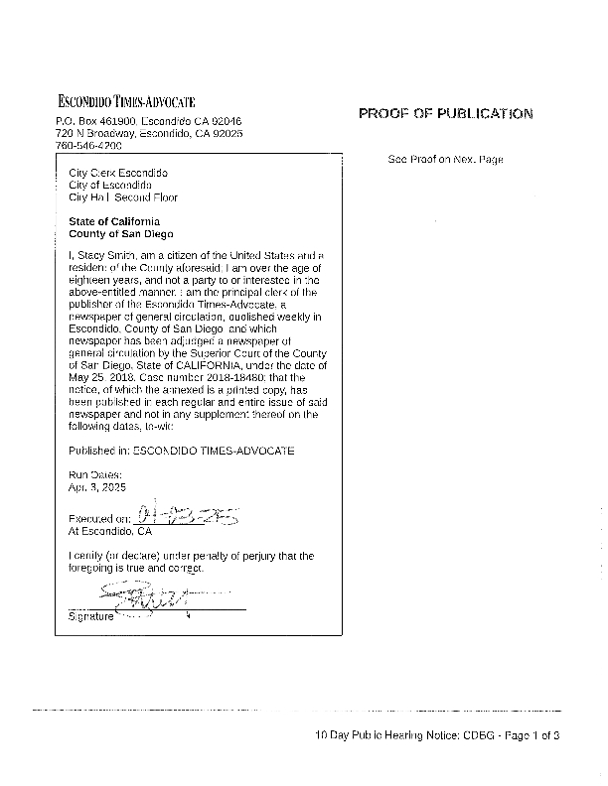
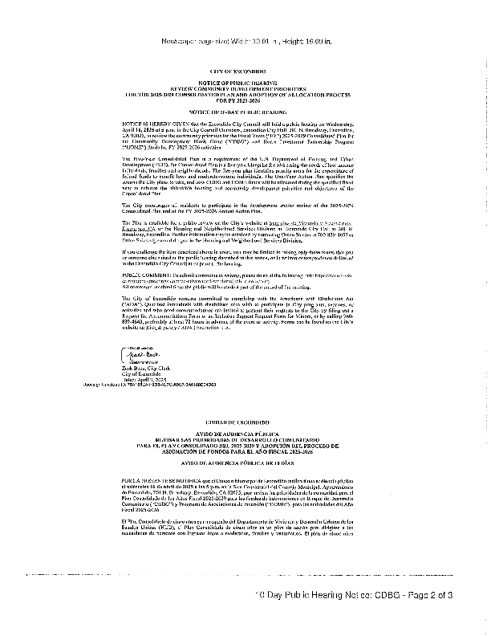
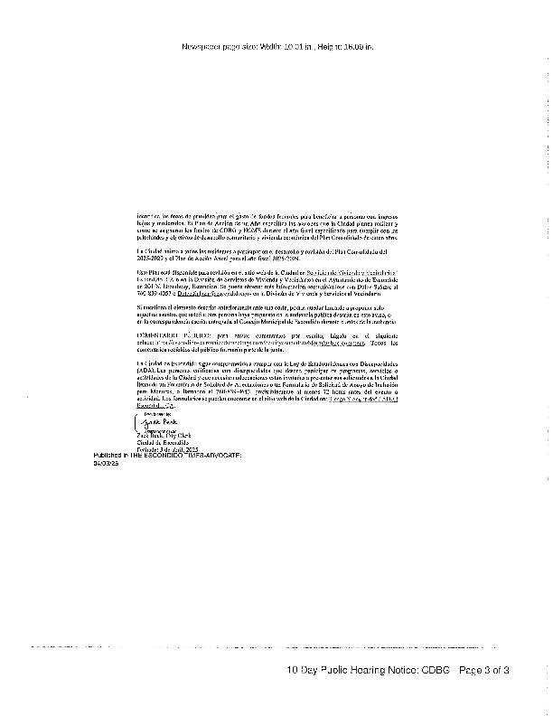
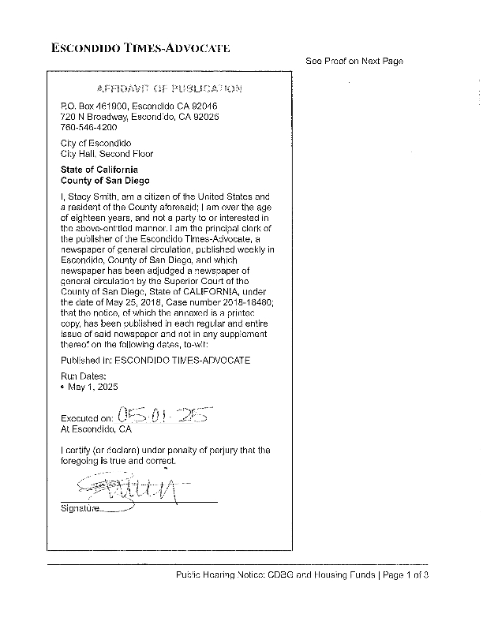
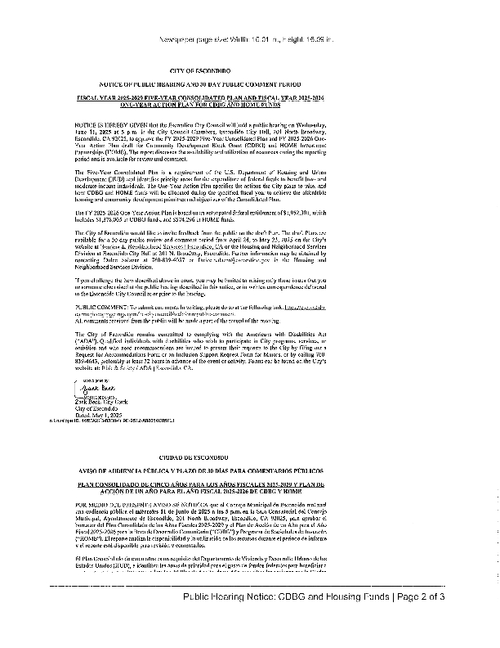
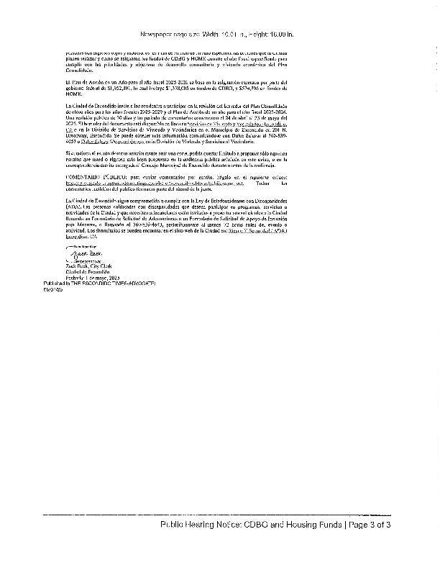
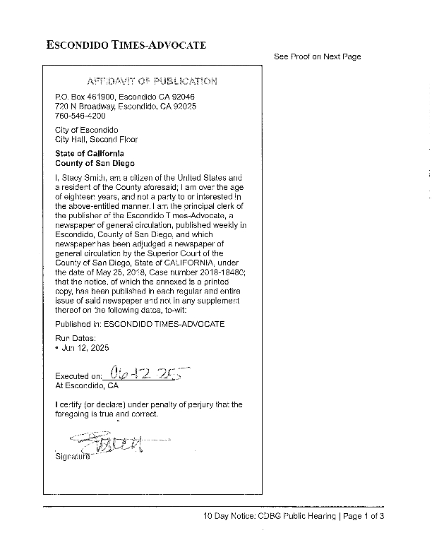
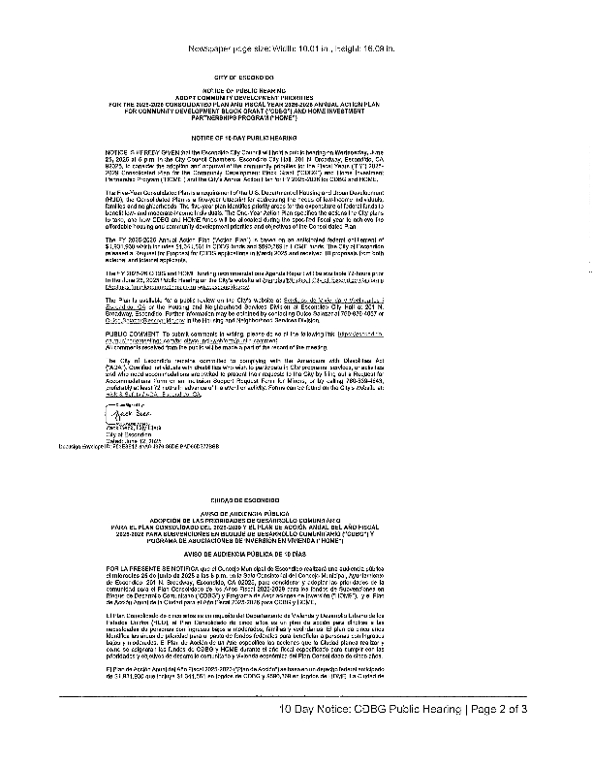
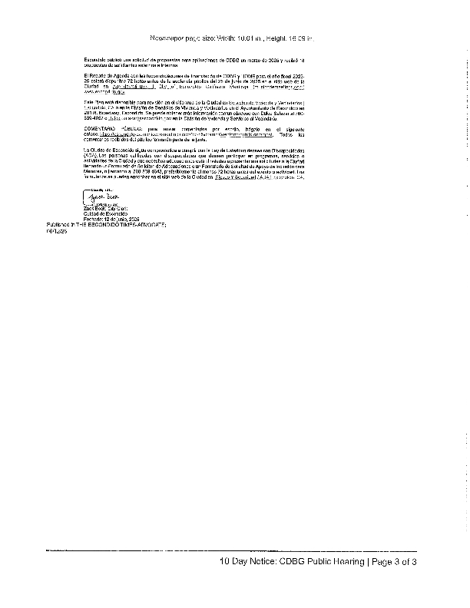

Grantee Unique Appendices

City of Escondido

  - Citizen Participation Plan for Programs Funded Under the U.S. Department of Housing and Urban Development’s Office of Community Planning and Development



Updated November 2024

Introduction

Citizen participation is a priority for the City of Escondido (City). The City receives an annual entitlement of Community Development Block Grant (CDBG), HOME Investment Partnerships Program (HOME), and Emergency Solutions Grant (ESG) funds from the U.S. Department of Housing and Urban Development (HUD) for housing and community development activities to assist people and communities with low to moderate incomes. In accordance with HUD requirements, the City must create a 5-Year Consolidated Plan (Consolidated Plan) that addresses affordable housing and community development needs, submit an Annual Action Plan (Annual Plan) to outline spending and activities for the upcoming program year, and provide a Consolidated Annual Performance and Evaluation Report (CAPER) that summarizes the City’s accomplishments and use of CDBG, HOME and ESG funds in the previous program year. Pursuant to the Code of Federal Regulations (CFR) at 24 CFR 91.105, the City must have and follow a detailed citizen participation plan that specifies the City’s policies and procedures for engaging citizens and encouraging them to participate in creating, evaluating, and implementing these federal entitlement funds.

This Citizen Participation Plan (CPP) serves to meet the federal requirements described above concurrently.

Participation Policies

The City welcomes and encourages public participation in developing relevant plans and reports. Citizen participation is vital throughout the planning process, including identifying needs, setting priorities based on those needs, recommending activities to address high priority needs, and evaluating the success of the programs and activities.

The primary goal of the CPP is to solicit views and recommendations from members of the community, organizations, and other interested parties and to incorporate the views and recommendations in the decision-making process. To accomplish this goal, the CPP mandates that the City will do the following in the development and implementation of the Consolidated Plan, CAPER, and the Assessment of Fair Housing, and/or other statutorily required plan to address fair housing:

- Encourage participation from community members and residents.

- Encourage the involvement of persons with low to moderate income, particularly those who reside in low-to-moderate communities where funds are proposed to be used.

- Encourage the involvement of persons with disabilities, racial and ethnic minorities, and persons who are non-English speaking and/or have Limited English Proficiency (LEP).

- Encourage participation from organizations and businesses that support people with low to moderate incomes, such as the Regional Task Force on Homelessness/San Diego Continuum of Care (CoC), businesses, developers, nonprofit organizations, philanthropic organizations, community-based and faith-based organizations, resident advisory boards, resident councils, and resident management corporations.

- Provide residents reasonable and timely access to information, meetings, and records.

- Provide residents the opportunity to review, offer input, and give feedback regarding the use of CDBG, HOME, and ESG funds; the Assessments of Fair Housing (AFH), Analyses of Impediments to Fair Housing Choice (AI), or other forms of fair housing planning; and the CAPER.

- Assist persons who are non-English-speaking and/or persons with LEP upon advance request, provided such services are available.

- Use comprehensive techniques to encourage and measure public participation and review program performance.

The City is committed to ensuring that all individuals have equal access to services and programs, including the process to update the Consolidated Plan and its various components. If you need special assistance to participate in a public hearing, please contact our ADA Coordinator at 760-839-4869. Notification 48 hours prior to the meeting will enable the City to make reasonable arrangements to ensure accessibility. Listening devices are available for the hearing impaired; please see the City Clerk.

Development of Plans

As an entitlement jurisdiction, the City is required to prepare the following documents:

- A Five-Year Consolidated Plan (Consolidated Plan)

- An Annual Action Plan

- A Consolidated Annual Performance and Evaluation Report (CAPER)

- AFH, AI, or other forms of fair housing planning

The City will make a concerted effort to notify residents, social service providers, business groups, nonprofit organizations, community and faith-based organizations, community boards and other interested parties of the development of the Consolidated Plan, Annual Plan, AFH, AI, or other forms of fair housing planning, and CAPER through public noticing, including electronic mail, online postings, and newspaper notices.

The City will issue a Notice of Funding Availability (NOFA) and/or Request for Proposals (RFP) inviting proposals for CDBG, HOME and ESG activities. Upon request, the City will provide technical assistance to groups representing persons with low to moderate income to develop proposals for eligible activities.

City staff will review annual grant proposals and make recommendations to the Escondido City Council (City Council) concerning federal funding. City Council meetings are open to the public and available for viewing on the City’s website. City Council agendas are posted 72 hours prior to a meeting and available on the City’s website and at Escondido City Hall (City Hall), 201 N. Broadway, Escondido, CA, 92025.

The City will prepare the Annual Plan, which may contain a list of projects to be funded for the given program year with any additional funding received. During each program year, additional funding may become available due to program income or projects that are under budget, delayed, or cancelled. A list of capital improvement projects may also be included in the Annual Plan and approved by the City Council to serve as back-up projects. The City may initiate these projects at any time when funding becomes available. The City must receive HUD approval for these back-up projects along with the approved and funded projects as part of its approval of the Annual Plan. Initiation and funding of these projects would not constitute a substantial amendment as defined within.

The City will make available any HUD-provided data and other supplemental information it plans to incorporate into its AFH, AI, or other forms of fair housing planning at the start of the public participation process (or as soon as is feasible).

Prior to adoption of the Consolidated Plan, Annual Plan (Plan(s)), the City will make available the estimated amount of CDBG, HOME, and ESG funding that it expects to receive, the activities that may be undertaken, the estimated amount of funds that will be used to benefit low-moderate income persons, and any activities that may result in displacement.

The City will publish a summary of the proposed Plan(s) and/or AFH, AI, or other forms of fair housing planning in the newspaper and have it available on the City’s website for a period of ten (10) days prior to a public meeting. The summary will describe the contents and purpose of the Plan(s) and/or AFH, AI, or other forms of fair housing planning and include a list of the locations where they may be examined. The Plan(s) and/or AFH, AI, or other forms of fair housing planning will be available for review at Escondido City Hall, on the City’s website, and at the Escondido Public Library. The City will provide a reasonable number of free copies to citizens and groups upon request.

The City will prepare an annual CAPER to evaluate the progress of the Consolidated Plan and to review accomplishments for the previous program year. Prior to submitting the CAPER to HUD, the public must be noticed, advising of the availability of the CAPER. The CAPER will be available for review at City Hall, on the City’s website, and at the Escondido Public Library. A comment period of not less than 15-days will be provided. All comments received in writing or orally will be included in the final submission to HUD.

Public Hearings

The City aims to hold public meetings at convenient times and locations, ensuring accessibility for persons with disabilities. The City continues to explore new ways to enhance participation and involvement, including the use of online needs assessments and surveys.

The City will meet the following public hearing requirements:

- Conduct at least two public hearings each year to obtain residents’ feedback regarding housing and community development needs, proposed allocation of CDBG and ESG funds, strategies and actions taken to affirmatively further fair housing, review program performance, and approve program/funding activities.

- Conduct at least one public hearing each year regarding the proposed allocation of HOME funds. HOME funds will be conditionally committed to an affordable housing development only after a public hearing to discuss the project.

- Conduct at least one public hearing during the development of the AFH, AI, or other forms of fair housing planning prior to publishing for public comment.

- Conduct at least one public hearing during the development of the Consolidated Plan prior to publishing the Consolidated Plan for public comment.

- Receive and consider comments concerning the Plan(s) and/or AFH, AI, or other forms of fair housing planning for a period of not less than 30 days. All comments received, in writing or orally at a public meeting, will be considered in preparing the final Plan(s) and/or AFH, AI, or other forms of fair housing planning. A summary of the comments or views, including those not accepted and the reasons, shall be attached to the final Plan(s) AFH, AI, or other forms of fair housing planning.

Public hearings are held in Escondido City Council Chambers located at City Hall at 201 N. Broadway in Escondido. If you need special assistance to participate in a public hearing, please contact our ADA Coordinator at 760-839-4869. Notification 48 hours prior to the meeting will enable the City to make reasonable arrangements to ensure accessibility. Listening devices are available for the hearing impaired; please see the City Clerk.

Public Notices

- Public notices, excluding the CAPER, will be published at least ten days prior to a hearing. Notices will include the date, time, location, and summary of the proposed action to help facilitate informed comments. Notices will be published in the newspaper and announced on the City’s website.

Plan Amendments

The City will amend its approved Plan(s) whenever it makes one of the following decisions:

- To carry out an activity not previously described in the Annual Plan using funds covered by the Consolidated Plan, including program income.

- To substantially amend the purpose, scope, location, or beneficiaries of an activity.

- To substantially amend the allocation priorities or the method of distributing funds.

A substantial amendment is defined as the following:

- An addition, modification, or elimination of a Consolidated Plan goal.

- An addition of a new activity not previously identified in the Annual Plan.

- A change that affects the funding level of more than $25,000 for projects budgeted at $100,000 or less, or greater than 25 percent of projects budgeted at more than $100,000.

Substantial amendments must be authorized by the City Council and will be available on the City’s website and through public notices in the newspaper. Public notices will be published at least ten days prior to the hearing. Notices will include the date, time, location, and summary of the proposed action to help facilitate informed comments. Minor changes and/or corrections may be made, so long as the changes do not constitute a substantial amendment. Minor changes, including but not limited to modifications of goal outcome indicators, shall not be considered a substantial amendment and do not require public review or a public hearing.

The City will receive and consider comments concerning substantial amendments and/or AFH, AI, or other forms of fair housing planning revisions for period of not less than 30 days. All comments received, in writing or orally at a public meeting, will be considered in preparing the final Plan(s) and/or AFH, AI, or other forms of fair housing planning. A summary of the comments or feedback, including those not accepted and the reasons, shall be attached to the final Plan(s) and/or AFH, AI, or other forms of fair housing planning.

Access to Information and Records

Any citizen, organization, or other interested party may submit written requests for information regarding the Consolidated Plan, Annual Plans, AFH, AI, or other forms of fair housing planning, and CAPER, including the City’s use of funds under the CDBG, HOME, and ESG programs and the benefit to persons with low-moderate incomes during the preceding five years.

This CPP, the current Consolidated Plan, Annual Plan, AFH, AI, or other forms of fair housing planning, CAPER, and any substantial amendments to these plans are available for public review at City Hall (201 N. Broadway) and on the City’s website.

Technical Assistance

Upon request, the City works with individuals or groups which represent people with lower incomes to develop proposals for funding assistance under the Consolidated Plan programs. City staff provides technical assistance for proposals that strengthen and expand the role of community-based development organizations in planning for eligible activities.

Anti-Displacement

The City strives to avoid and minimize the displacement of individuals due to HUD- funded activities. To the greatest extent possible, the City will consider the impact of displacement in the site selection during the project planning phase and will provide information to displaced individuals on available assistance and relocation benefits.

Prior to approval of any HUD-funded activities with the potential for temporary or permanent displacement of individuals or businesses, the responsible agency (City or private developer) must provide a written plan of action for comparable replacement housing and assistance to displaced households based on the Uniform Relocation Assistance and Real Property Acquisitions Policies Act of 1970 (URA), 49 CFR Part 24.

Comment and Complaint Process

The City will consider any comments from citizens received in writing or orally at public hearings in preparing this CPP, the Consolidated Plan, Annual Plans, CAPERs, AFH, AI, or other forms of fair housing planning, and/or substantial amendments to these plans. A summary of all comments will be attached and submitted to HUD.

The City will respond to written complaints received relating to the Consolidated Plan, Annual Plans, CAPERs, AFH, AI, or other forms of fair housing planning, and/or substantial amendments. Written complaints must describe the objection and provide contact information of the complainant. The City will respond to complaints within 15 working days of receiving the written complaint, acknowledging the letter and identifying a plan of action, if necessary. Correspondence may be addressed to:

City of Escondido
Dulce Salazar
201 North Broadway
Escondido, CA 92025

Persons wishing to contact the Los Angeles Area HUD Office may address correspondence to:

U.S. Housing and Urban Development
Attn: Alexander A. Gonzales
300 North Los Angeles St., Suite 4054
Los Angeles, CA 90012

Grantee SF-424's and Certification(s)
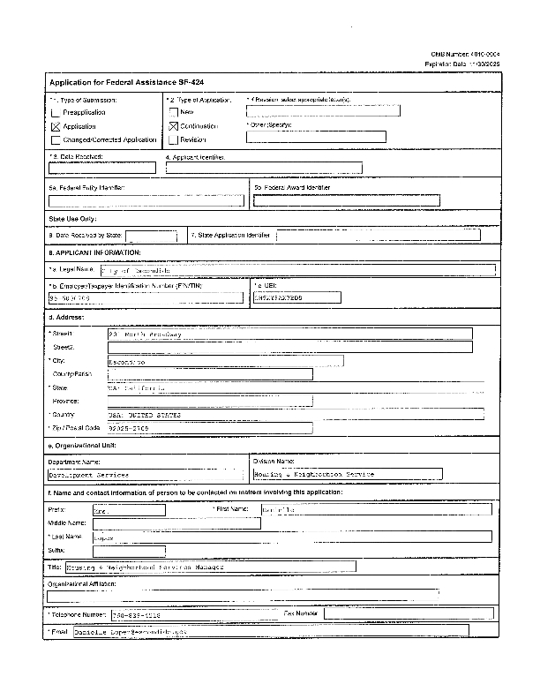
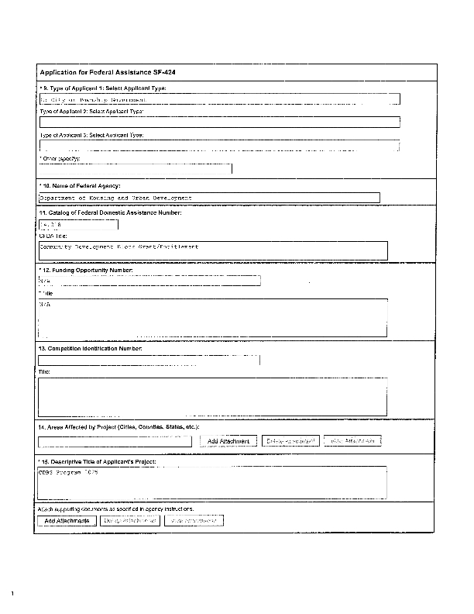
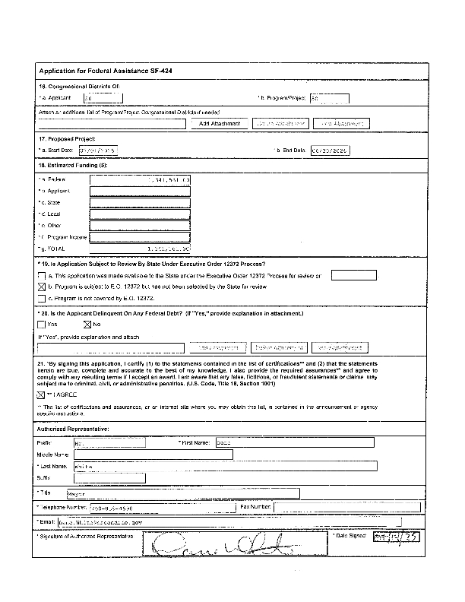
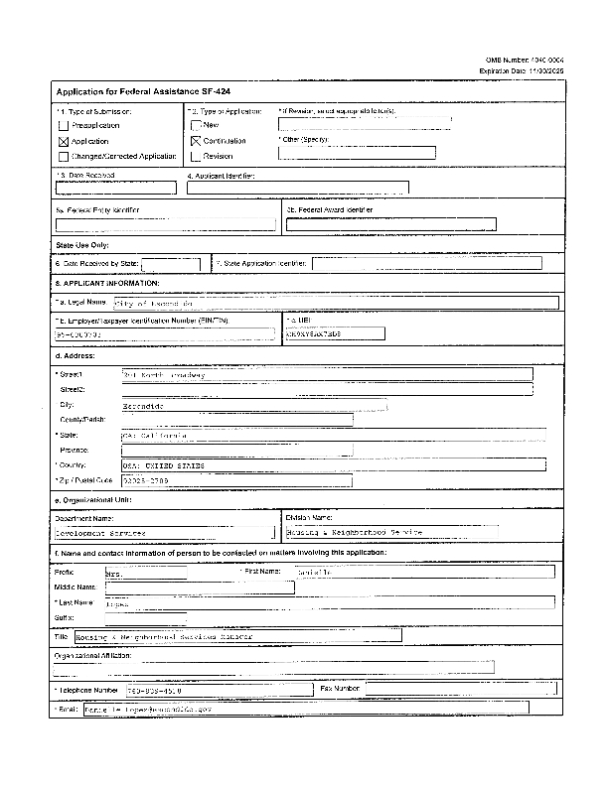
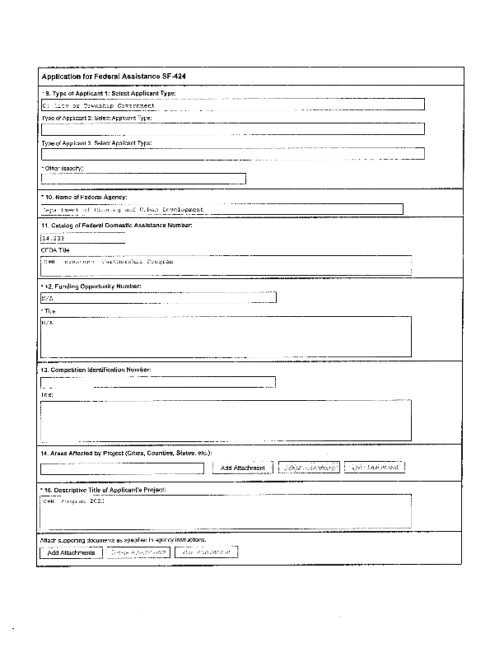
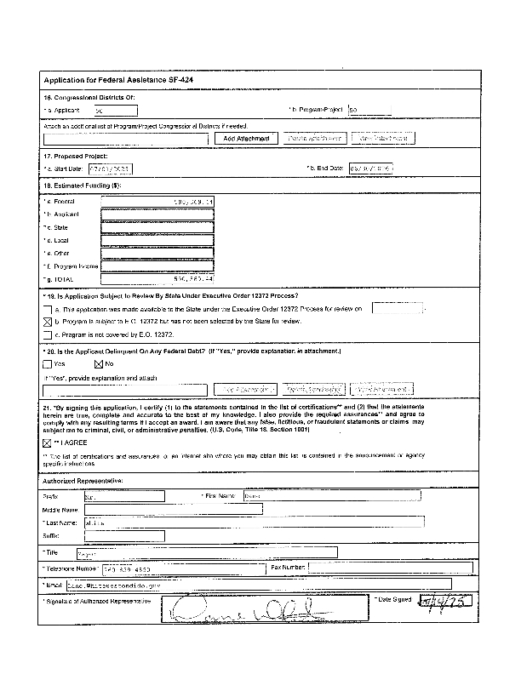
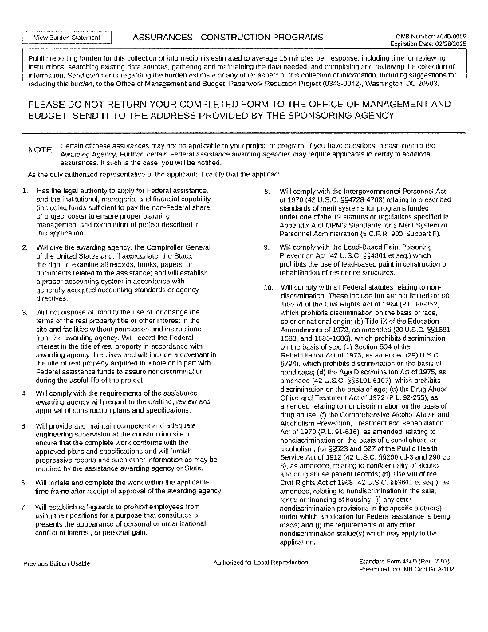
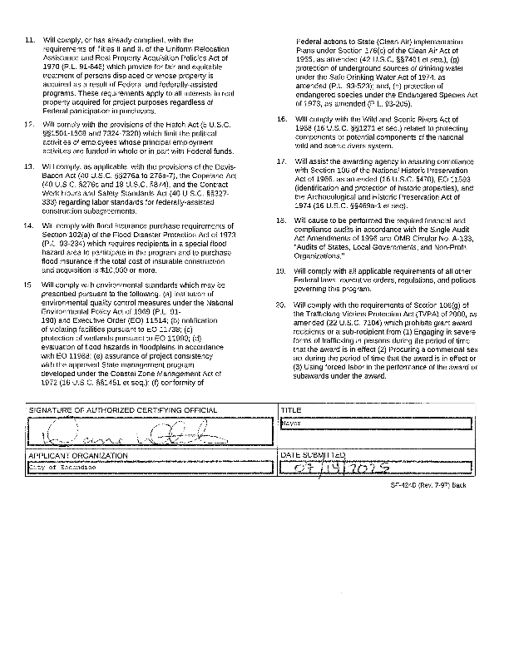
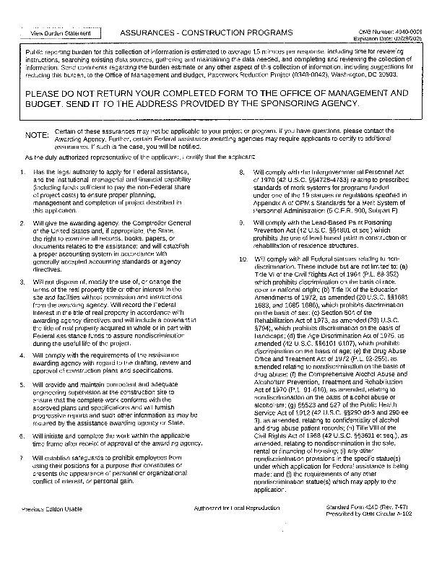
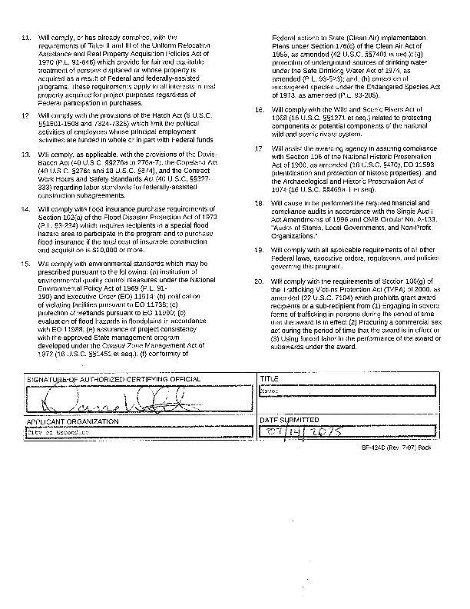
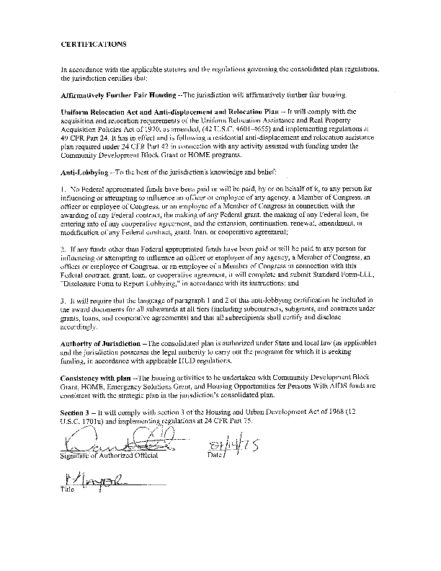
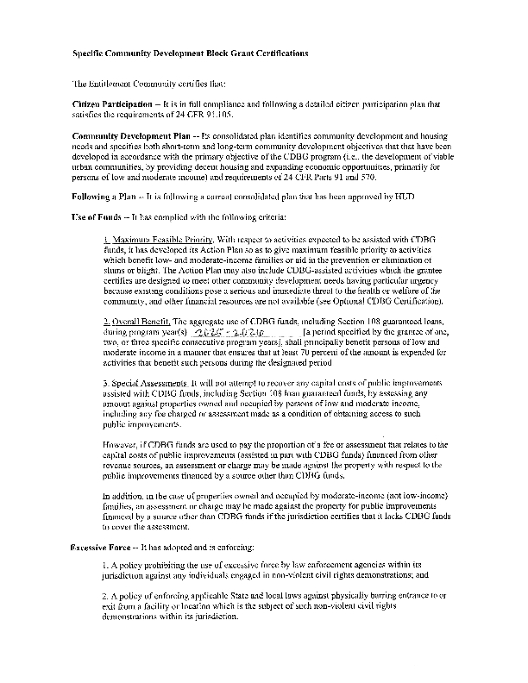

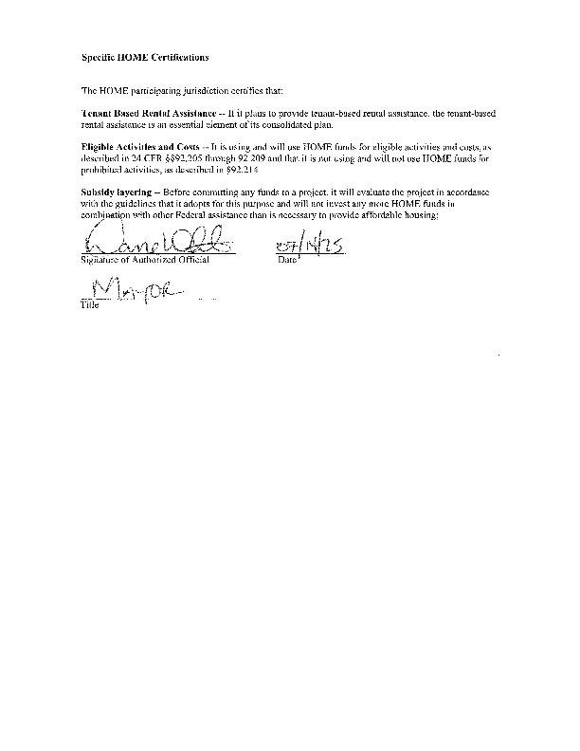


HOME-ARP
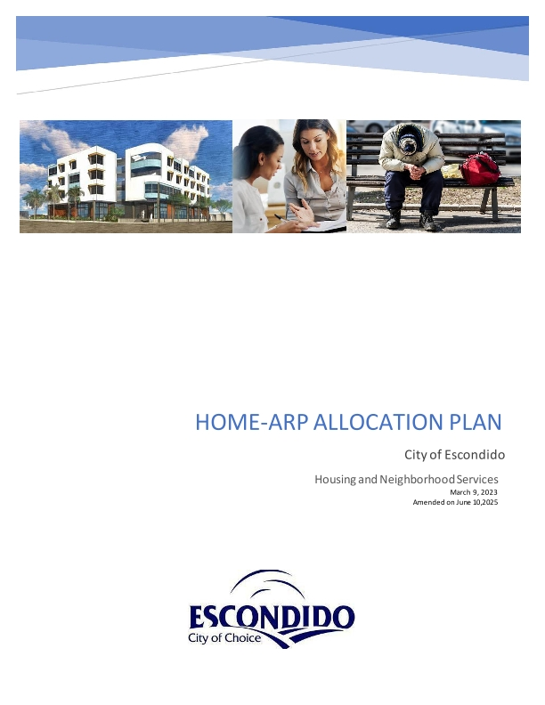
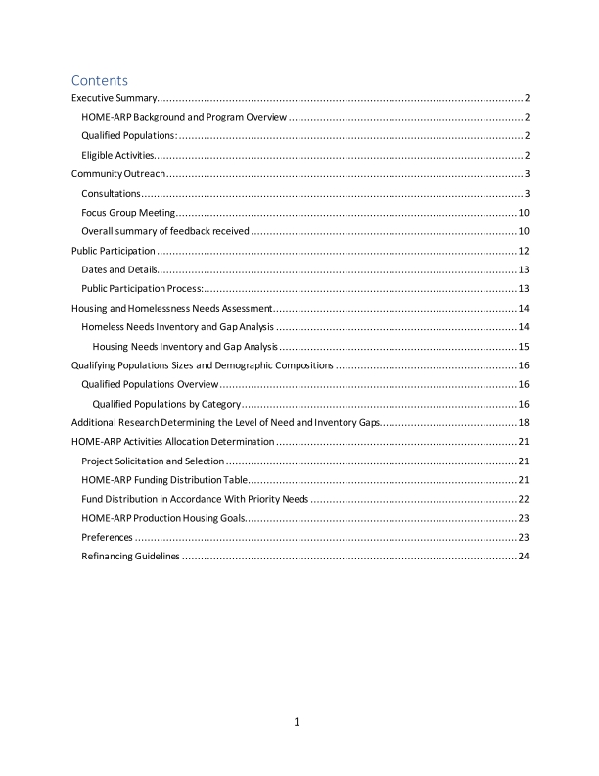
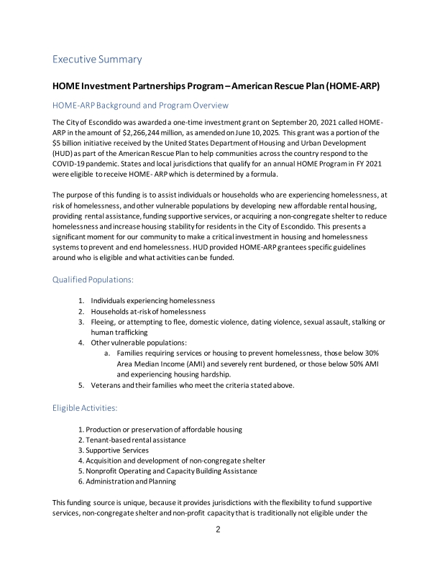
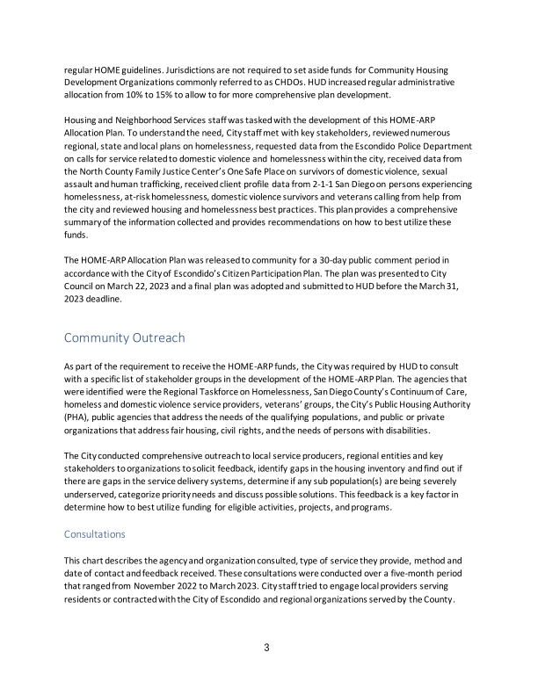
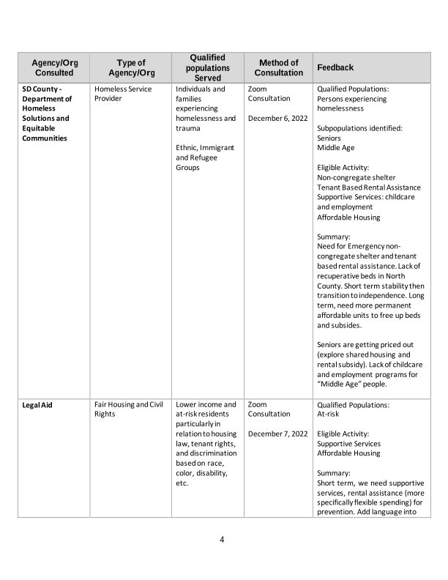
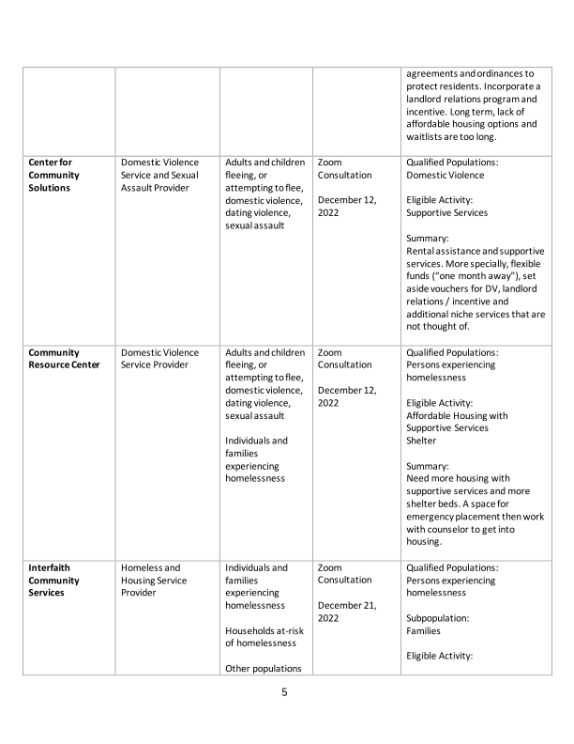
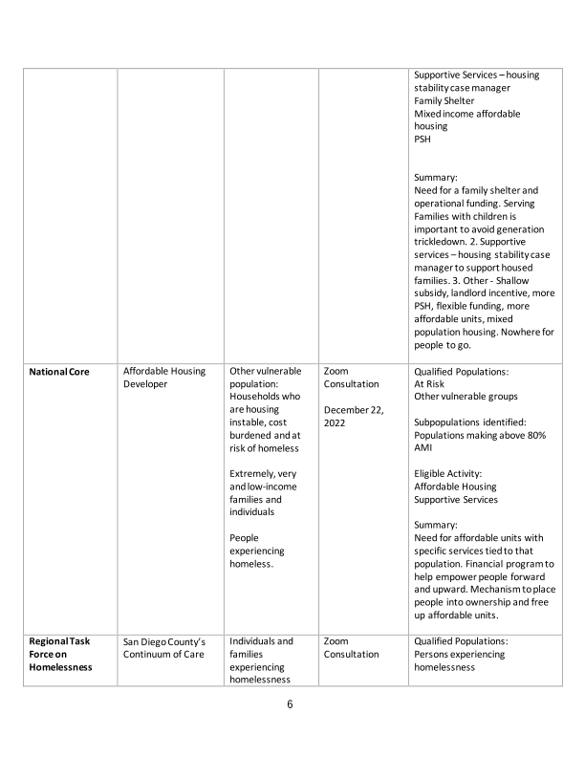
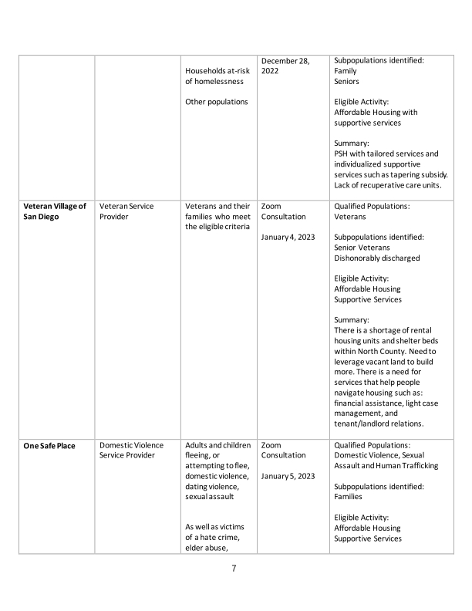
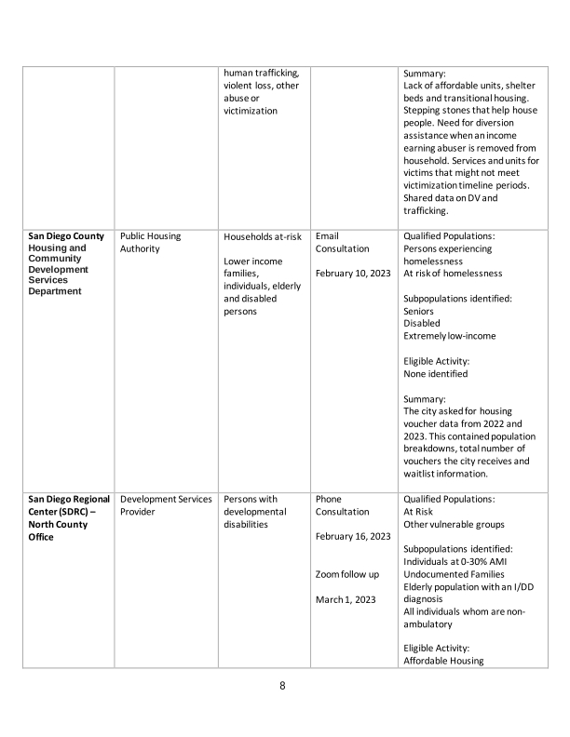
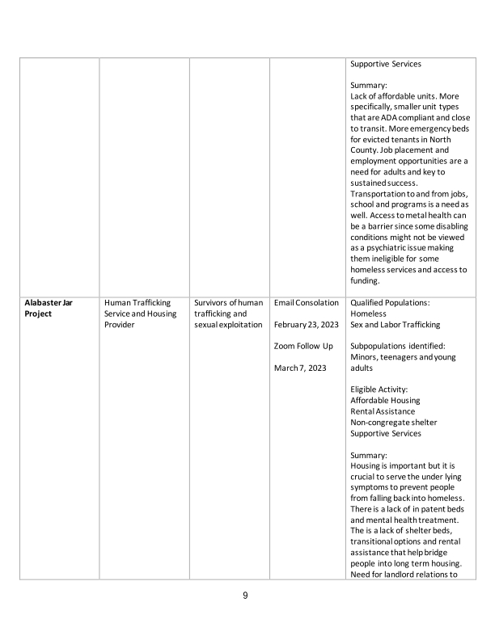
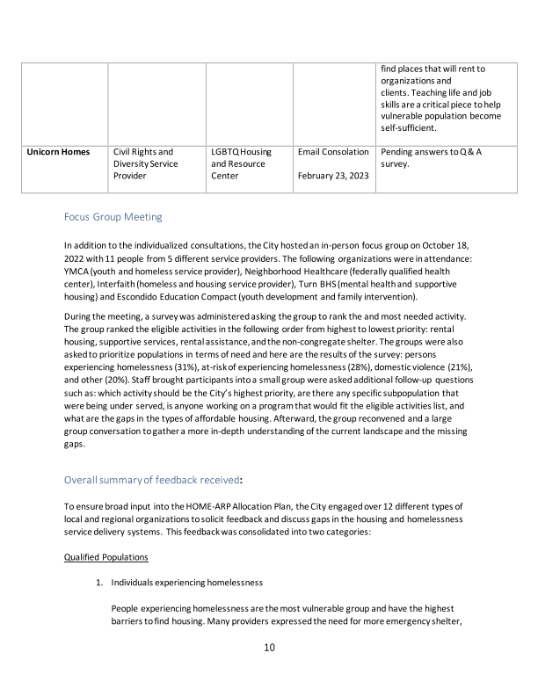
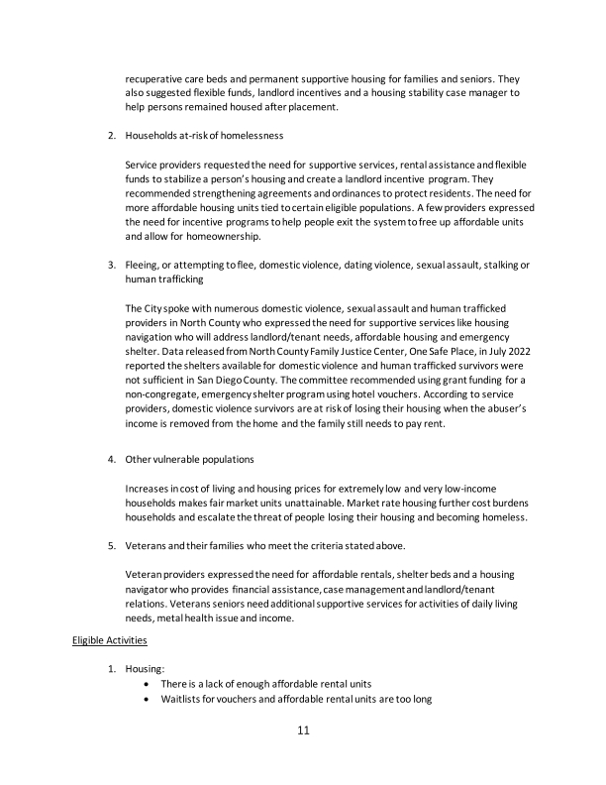
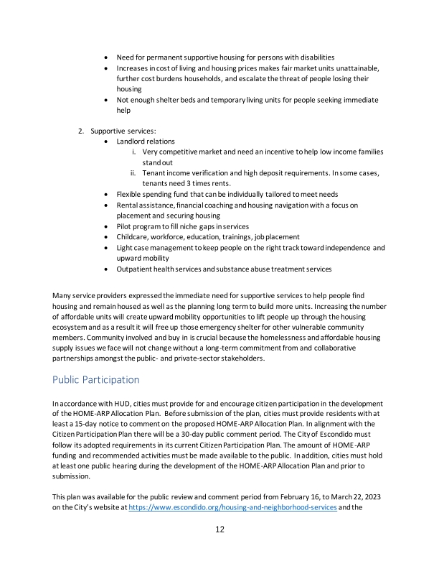
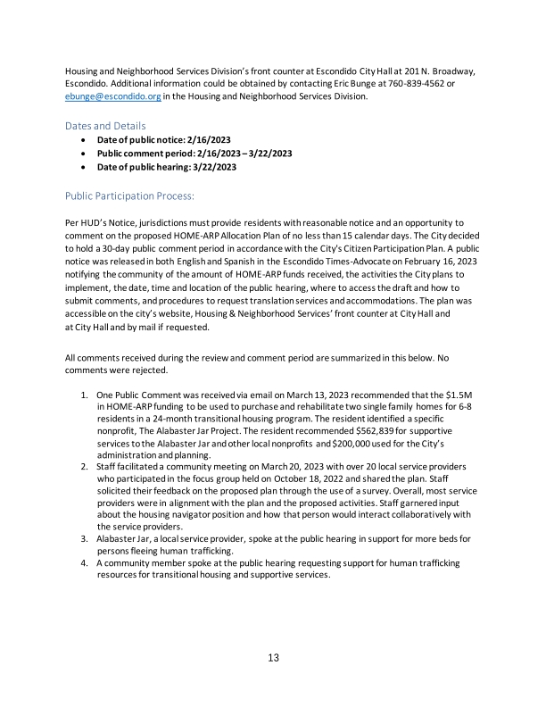
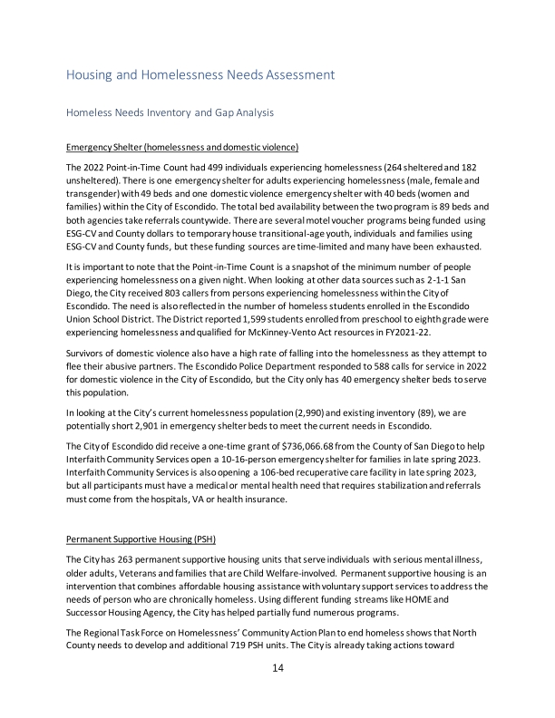
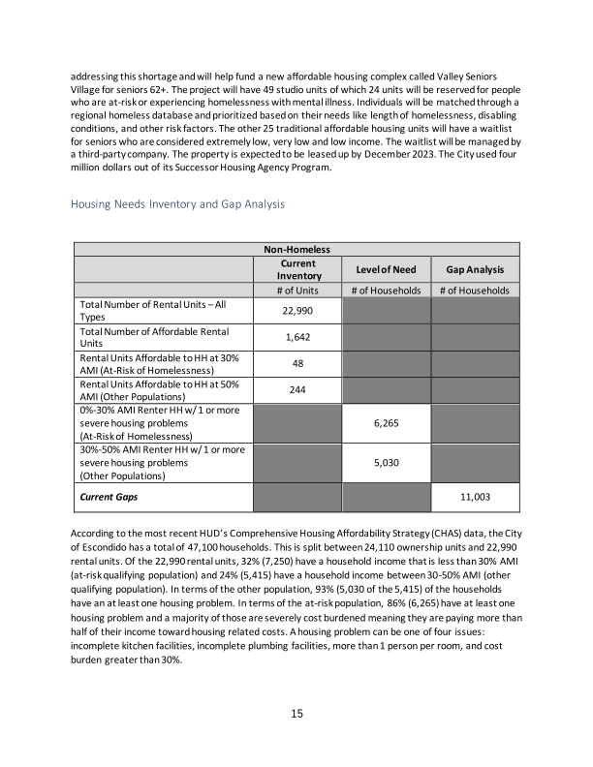
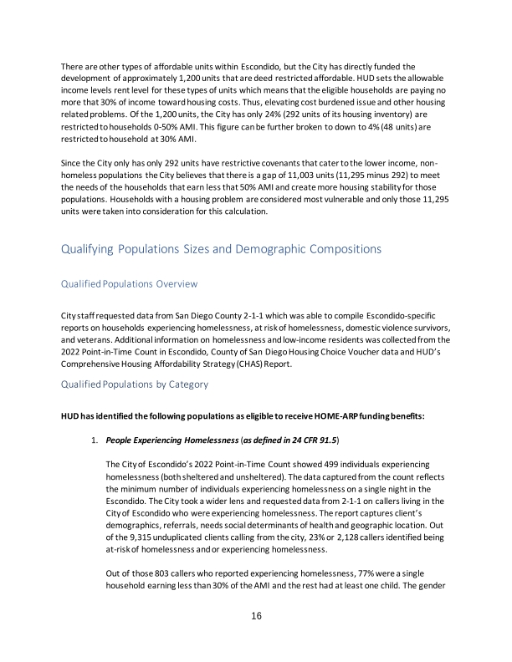
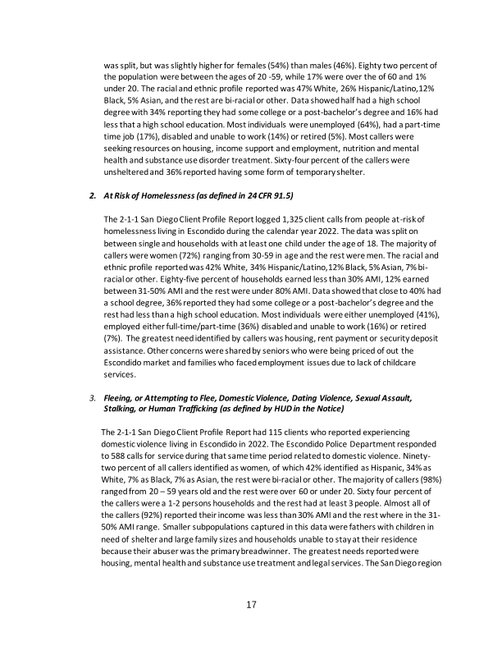
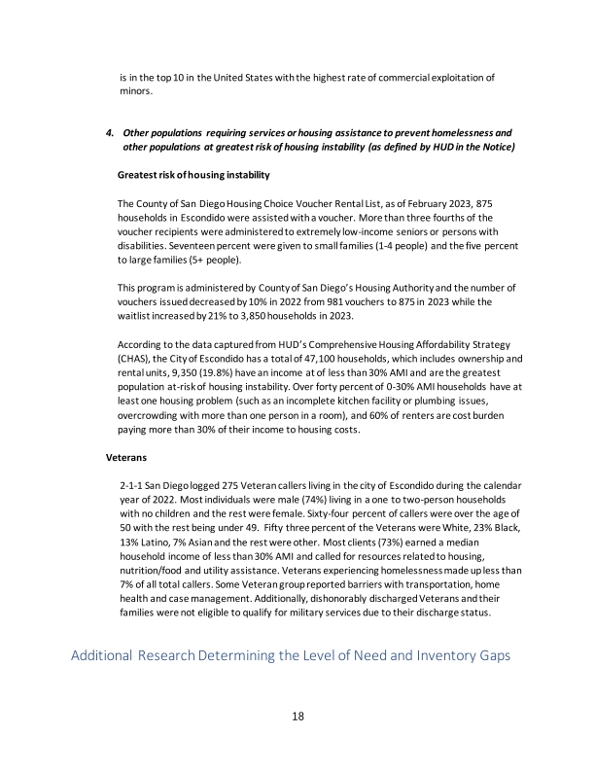
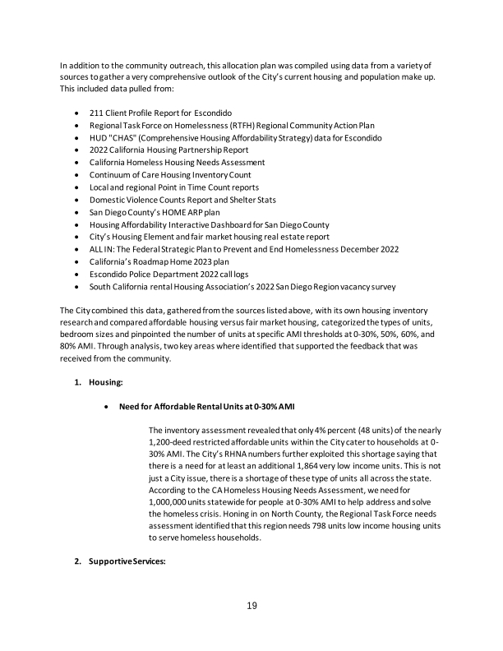
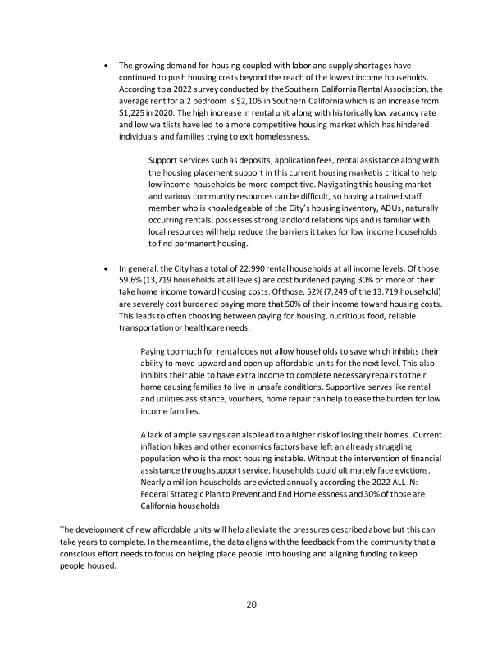
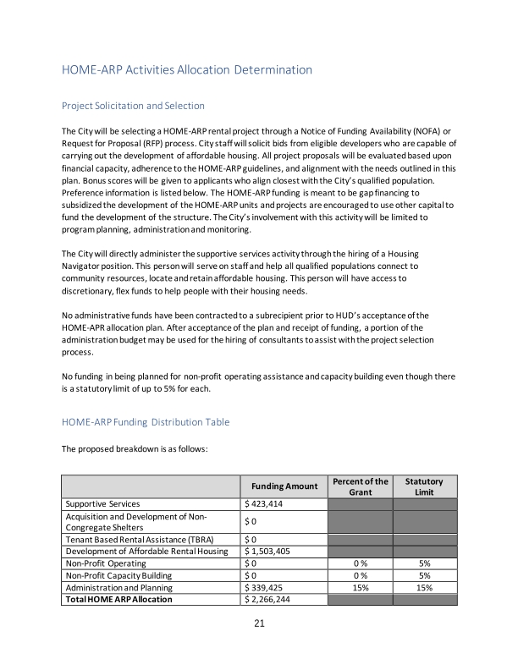
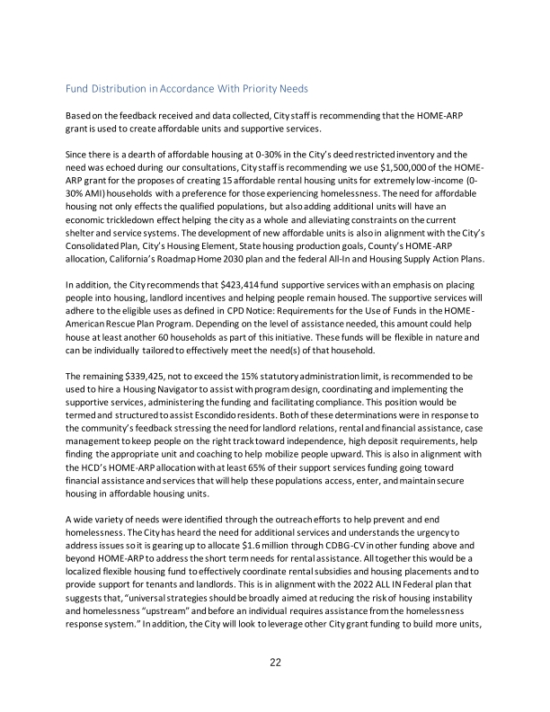
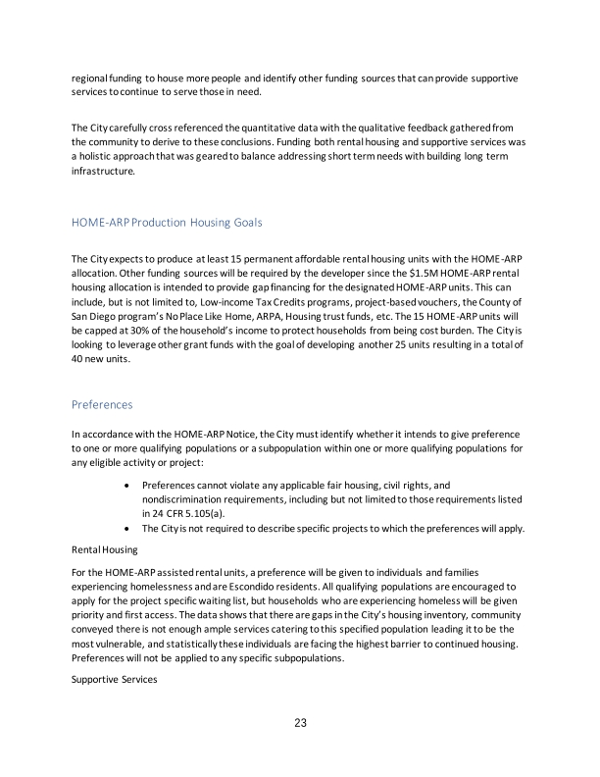
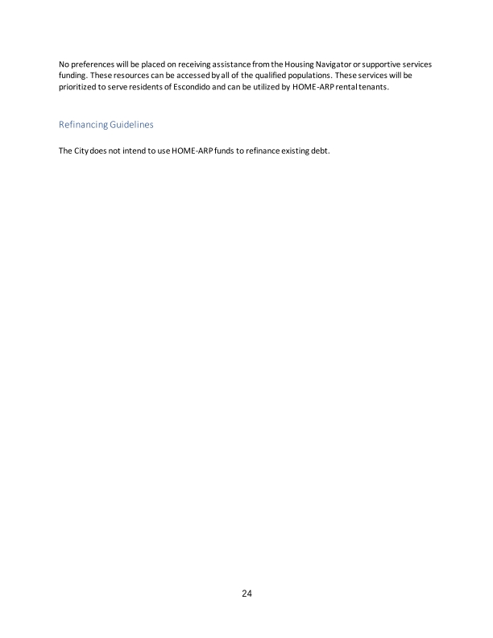

Appendix - Alternate/Local Data Sources

1 | Data Source Name  Maplebrook
1 | List the name of the organization or individual who originated the data set.  City of Maplebrook
1 | Provide a brief summary of the data set.  The city conducted a neighborhood planning study of the community.
1 | What was the purpose for developing this data set?  To determine existing community needs.
1 | How comprehensive is the coverage of this administrative data? Is data collection concentrated in one geographic area or among a certain population?  Data is from entire neighborhood.
1 | What time period (provide the year, and optionally month, or month and day) is covered by this data set?  2013-2014 time period
1 | What is the status of the data set (complete, in progress, or planned)?  The data set is complete.
2 | Data Source Name  Source: ACS, 2018-2022 [Data Series B25123]
2 | List the name of the organization or individual who originated the data set.  American Community Survy 2018-2022
2 | Provide a brief summary of the data set.
2 | What was the purpose for developing this data set?
2 | Provide the year (and optionally month, or month and day) for when the data was collected.
2 | Briefly describe the methodology for the data collection.
2 | Describe the total population from which the sample was taken.
2 | Describe the demographics of the respondents or characteristics of the unit of measure, and the number of respondents or units surveyed.

